**SOFTWARE REQUIREMENT SPECIFICATION**

**DOCUMENT**

**REX_COFFEE MANAGEMENT SYSTEM**

**Version:** Version 2.0

**ABSTRACT**

This document is intended to be the SRS for developing **REX_COFFEE MANAGEMENT SYSTEM**

|  |  |  |  |
| --- | --- | --- | --- |
| **Project Title** | **REX_COFFEE MANAGEMENT SYSTEM** | | |
| **Lead Institution** | **International School, Duy Tan University** | | |
| **Project Mentor** | **MSc Huy Nguyen Dang Quang** | | |
| **Team Name** | **2** | | |
| **Team Members** | Bao Nguyen Quang | | |
| Hien Nguyen Thanh Long | | |
| Huy Phan Nhat | | |
| **Start Date** | Nov 26, 24 | **End Date** | Dec 21, 24 |

**ROPRIETARY INFORMATION**: The information contained in this document is the property of TEAM 2. Except as specifically authorized in writing by **TEAM 2**, the holder of this document shall keep all information contained herein confidential and shall protect same in whole or in part from disclosure and dissemination to all third parties.

Table of Contents

Revision History 7

1. Introduction 8

1.1. Purpose 8

1.2. Intended Audience and Reading Suggestions 8

1.3. References 8

2. Project Overview 10

2.1. Project Description 10

2.2. Business Problems 10

2.3. Business Need 10

2.4. Project Analyst 11

2.4.1. Business Function Diagram 11

2.4.2. System Context Diagram 12

2.4.3. Data Flow Diagram 13

2.5. Software Requirement Specification 13

2.5.1. High level Fucntional Requirement (FR) 13

2.5.2. Stakeholders 16

2.5.3. Usecase 17

2.5.3.1. List of use cases 17

2.5.3.2. Rex_Coffee Use Case Diagram Overview 18

2.5.4. Use Case Specification 18

*UC 01: Scan QR Code* 18

*UC 02: View Menu* 20

*UC 03: Order* 22

*UC 04: View Order Status* 24

*UC 05:* *Cancel Order Item* 25

*UC 06: Payment* 27

*UC 07: Book* 30

*UC 08: Login (Waiter)* 33

*UC 09: Receiver service notifications* 39

*UC 10: View order status* 42

*UC 11:* *Login (Barista)* 48

*UC 12: See list of dishes ordered by customers* 55

*UC 13: Notice of out of stock* 58

*UC 14: Notify that the dish is done* 60

*UC 15: Login (Cashier)* 62

*UC 16: See list of dishes ordered by customers* 69

*UC 17: Issue invoices* 72

*UC 18: Payment* 74

*UC 19: Summary of revenue* 77

*UC 20: Login (Admin)* 81

*UC 21: Manage customer booking* 88

Main Flow D: Update Customer Reservation Information 90

*UC 22: Account management* 91

Main Flow A: View the Account List 92

Main Flow B: Add a New Account 92

Main Flow D: Update Account Information 93

*UC 23: Menu management* 95

Main Flow A: View the List of Menu Items 95

Main Flow B: Add a New Menu Item 95

Main Flow C: Delete a Menu Item 96

Main Flow D: Update Menu Item Information 96

*UC 24: Update price* 98

Main Flow C: Decrease the Price of Less Popular Menu Items 99

Alternative Flow: 99

*UC 25: Revenue management* 100

Main Flow A: View Revenue Overview 100

Main Flow B: Export Revenue Report 101

Alternative Flow 101

*UC 26: Manage Desk layout* 102

Main Flow D: Delete Desk 105

*UC 27: Manage QR codes for each table.* 106

2.5.5. Software Quality Attributes 111

2.5.5.1. Usability 111

2.5.5.2. Reliability 111

2.5.5.3. Security 111

2.5.5.4. Maintainability 111

2.5.5.5. Performance 111

2.6. Software Design Description 112

2.6.1. Sequence Diagrams 112

2.6.1.1. Scan QR code 112

2.6.1.2. View menu 112

2.6.1.3. Order 113

2.6.1.4. View order status 113

2.6.1.5. Cancel the dish 114

2.6.1.6. Payment 115

2.6.1.7. Book 116

2.6.1.8. Login (Waiter) 117

2.6.1.9. Receive service notifications 117

2.6.1.10. View order status 118

2.6.1.11. Login (Barista) 118

2.6.1.12. See list of dishes ordered by customers (Barista) 119

2.6.1.13. Notice of out of stock 120

2.6.1.14. Notify that the dish is done 121

2.6.1.15. Login (Cashier) 122

2.6.1.16. See list of dishes ordered by customers (Cashier) 122

2.6.1.17. Issue invoices 123

2.6.1.18. Payment (Cashier) 123

2.6.1.19. Summary of revenue 124

2.6.1.20. Manage customer bookings 124

2.6.1.21. Manage desk plans 126

2.6.1.22. Menu management 128

2.6.1.23. Update price 129

2.6.1.24. Manage QR codes of each tables 130

2.6.1.25. Revenue management 131

2.6.1.26. Account management 131

2.6.2. Activity Diagrams 132

2.6.2.1. Scan QR code 132

2.6.2.2. View menu 132

2.6.2.3. Order 133

2.6.2.4. View order status 134

2.6.2.5. Cancel the dish 135

2.6.2.6. Payment 136

2.6.2.7. Book 137

2.6.2.8. Login (Waiter) 138

2.6.2.9. Receive service notifications 139

2.6.2.10. View order status 139

2.6.2.11. Login (Barista) 140

2.6.2.12. See list of dishes ordered by customers (Barista) 141

2.6.2.13. Notice of out of stock 142

2.6.2.14. Notify that the dish is done 143

2.6.2.15. Login (Cashier) 144

2.6.2.16. See list of dishes ordered by customers (Cashier) 145

2.6.2.17. Issue invoices 146

2.6.2.18. Payment (Cashier) 147

2.6.2.19. Summary of revenue 148

2.6.2.20. Manage customer bookings 149

2.6.2.21. Login (Admin) 150

2.6.2.22. Manage desk plans 151

2.6.2.23. Menu management 153

2.6.2.24. Update price 155

2.6.2.25. Manage QR codes of each tables 156

2.6.2.26. Revenue management 159

2.6.2.27. Account management 160

2.6.3. Class Diagram 162

2.6.4. Allocation Diagram 162

Appendix A: Glossary 162

# Revision History

|  |  |  |  |  |
| --- | --- | --- | --- | --- |
| Date | Change Item | Description | by | Version |
| Nov 26, 24 | Draft |  | All | 1.0 |
| Nov 27, 24 | Update | Introduction | Hien | 1.1 |
| Nov 28, 24 | Update | Project Overview | Huy | 1.2 |
| Nov 29, 24 | Update | Update BFD | All | 1.3 |
| Nov 30, 24 | Update | Update DFD lv0, lv1 | All | 1.4 |
| Dec 02, 24 | Update | Update DFD lv2 | Hien | 1.5 |
| Dec 04, 24 | Update | Update UC diagram | Huy | 1.6 |
| Dec 14, 24 | Update | Update UC specifications | All | 1.7 |
| Dec 19,24 | Update | Update Activity and Sequence diagram | All | 1.8 |
| Dec 20,24 | Update | Update class diagram | All | 1.9 |
| Dec 21, 24 | SRS | Complete | All | 2.0 |

# Introduction

## Purpose

The document provides an overview of the project including the purpose and scope of the project:

* The document provides an overview of the project including the purpose and scope of the project.
* Also, identifies the daily operational processes of the cafe.
* Identify management needs for software operations.
* Identify challenges and desired improvements that provide a solution to the business needs and provide an overview of the system architecture.
* Provide functionality to facilitate customer service for employees.
* Enhance the quality of the customer experience.
* Explore user interface and experience requirements.
* Provide an overview of resources, schedule, solution, and budget for the project

## Intended Audience and Reading Suggestions

|  |  |
| --- | --- |
| Intended Audience | Reading Suggestions |
| Shop Manager | Operational reports, daily sales summaries, and inventory status for effective decision-making. |
| Bartender | Recipe manuals, workflow guidelines, and customer service tips for improving service quality. |
| Customers | Identifying customer segments helps diversify incentive programs, thereby improving service quality. |
| Cashier | Financial reports, daily revenue logs, and expense sheets for accurate bookkeeping. |
| Waiter | Clear and concise instructions on how to place orders for customers, send orders to bartenders, and cancel orders for customers. |

## References

|  |  |  |
| --- | --- | --- |
| **No.** | **References** | **Document Information** |
| 1 | **How to run a coffee** **shop easier** | <https://www.facebook.com/groups/httpschuquancaphe.vn/posts/43>96727010363849/. |
| 2 | **Analyze and design** **functions for the system** | <https://studyresource.duytan.edu.vn/access/content/group/229472/>Group%20Project/ur_project_1_2023.pdf. <https://studyresource.duytan.edu.vn/access/content/group/229472/>Template/Proposal%20Document%20Template.docx.  Resource MyDTU CMU-SE 214 AIS |
| 3 | **Cafe Management** **Systems** | CoffeeCup, Upserve, CafeX : Provide specialized coffee shop management solutions, from ordering, payment to revenue reporting and customer interaction. |
| 4 | **Information &** **Resources for Cafe** **Owners** | CoffeeBI, Perfect Daily Grind, Barista Institute: Sites that share knowledge about the coffee industry, market trends, and how to manage and develop services for coffee shops. |

# Project Overview

## Project Description

The Coffee Shop Management System is designed to streamline and automate daily operations in a coffee shop. This system provides tailored functionalities for key stakeholders, including customers, waiters, baristas, cashiers, and administrators. It integrates features such as order management, menu updates, payment processing, and revenue management, ensuring a seamless experience for both customers and staff

## Business Problems

Coffee shop face multiple challenges, including:

* Inefficient order-taking processes, leading to delays and errors.
* Lack of visibility into real-time inventory, causing dissatisfaction when items are out of stock
* Manual management of tables, orders, and payments, resulting in operational bottlenecks
* Difficulty in generating revenue reports and tracking performance metrics
* Limited interaction between staff roles, which affects overall efficiency and customer satisfaction

## Business Need

The coffee shop requires a unified and automated management system to address these challenges by:

* Enhancing the customer experience through streamlined ordering and real-time updates
* Providing staff with tools to manage and track orders efficiently, minimizing errors
* Allowing administrators to oversee operations, update menus, and manage tables and prices dynamically
* Offering detailed revenue and performance insights to improve decision-making and profitability
* Ensuring seamless communication between customers and staff to improve service quality

## Project Analyst

## Business Function Diagram

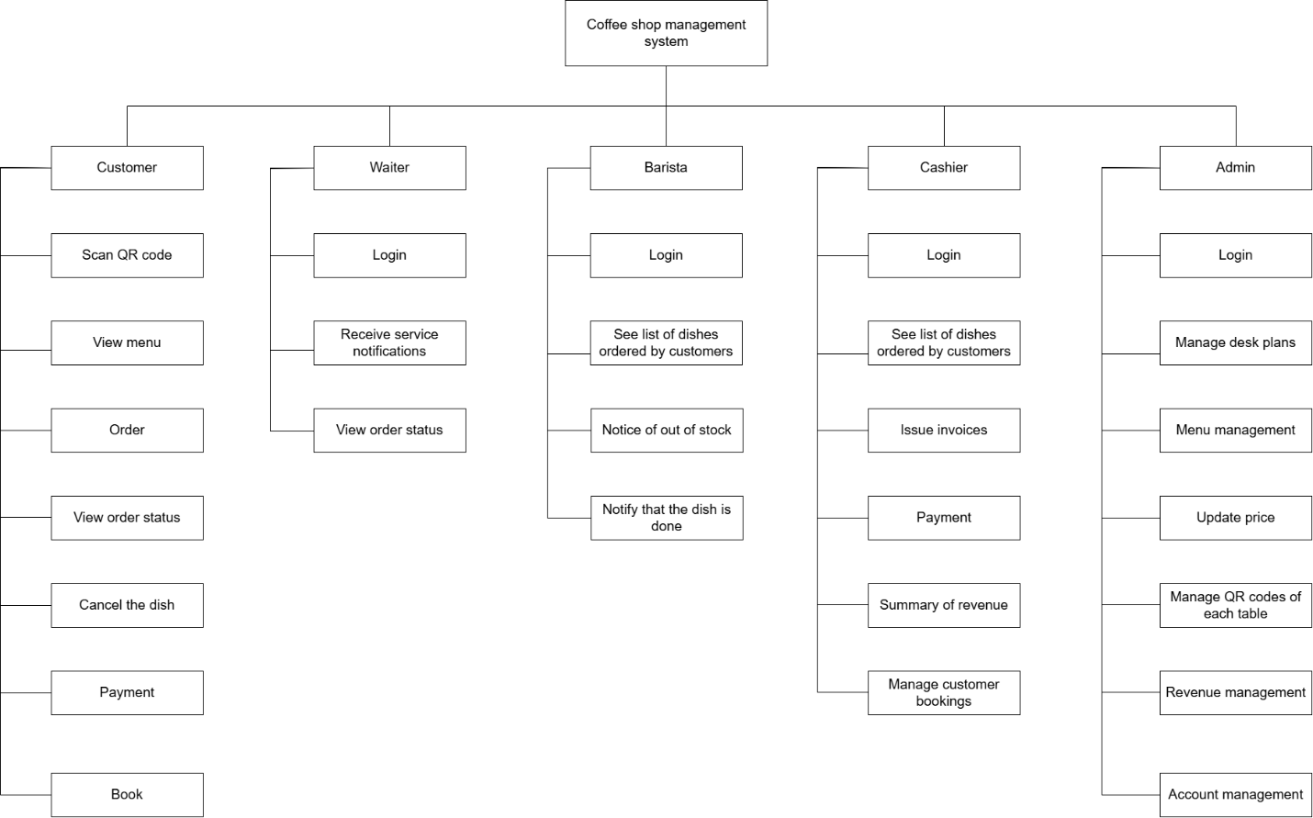

## System Context Diagram

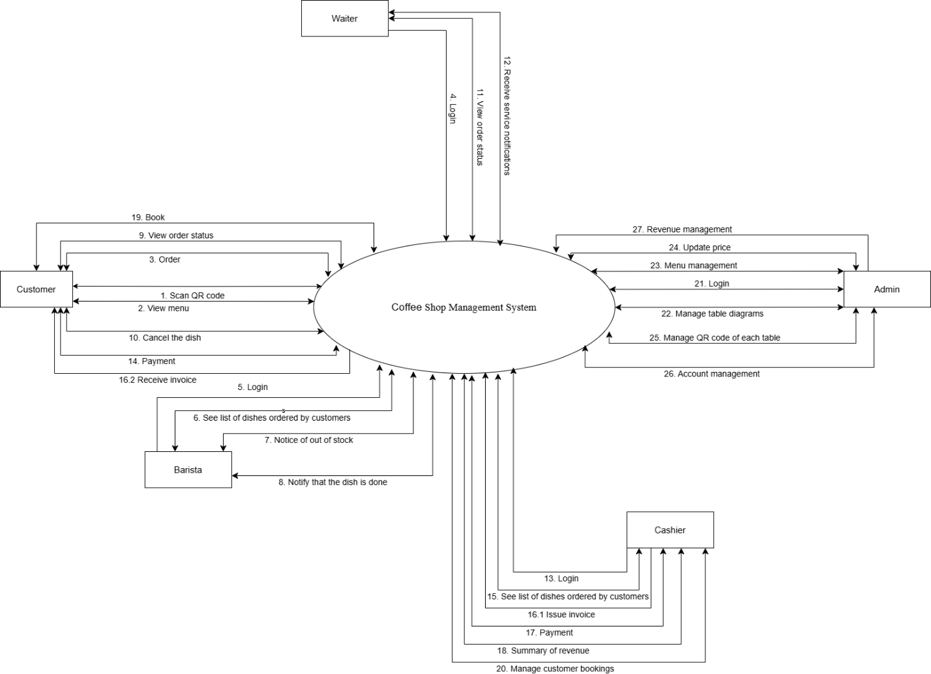

## Data Flow Diagram

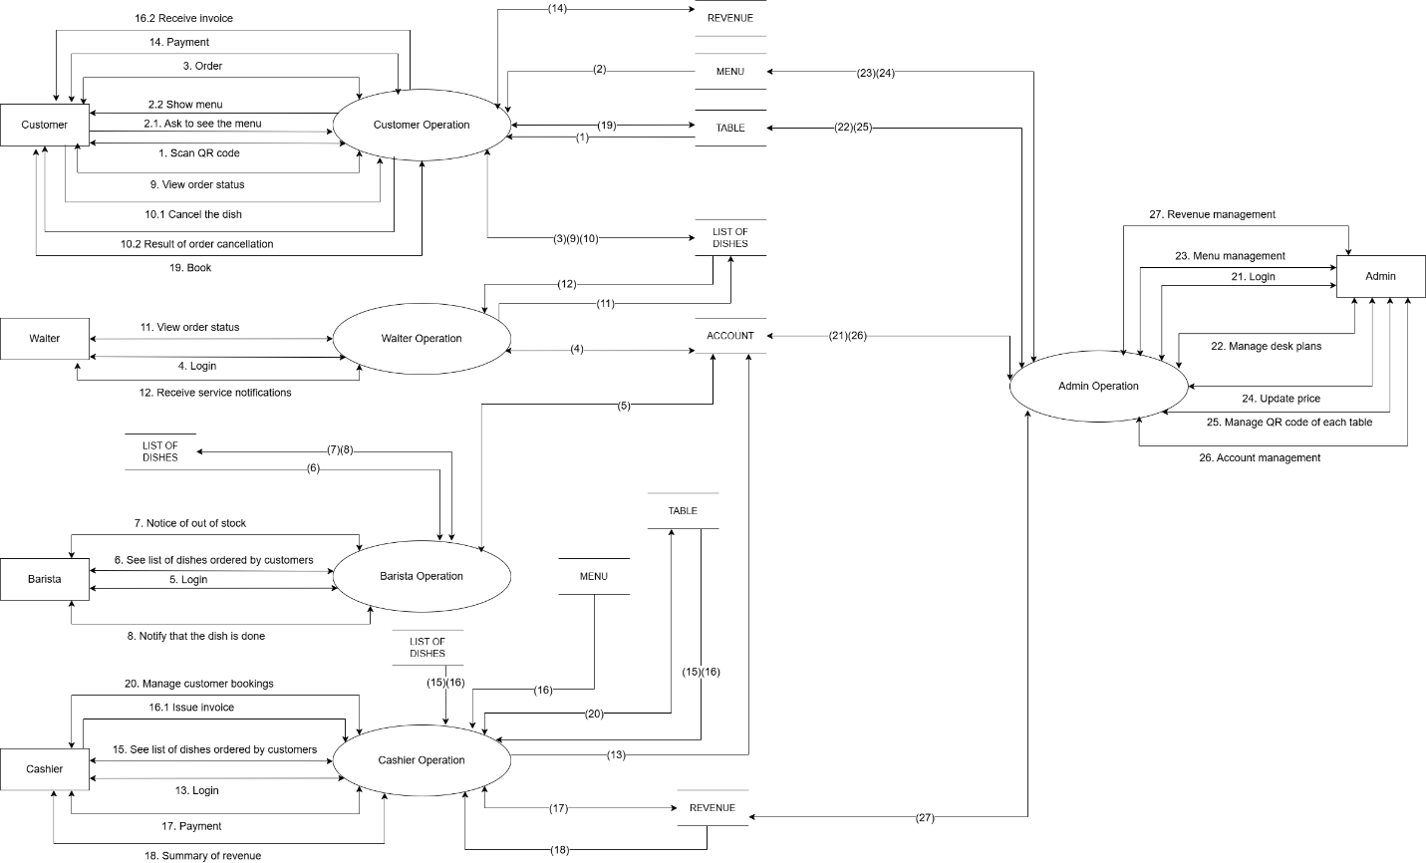 DFD level 2:

Dfd mức 2 khách hàng :

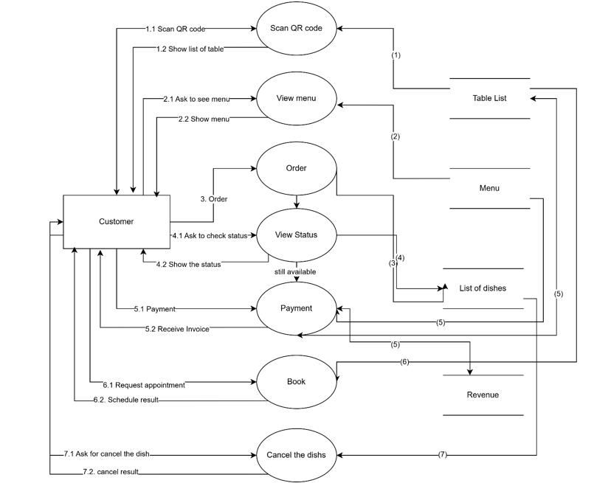

Dfd mức 2 phục vụ :

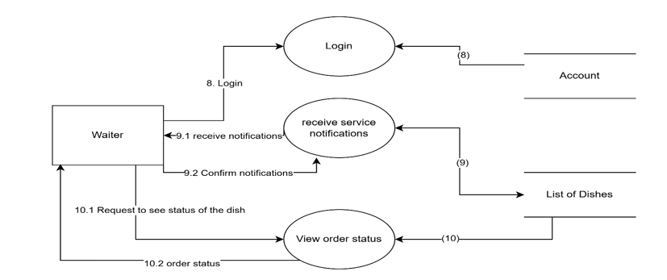

Dfd mức 2 pha chế :

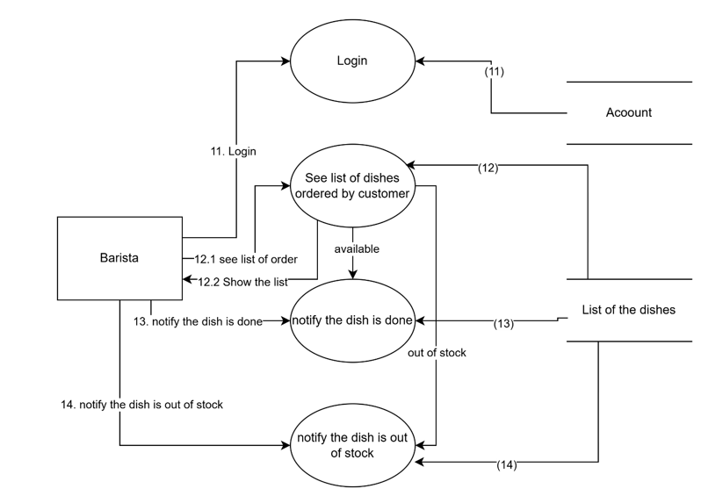

Dfd mức 2 thu ngân :

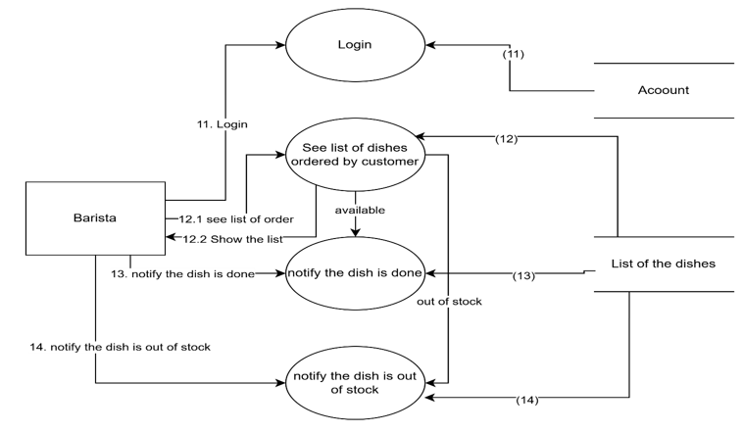

Dfd mức 2 Adnin :

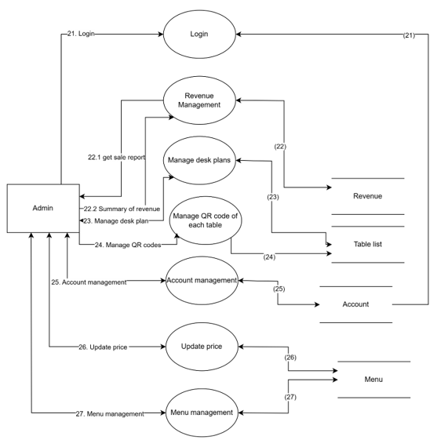

## Software Requirement Specification

## High level Fucntional Requirement (FR)

|  |  |  |
| --- | --- | --- |
| FR1.1 | Title | Scan QR code |
| Stakeholder | Customer , Coffeeshop |
| Description | The customer scans the QR code provided on the table or receipt to access the coffeeshop's menu. The QR code scanning process will direct the customer to the menu interface. The system will display the menu and available transaction options after the customer scans the code |
| FR1.2 | Title | **View menu** |
| Stakeholder | Customer , Coffeeshop |
| Description | The customer can view the menu on the system interface after scanning the QR code. The menu will be displayed with all available dishes, drinks, and their prices. The system allows the customer to view dish details, images |
| FR1.3 | Title | Order |
| Stakeholder | Customer , Coffeeshop |
| Description | After viewing the menu, the customer can select dishes and add them to the cart. The system records the selected dishes, quantities, and any special instructions (such as how to prepare or additional notes). The system will display the total price of the order and the details of the selected dishes |
| FR1.4 | Title | View order status |
| Stakeholder | Customer , Coffeeshop |
| Description | The customer can check the status of their order through the system. The order status may include stages such as "Pending", "In Progress", "Completed", or "Delivered". The system will update the status and notify the customer of the order's progress |
| FR1.5 | Title | Cancel order item |
| Stakeholder | Customer , Coffeeshop |
| Description | The customer can cancel an item from the order before it is processed or delivered. The system will update the cart and recalculate the total amount after the item is canceled. After the cancellation, the customer will receive a confirmation notification |
| FR1.6 | Title | Payment |
| Stakeholder | Customer , Coffeeshop |
| Description | After the order is completed, the customer will pay for the selected dishes. The system provides various payment methods such as cash, credit cards, or online bank transfers. After a successful payment, the system will confirm the transaction and send a notification to the customer confirming the payment |
| FR1.7 | Title | Book |
| Stakeholder | Customer , Coffeeshop |
| Description | The customer can book a table at the coffeeshop for a specific date and time. The system will check the availability of tables and ask the customer to provide reservation information (number of people, date, time). After confirming the details, the system will store the information and update the table's status. A confirmation notification will be sent to the customer |
| FR1.8 | Title | **Login** |
| Employee | Waiter who uses Rex_Coffee to log into the system |
| Description | Waiter logs in to the system by providing a valid login name and password to use the functions corresponding to their authority. If the waiter forgets the password, he or she can click the forgot password hyperlink to create a new password |
| FR1.9 | Title | **Receiver service notifications** |
| Employee | Waiter who uses Rex_Coffee to track order notifications and serve orders to customers |
| Description | Waiter chooses the “**Thông báo phục vụ**” function to monitor and promptly serve customers |
| FR1.10 | Title | **View order status** |
| Employee | Waiter who uses Rex_Coffee to track order status |
| Description | Waiter selects the function to view order status to monitor order status from placing until completion. The system displays detailed current status of each item in the order, helping staff prepare to serve promptly. |
| FR1.11 | Title | **Login** |
| Employee | Barista who uses Rex_Coffee to log into the system |
| Description | Barista logs in to the system by providing a valid login name and password to use the functions corresponding to their authority. If the barista forgets the password, he or she can click the forgot password hyperlink to create a new password |
| FR1.12 | Title | **See list of dishes ordered by customers** |
| Employee | Barista who uses Rex_Coffee to view the list of dishes and prepare dishes |
| Description | Barista can view the list of orders in chronological order or by table to help them process and prepare dishes according to their requirements. |
| FR1.13 | Title | **Notice of out of stock** |
| Employee | Barista who uses Rex_Coffee to promptly notify the waiter that the dish is out of order |
| Description | Barista can notify that a dish is out of stock when the ingredients for that dish are not enough for waiters to interact with customers. |
| FR1.14 | Title | **Notify that the dish is done** |
| Employee | Barista who uses Rex_Coffee to promptly notify the waiter of the finished dish |
| Description | The barista uses the system to announce that the dish is complete and ready to serve. The system will automatically send notifications to service staff |
| FR1.15 | Title | **Login** |
| Employee | Cashier who uses Rex_Coffee to log into the system |
| Description | Cashier logs in to the system by providing a valid login name and password to use the functions corresponding to their authority. If the cashier forgets the password, he or she can click the forgot password hyperlink to create a new password |
| FR1.16 | Title | **See list of dishes ordered by customers** |
| Employee | Cashier who uses Rex_Coffee to view the list of items in your order and easily pay |
| Description | Cashier uses the system to view a list of dishes ordered by customers by table, including detailed information about the dish, completion status and total quantity. Support Cashier in managing payments and ensuring accuracy in the service process. |
| FR1.17 | Title | **Issue invoices** |
| Employee | Cashier who uses Rex_Coffee to issue invoices to customers |
| Description | The cashier uses the system to create and print detailed invoices for customers based on the list of paid items. Invoice includes item information, quantity, price and total |
| FR1.18 | Title | **Payment** |
| Employee | Cashiers use Rex_Coffee to help with customer payments |
| Description | The cashier can help customers pay directly at the cashier counter. |
| FR1.19 | Title | **Summary of revenue** |
| Employee | Cashier can use Rex_Coffee to allows the cashier to view and export revenue reports. |
| Description | The cashier can summarize sales revenue for specific time periods, including daily, weekly, monthly, or custom date ranges, providing detailed reports that include total sales, number of transactions, and average revenue per transaction. |
| FR1.20 | Title | **Manage customer booking** |
| Employee | Cashier uses Rex_Coffee to be able to place, edit and cancel customer reservations through the system. |
| Description | The cashier can book, edit, and cancel customer reservations through the system, allowing for real-time updates to reservation availability. While booking, the cashier can input customer details, select specific dates, times, and services, and issue confirmation receipts. Editing a reservation enables changes to the date, time, or service, while cancellation immediately frees up the reserved slot, with the option to notify the customer via email or SMS |
| FR1.21 | Title | **Login** |
| Employee | Admin who uses Rex_Coffee to log into the system |
| Description | Admin log in to the system by providing a valid login name and password to use the functions corresponding to their authority. If the Admin forgets the password, he or she can click the forgot password hyperlink to create a new password |
| FR1.22 | Title | **Account management** |
| Employee | Admin uses Rex_Coffee to be able to view, add, edit, or delete user accounts through the management system. |
| Description | Admin can go to the settings section to manage user accounts with functions such as: add, delete, view, edit accounts, then users can click update to update. |
| FR1.23 | Title | **Menu management** |
| Employee | Admin uses Rex_Coffee to be able to view, add, edit, or delete menu through the management system. |
| Description | Admin can go to the settings section to manage the menu to easily manage the restaurant's menu quickly and conveniently with the utilities that have been added to the software. |
| FR1.24 | Title | **Update price** |
| Employee | Admin uses Rex_Coffee to be able to update the prices of menu items, including increasing prices for bestsellers or decreasing prices for items with low revenue. |
| Description | Admin can go to the settings section to update price to easily manage the restaurant's menu quickly and conveniently with the utilities that have been added to the software. |
| FR1.25 | Title | **Revenue management** |
| Employee | Admin uses Rex_Coffee to be able to can view and filter revenue by time, export revenue reports, and view detailed transactions. |
| Description | Admin can go to the settings section to Revenue Management to easily manage the restaurant's menu quickly and conveniently with the utilities that have been added to the software. |
| FR1.26 | Title | **Manage desk layout** |
| Employee | Admin uses Rex_Coffee to be able to set up, edit, and delete desk a. |
| Description | Admin uses Rex_Coffee to be able to facilitate efficient desk layout management by setting up, editing, viewing and deleting desks in the diagram |
| FR1.27 | Title | **Manage QR codes for each tables** |
| Employee | Admin uses Rex_Coffee to be able to facilitate efficientManage QRcodes for each tables  management by setting up, editing, viewing and deleting desks in the diagram |
| Description | Admin can go to the settings section to QR codes for each tables Management to easily manage the restaurant's menu quickly and conveniently with the utilities that have been added to the software. |

## Stakeholders

|  |  |
| --- | --- |
| Stakeholder | Description |
| Customer | People who use the Rex_Coffee to order and reserve |
| System administrators | People who administer and configure the Rex_Coffee application |
| Engineer | Person who deploy the Rex_Coffee system |
| Employee | Person who use to order, manage and operates the cafe |

## Usecase

## List of use cases

|  |  |  |
| --- | --- | --- |
| Use case ID | Use case name | Functional Req. |
| UC.01 | Scan QR code | FR1.1 |
| UC.02 | View Menu | FR1.2 |
| UC.03 | Order | FR1.3 |
| UC.04 | View order status | FR1.4 |
| UC.05 | Cancel order item | FR1.5 |
| UC.06 | Payment | FR1.6 |
| UC.07 | Book | FR1.7 |
| UC.08 | Login | FR1.8 |
| UC.09 | Receiver service notifications | FR1.9 |
| UC.10 | View order status | FR1.10 |
| UC.11 | Login | FR1.11 |
| UC.12 | See list of dishes ordered by customers | FR1.12 |
| UC.13 | Notice of out of stock | FR1.13 |
| UC.14 | Notify that the dish is done | FR1.14 |
| UC.15 | Login | FR1.15 |
| UC.16 | See list of dishes ordered by customers | FR1.16 |
| UC.17 | Issue invoices | FR1.17 |
| UC.18 | Payment | FR1.18 |
| UC.19 | Summary of revenue | FR1.19 |
| UC.20 | Manage customer booking | FR1.20 |
| UC.21 | Login | FR1.21 |
| UC.22 | Account management | FR1.22 |
| UC.23 | Menu management | FR1.23 |
| UC.24 | Update price | FR1.24 |
| UC.25 | Revenue management | FR1.25 |
| UC.26 | Manage desk layout | FR1.26 |
| UC.27 | Manage QR codes for each tables | FR1.27 |

## Rex_Coffee Use Case Diagram Overview

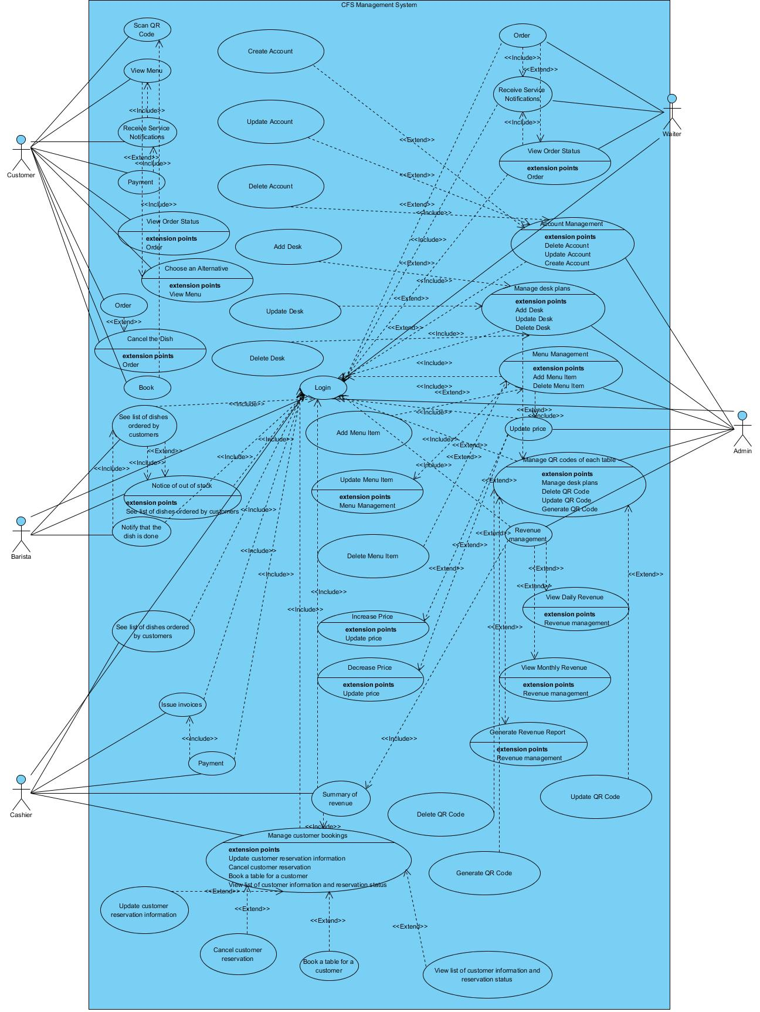

## Use Case Specification

### *UC 01: Scan QR Code*

|  |  |  |  |  |  |
| --- | --- | --- | --- | --- | --- |
| **Use Case ID** | UC.01 | | | | |
| **Use Case Name** | Scan QR Code | | | | |
|  | Huy Phan | | **Last updated by** | | Huy Phan |
| **Date Created** | Nov 06, 2024 | | **Date last updated** | | Nov 16, 2024 |
| **Actors** | Customer | | | | |
| **Brief Description** | Customers scan the QR code pre-pasted on the table to access the corresponding menu | | | | |
| **Goal** | Successfully accessing the menu associated with the scanned table | | | | |
| **Trigger** | Customers select the "Scan QR code" feature on the app or QR scanner | | | | |
| **Pre-conditions** | Customer's device supports scanning QR codes, QR codes on tables are valid and recognized by the system | | | | |
| **Post-conditions** | The corresponding menu for the scanned table is displayed to the customer, the system confirms the connection between the customer and the table | | | | |
| **Main Flow** | **Step** | **Actor Action** | | **System Response** | |
| **1** | Customers use mobile phones to scan QR located at the table | | Desk Code and Table Status Testing System | |
| **2** |  | | After a successful test, the system displays the homepage with options: view menu, order, view status of ordered dishes, payment and reservation | |
| **3** | The customer selects one of the options on the homepage | | Processing system according to customer's option | |
| **4** | The customer takes other actions and exits the system | | Session Termination System | |
| **Alternative Flow** | **Alternative Flow 1 : Pre-booked table** | | | | |
| **Step** | **Actor Action** | | **System Response** | |
| **1** | Customers use their mobile phones to scan QR codes | | Desk Code and Table Status Testing System | |
| **2** |  | | The system informs : "The table has been booked" and asks customers to change to another table | |
| **Exception Flow** | **Exception Flow 1: Server Connection Error** | | | | |
| **Step** | **Actor Action** | | **System Response** | |
| **1** | Customers use their mobile phones to scan QR codes | | The system checks the QR code and tries to connect to the server | |
| **2** |  | | The system announces a connection error and asks the customer to try again or check the network connection | |
| **Priority** | High | | | | |
| **Business Rule** | _ Each table has a unique QR code linked to its corresponding menu  _ QR codes must be periodically checked for validity  _ The system must ensure that each QR code is used by only one customer at a time | | | | |
|  |  |  |  |  |  |

**- Prototype**

**1. :**

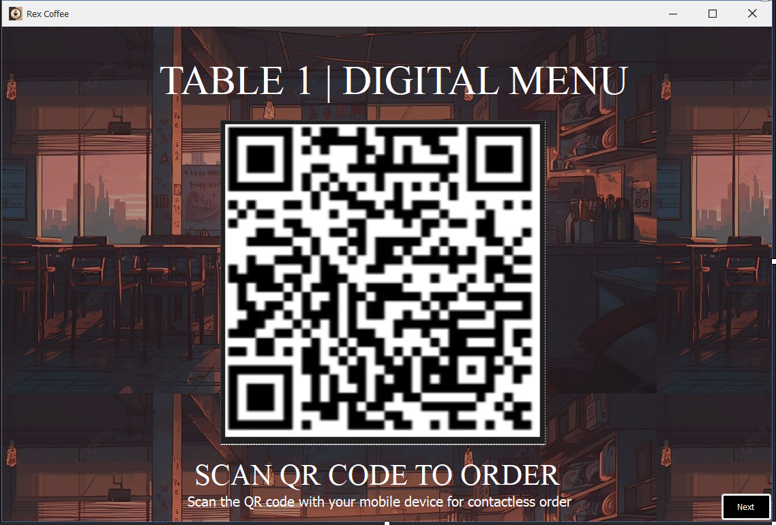

**2. :**  
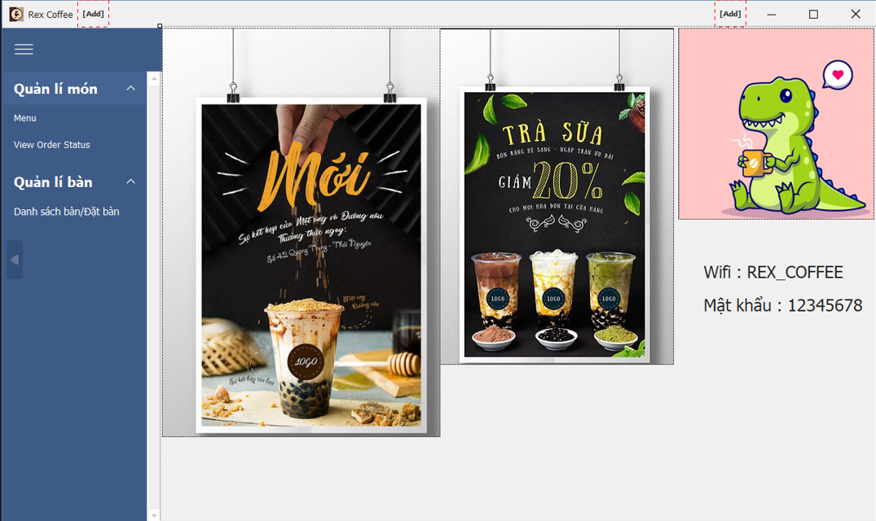

### *UC 02: View Menu*

|  |  |  |  |  |  |
| --- | --- | --- | --- | --- | --- |
| **Use Case ID** | UC.02 | | | | |
| **Use Case Name** | View Menu | | | | |
| **Created by** | Huy Phan | | **Last updated by** | | Huy Phan |
| **Date Created** | Nov 06, 2024 | | **Date last updated** | | Nov 16, 2024 |
| **Actors** | Customer | | | | |
| **Brief Description** | Customers can view the menu after scanning the QR code and accessing the system | | | | |
| **Goal** | Customers can browse and see all the dishes available in the restaurant's menu | | | | |
| **Trigger** | The customer selects the "View menu" option from the homepage after successfully scanning the QR code | | | | |
| **Pre-conditions** | _ The customer has successfully scanned the QR code and connected to the system  _ The system has loaded the restaurant's menu | | | | |
| **Post-conditions** | _ The menu is fully displayed to customers  _ Customers can choose dishes from the menu | | | | |
| **Main Flow** | **Step** | **Actor Action** | | **System Response** | |
| **1** | Customers select "View menu" from the homepage | | The system checks the availability of the menu, ensuring that the list of dishes is fully updated. | |
| **2** |  | | If the menu is valid, the system loads and displays a list of dishes with full information: item name, price, description | |
| **3** | Customers scroll through the list to see the dishes | |  | |
| **Alternative Flow** | **Alternative Flow 1 : No Dishes Updated** | | | | |
| **Step** | **Actor Action** | | **System Response** | |
| **1** | Customers select "View menu" from the homepage | | The system checks the availability of the menu, ensuring that the list of dishes is fully updated. | |
| **2** |  | | The system detects that the menu has not been updated. | |
| **4** |  | | The system displays the message: "No dishes have been updated at this time. Please come back later" | |
| **Exception Flow** | **Exception Flow 1 : Network Error Loading Menu** | | | | |
| **Step** | **Actor Action** | | **System Response** | |
| **1** | Customers select the "View Menu" option | | The system detects that the network connection is lost or the request cannot be sent to the server | |
| **2** |  | | The system displays an error message: "The menu could not be loaded. Please check the network connection and try again" | |
| **Priority** | High | | | | |
| **Business Rule** | _ The menu must be fully updated by the restaurant administrator before being displayed to customers  _ The system must support fast menu loading and display data in a clear format  In case of errors, the system must display a clear instruction message to the customer | | | | |
|  |  |  |  |  |  |

**- Prototype : ( Order , View Menu , Cancel Order Iteam and Payment )**

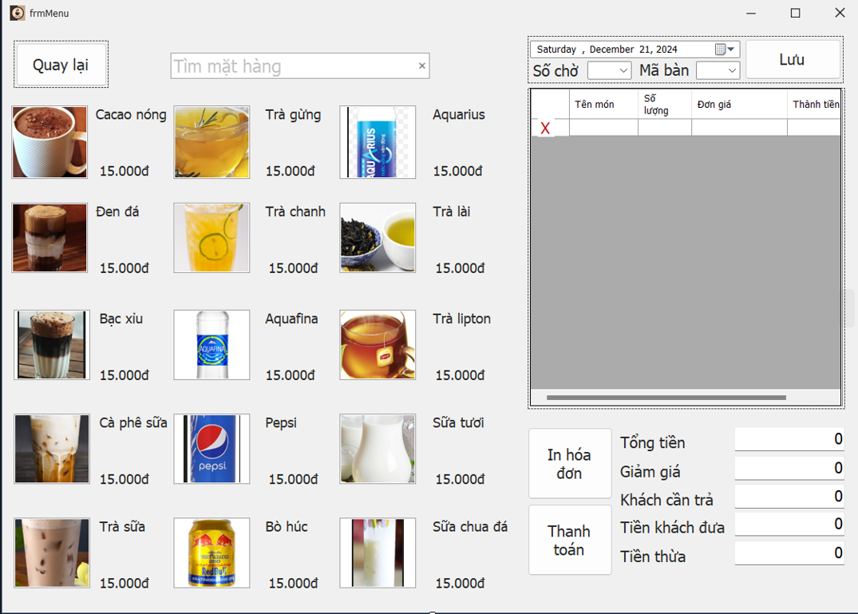

### *UC 03: Order*

|  |  |  |  |  |  |
| --- | --- | --- | --- | --- | --- |
| **Use Case ID** | UC.03 | | | | |
| **Use Case Name** | Order | | | | |
| **Created by** | Huy Phan | | **Last updated by** | | Huy Phan |
| **Date Created** | Nov 06, 2024 | | **Date last updated** | | Nov 16, 2024 |
| **Actors** | Customer | | | | |
| **Brief Description** | The customer chooses a dish from the menu, places an order, and in case the dish is not available, the system suggests an alternative dish for the customer to decide | | | | |
| **Goal** | Successful order, including choosing an alternative if the original dish is not available | | | | |
| **Trigger** | Customers choose an item from the menu | | | | |
| **Pre-conditions** | _ The customer has scanned the QR code and accessed the menu  _ Dishes are available in the menu and can be added to the order | | | | |
| **Post-conditions** | _ The order is confirmed and the customer can proceed with the payment or ordering options. | | | | |
| **Main Flow** | **Step** | **Actor Action** | | **System Response** | |
| **1** | Customers access the menu | | The system displays a list of dishes with detailed information (item name, price) | |
| **2** | Customers choose items from the menu | | System to check the availability of the selected dish | |
| **3** |  | | Add to cart system | |
| **4** | Customer confirms order | | The system records orders and displays a successful confirmation message | |
| **5** | Customers return to the menu and choose another item or exit the system | |  | |
| **Alternative Flow** | **Alternative Flow 1 : Unavailable Food** | | | | |
| **Step** | **Actor Action** | | **System Response** | |
| **1** | Customers choose items from the menu | | The system checks the status and detects the unavailable item | |
| **2** |  | | The system displays a message: "The dish is out of stock. Please choose a substitute" | |
|  | Customers return to the menu to edit or select an alternative | |  | |
| **Alternative Flow 2: The number of dishes is too limited** | | | | |
| **Step** | **Actor Action** | | **System Response** | |
| **1** | The customer chooses a dish, but the system has a problem adding the dish | | The system informs: "The number of dishes you choose exceeds the available quantity. Please select again" | |
| **2** | The customer edits the number of dishes or deletes them | | The system refreshes the cart and displays new information | |
| **Exception Flow** | **Exception Flow 1: System error when adding items to cart** | | | | |
| **Step** | **Actor Action** | | **System Response** | |
| **1** | The customer chooses a dish, but the system has a problem adding the dish | | The system displays an error message: "An error occurred while adding an item to the cart. Please try again" | |
| **2** | Customers can try again or cancel | | The system displays the option to retry or cancel the action | |
| **Exception Flow 2: The dish is not available due to an update error** | | | | |
| **Step** | **Actor Action** | | **System Response** | |
| **1** | Customers choose dishes that are not available | | The system announced: "This dish is currently unavailable. Please try again later" | |
| **2** | Customers can choose another dish or exit the system | | The system displays substitutions or finishes | |
| **Priority** | High | | | | |
| **Business Rule** | _ Each dish on the menu must have enough necessary information (name, description, price, image) for customers to choose  The system must ensure that the dish selected must have sufficient quantities available  _ The cart cannot be confirmed if there are no items in it | | | | |
|  |  |  |  |  |  |

### *UC 04: View Order Status*

|  |  |  |  |  |  |
| --- | --- | --- | --- | --- | --- |
| **Use Case ID** | UC.04 | | | | |
| **Use Case Name** | View Order Status | | | | |
| **Created by** | Huy Phan | | **Last updated by** | | Huy Phan |
| **Date Created** | Nov 06, 2024 | | **Date last updated** | | Nov 16, 2024 |
| **Actors** | Customer | | | | |
| **Brief Description** | Customers view the status of ordered items, including information such as items being prepared, delivered, or completed | | | | |
| **Goal** | Help customers track the status of ordered items quickly | | | | |
| **Trigger** | Customers select the "View Item Status" option from the homepage | | | | |
| **Pre-conditions** | _ The customer has ordered at least one item before  _ The system displays the list of items in the shopping cart | | | | |
| **Post-conditions** | Customers view the status of all ordered items. Real-time status update system | | | | |
| **Main Flow** | **Step** | **Actor Action** | | **System Response** | |
| **1** | Customers select the "View Item Status" option from the homepage | | The system checks the table code and details of the ordered dishes | |
| **2** |  | | The system displays a list of items ordered by customers with the corresponding status | |
| **3** | Customers view and track the status of their dishes | | The system updates in real time if there is a change in the status of the dish | |
|  | **4** | The customer exits and returns to the homepage | |  | |
| **Alternative Flow** | **Alternative Flow 1 : No Items Ordered** | | | | |
| **Step** | **Actor Action** | | **System Response** | |
| **1** | The customer selects "View Item Status" | | The system checks the table code and details of the ordered dishes | |
| **2** |  | | The system notifies: "You haven't ordered anything yet" and returns to the homepage | |
| **Exception Flow** | **Exception Flow 1: Item Status Display Error** | | | | |
| **Step** | **Actor Action** | | **System Response** | |
| **1** | The customer selects "View Item Status" | | The system informs: "The item status cannot be loaded at this time. Please try again" | |
| **Priority** | High | | | | |
| **Business Rule** | _ Item status should be clearly visible, real-time update  _ If the status has not been updated, the system will display the message "Processing" | | | | |
|  |  |  |  |  |  |

**- Prototype**

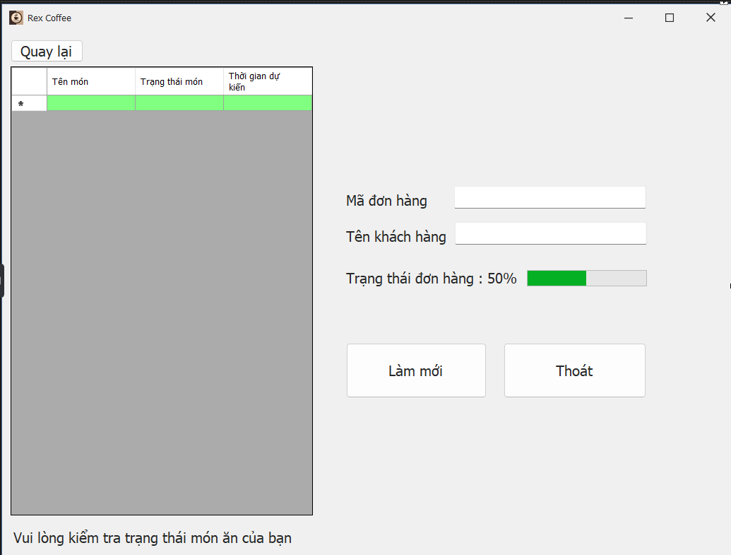

### *UC 05:* *Cancel Order Item*

|  |  |  |  |  |  |
| --- | --- | --- | --- | --- | --- |
| **Use Case ID** | UC.05 | | | | |
| **Use Case Name** | Cancel Order Item | | | | |
| **Created by** | Huy Phan | | **Last updated by** | | Huy Phan |
| **Date Created** | Nov 06, 2024 | | **Date last updated** | | Nov 16, 2024 |
| **Actors** | Customer | | | | |
| **Brief Description** | Customers can cancel their order if they change their mind or order the wrong item only if the dish has not been prepared | | | | |
| **Goal** | Successfully cancel an item in the ordered item list and update the status of the system | | | | |
| **Trigger** | Customers select the "Cancel" function in View Order Status | | | | |
| **Pre-conditions** | _ The system must have a list of customers' ordered items  _ The system must be working properly and not have connection failures | | | | |
| **Post-conditions** | _ The dish is successfully canceled and no longer appears in the list of ordered dishes  _ The system updates the status and total value of the customer's order | | | | |
| **Main Flow** | **Step** | **Actor Action** | | **System Response** | |
| **1** | Customers choose the "Cancel" function | | Table code and menu check system | |
| **2** |  | | The system displays a list of ordered items | |
| **3** | Customers select the item they want to cancel | | Item Status Check System | |
| **4** |  | | The system confirms the item to be canceled and displays a confirmation message | |
| **5** | Customer confirms cancellation | | The system updates the list of ordered items and the total order value | |
| **6** | Customers can manipulate other actions or exit the system | |  | |
| **Alternative Flow** | **Alternative Flow 1 : Prepared Items** | | | | |
| **Step** | **Actor Action** | | **System Response** | |
| **1** | Customers choose the "Cancel" function | | The system displays a list of ordered items | |
| **2** | Customers select the item they want to cancel | | Item Status Check System | |
| **3** |  | | The system informs: "The item has been prepared and cannot be canceled" | |
| **Alternative Flow 2 : No Items on the List to Cancel** | | | | |
| **Step** | **Actor Action** | | **System Response** | |
| **1** | |  | | --- | | Customers choose the "Cancel" function |      |  | | --- | |  | | | Table code and menu check system | |
| **2** |  | | The system announced: "There are currently no items on the list to cancel" | |
| **Exception Flow** | **Exception Flow 1: Lost system connection during cancellation** | | | | |
| **Step** | **Actor Action** | | **System Response** | |
| **1** | Customers choose items to cancel | | The system loses connection to the server during processing | |
| **2** |  | | The system informs: "Unable to make a cancellation request due to a loss of connection. Please try again later" | |
| **3** | Customers try again or return to the main menu | |  | |
| **Exception Flow 2 : System Error Updating Item List** | | | | |
| **Step** | Actor Action | | System Response | |
| **1** | Customer confirms cancellation | | The system has an error when updating the status of the ordered item list | |
| **2** |  | | The system announced: "An error occurred when canceling the item. Please try again later" | |
| **3** | Customers try again or return to the main menu | |  | |
| **Priority** | High | | | | |
| **Business Rule** | _ Each successfully canceled dish must be removed from the ordered item list immediately.  _ The total order value needs to be updated again after cancellation.  _ The system needs to clearly notify if an error occurs to avoid confusion for customers. | | | | |
|  |  |  |  |  |  |

### *UC 06: Payment*

|  |  |  |  |  |  |
| --- | --- | --- | --- | --- | --- |
| **Use Case ID** | UC.06 | | | | |
| **Use Case Name** | Payment | | | | |
| **Created by** | Huy Phan | | **Last updated by** | | Huy Phan |
| **Date Created** | Nov 06, 2024 | | **Date last updated** | | Nov 16, 2024 |
| **Actors** | Customer | | | | |
| **Brief Description** | The customer pays their bill after completing the order and confirming the order | | | | |
| **Goal** | The customer successfully pays the invoice, and the system updates the invoice status | | | | |
| **Trigger** | Customers select the "Payment" feature on the system | | | | |
| **Pre-conditions** | _ The system has displayed a list of ordered items and the total invoice value.  _ The customer must have an invoice to be paid.  _ The system supports payment methods such as cash, card, or wire transfer | | | | |
| **Post-conditions** | _ The invoice has been paid successfully, and the status is updated to "Paid"  _ The system stores payment transaction information for later inspection | | | | |
| **Main Flow** | **Step** | **Actor Action** | | **System Response** | |
| **1** | Customers select the "Payment" function | | Table code and menu check system | |
| **2** |  | | The system displays detailed invoices, total value, and available payment methods | |
| **3** | Customers choose a payment method | | The system confirms and displays a message asking customers to confirm | |
| **4** | Customer confirms payment | | The system processes transactions according to the selected payment method | |
| **5** | The customer proceeds to pay according to the selected method | | The system checks if the payment attempt has been completed | |
| **6** |  | | The system displays a "Payment Successful" message and updates the invoice status | |
| **7** | The customer exits the system | |  | |
| **Alternative Flow** | **Alternative Flow 1: The customer changes the payment method** | | | | |
| **Step** | **Actor Action** | | **System Response** | |
| **1** | The customer chooses the original payment method | | The system confirms and displays a message asking customers to confirm | |
| **2** | Customers do not confirm and change to another payment method | | System Back to Step 2 | |
| **Alternative Flow 2 : No Items on the List to Cancel** | | | | |
| **Step** | **Actor Action** | | **System Response** | |
| **1** | Customers select the "Payment" function | | Table code and menu check system | |
| **2** |  | | The system announced: "There are no items on the list of items ordered for payment. Ask customers to choose the dish first" | |
| **Alternative Flow 3: Payment Failed** | | | | |
| **Step** | **Actor Action** | | **System Response** | |
| **1** | The customer proceeds to pay according to the selected method | | The system checks if the payment attempt has been completed | |
| **2** |  | | The system informs: "The transaction has not been completed, the customer is required to choose the payment method again" | |
| **Exception Flow** | **Exception Flow 1: Network connection error when paying online** | | | | |
| **Step** | **Actor Action** | | **System Response** | |
| **1** | Customers choose a payment method via bank account | | The system sends transaction requests to the payment gateway | |
| **2** |  | | Encountering a network connection error, the system announced: "Currently, online payment cannot be made. Please check the network connection or choose another method" | |
| **3** | The customer chooses a different payment method (e.g., cash) | | The system returns to the step of selecting a payment method | |
| **Exception Flow 2: System Error Processing Transaction** | | | | |
| **Step** | Actor Action | | System Response | |
| **1** | The customer confirms the payment after selecting the method | | The system processes the transaction but encounters a system error (unable to verify or record the transaction) | |
| **2** |  | | The system informs: "System error. Please try again in a few minutes" | |
| **3** | The customer decides to try again or choose a different method | | The system returns to the step of selecting a payment method | |
| **Exception Flow 3: The customer exits the system during the checkout process** | | | | |
| **Step** | **Actor Action** | | **System Response** | |
| **1** | The customer starts the checkout process but exits the system before completing the transaction | | The system records the invoice status as "Unpaid" | |
| **Priority** | High | | | | |
| **Business Rule** | _ Payment via bank account must ensure the safety and confidentiality of customers' information.  If you choose to pay in cash, the staff must come to customer support in the shortest time.  _ Invoices cannot be transferred to the status of "Paid" until the transaction is completed.  _ The system needs to clearly notify in case the transaction fails or encounters an error. | | | | |
|  |  |  |  |  |  |

### *UC 07: Book*

|  |  |  |  |  |  |
| --- | --- | --- | --- | --- | --- |
| **Use Case ID** | UC.07 | | | | |
| **Use Case Name** | Book | | | | |
| **Created by** | Huy Phan | | **Last updated by** | | Huy Phan |
| **Date Created** | Nov 06, 2024 | | **Date last updated** | | Nov 17, 2024 |
| **Actors** | Customer | | | | |
| **Brief Description** | Customers book a table in advance for a specific date and time at the restaurant through the system. The system checks the availability of tables, saves reservation information, and sends confirmations to customers | | | | |
| **Goal** | The customer successfully makes a reservation, the system updates the table status and saves the reservation information | | | | |
| **Trigger** | Customers select the "Book Table" function on the system | | | | |
| **Pre-conditions** | _ The customer has logged in to the system  _ The system has updated the table status (empty/set)  _ The system allows table reservations up to X days in advance and only during the restaurant's operating hours  _ Customers must bring their phones to scan the code or filled in information to receive the table | | | | |
| **Post-conditions** | _ The table is successfully placed, the table status is updated to "Booked."  _ Booking information is saved to the system.  _ A confirmation message is sent to the customer. | | | | |
| **Main Flow** | **Step** | **Actor Action** | | **System Response** | |
| **1** | Customers select the "Book" function | | The system displays the table list and time slots | |
| **2** | Customers choose a table, date, time | | Desk status check system and selected time frame | |
| **3** |  | | The system opens the form to fill in the customer's information | |
| **4** | Customers fill in, provide reservation information, and can make notes to staff | | Information Validity Check System | |
| **5** |  | | The system confirms information and displays a notification requesting a reservation confirmation | |
| **6** | Customer confirms booking information | | The system saves booking information and updates the table status as "Booked" and sends a successful booking confirmation notification to the customer | |
| **7** | Customers can manipulate other applications to exit the application | |  | |
| **Alternative Flow** | **Alternative Flow 1 : No available table for the requested date/time** | | | | |
| **Step** | **Actor Action** | | **System Response** | |
| **1** | Customers choose a table, date, time | | Desk status check system and selected time frame | |
| **2** |  | | The system announced: "There are currently no empty tables at this time. Please select another time" back to step 1 | |
| **Alternative Flow 2: Incomplete or invalid information** | | | | |
| **Step** | **Actor Action** | | **System Response** | |
| **1** | Customers fill in, provide reservation information, and can make notes to staff | | Information Validity Check System | |
| **2** |  | | The system notifies : "Invalid information required to be filled in by the customer" | |
| **3** |  | | The system returns to step 3 for customers to fill in and supplement the missing information | |
| **Exception Flow** | **Exception Flow 1 : Network connection error when entering the table booking function** | | | | |
| **Step** | **Actor Action** | | **System Response** | |
| **1** | Customers select the "Book" function | | The system announced: "Connection error. Please check the network and try again later" | |
| **Exception Flow 2: System Error Saving Booking Information** | | | | |
| **Step** | Actor Action | | System Response | |
| **1** | Customer confirms booking information | | The system announced: "The system error could not save the information. Please try again later." | |
| **Priority** | High | | | | |
| **Business Rule** | _ Reservations can only be made for a maximum of a certain number of days in advance (X days)  _ Reservations are only valid during the restaurant's operating hours  _ Customers must have a phone number or identification document that matches the information provided to receive the table | | | | |
|  |  |  |  |  |  |

**- Prototype**

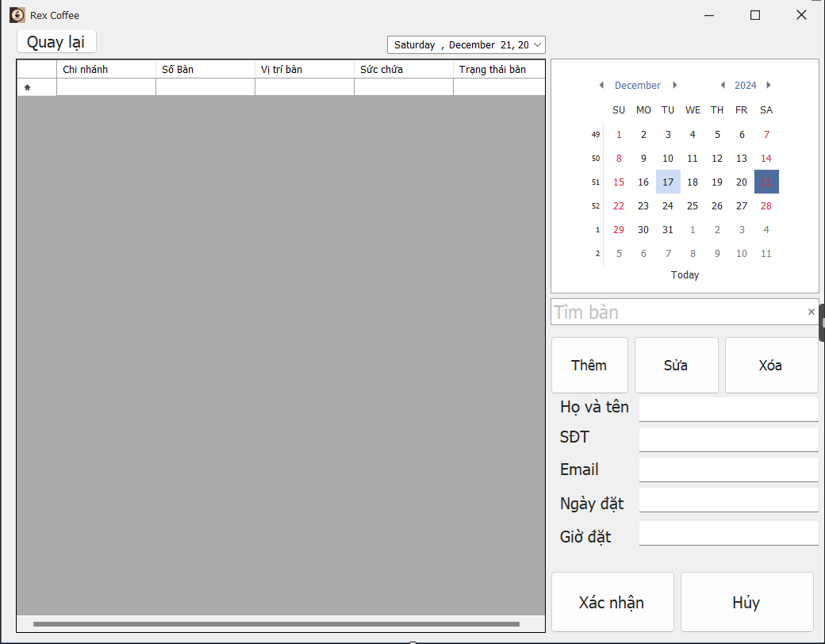

### *UC 08: Login (Waiter)*

|  |  |  |  |  |  |
| --- | --- | --- | --- | --- | --- |
| **Use Case ID** | UC.08 | | | | |
| **Use Case Name** | Log in to the system | | | | |
| **Created by** | Bao Nguyen | | **Last updated by** | | Bao Nguyen |
| **Date Created** | Dec 06, 2024 | | **Date last updated** | | Dec 06, 2024 |
| **Actors** | Waiter (User) , Authentication system (System) | | | | |
| **Brief Description** | Users log in to the system by providing a valid login name and password to use the functions corresponding to their authority. | | | | |
| **Goal** | This function allows users to log into the system | | | | |
| **Trigger** | The user selects the " **Phục vụ** " button on the interface at first | | | | |
| **Pre-conditions** | * The user already has a valid account. * The system is active and connected to the database. | | | | |
| **Post-conditions** | * The user is successfully authenticated and has access to the system and is redirected to the functional interface corresponding to the authority. * User session is created for the user. | | | | |
| **Main Flow** | **Step** | **Actor Action** | | **System Response** | |
| **1** | The user selects the “**Phục vụ**” button in the start interface | | Displays the login interface, including fields for entering login name and password | |
| **2** | Enter a valid username and password in the corresponding fields. | |  | |
| **3** | Click the " **Đăng nhập**" button to submit information. | | Check the user input information. The system sends a request to verify the login name and password to the database. | |
| **4** |  | | If the login name and password are valid, the system displays the functional interface corresponding to the authority | |
| **5** | Have access to the main interface and can use functions corresponding to their powers | |  | |
| **Alternative Flow** | **Alternative Flow 1: Login information is incorrect** | | | | |
| **Step** | **Actor Action** | | **System Response** | |
| **1** | The user selects the “**Phục vụ**” button in the start interface | | Displays the login interface, including fields for entering login name and password | |
| **2** | The user entered the wrong login name or password | |  | |
| **3** | Click the " **Đăng nhập**" button to submit information. | | Check the user input information. The system sends a request to verify the login name and password to the database. | |
| **4** |  | | Verify the information and find that the login name or password is incorrect. | |
| **5** |  | | Show error message:"**Tên đăng nhập hoặc mật khẩu không đúng. Vui lòng thử lại**." | |
| **6** | Try re-entering your login information. | |  | |
| **7** | Click the " **Đăng nhập**" button to submit information. | | Continue verifying new information (return to step 3 of the main flow). | |
| **Alternative Flow 2: The user clicks on the forgot password link** | | | | |
| **Step** | **Actor Action** | | **System Response** | |
| **1** | The user selects the “**Phục vụ**” button in the start interface | | Displays the login interface, including fields for entering login name and password | |
| **2** | Click the " **Quên mật khẩu**" link on the login page. | | Display the interface asking to enter the user's registered email address to recover the password. | |
| **3** | Enter email address | |  | |
| **4** | Press the "**Gửi**" button ". | | Check emails in the database. | |
| **5** |  | | If the email is valid, the system sends an email containing a password reset link. | |
| **6** | Open the email and tap the password reset link. | | Display the new password reset interface. | |
| **7** | Enter a new password | |  | |
| **8** | press the " **Xác nhận**" button. | | Update new password and display success message. | |
| **9** |  | | Switch back to the login interface | |
| **Exception Flow** | **Exception Flow 1: The system lost connection to the database** | | | | |
| **Step** | **Actor Action** | | **System Response** | |
| **1** | The user selects the “**Phục vụ**” button in the start interface | | Displays the login interface, including fields for entering login name and password | |
| **2** | Enter a valid username and password in the corresponding fields. | |  | |
| **3** | Click the " **Đăng nhập**" button to submit information. | | Verified information but unable to access database due to lost connection. | |
| **4** |  | | Show error message:"**Lỗi kết nối với máy chủ. Vui lòng thử lại sau*.***" | |
| **5** | Contact and report to administrator | |  | |
| **Exception Flow 2: User does not enter User or Password** | | | | |
| **Step** | **Actor Action** | | **System Response** | |
| **1** | The user selects the “**Phục vụ**” button in the start interface | | Displays the login interface, including fields for entering login name and password | |
| **2** | User does not enter User or Password | |  | |
| **3** | Click the " **Đăng nhập**" button to submit information. | | Check the information the user entered. If the User or Password information is empty, display a message: “**Yêu cầu nhập User hoặc Password**” | |
| **4** | Enter full User and Password information | |  | |
| **5** | Click the " **Đăng nhập**" button to submit information. | | Continue verifying new information (return to step 3 of the main flow). | |
| **Priority** | High | | | | |
| **Business Rule** | Passwords must be at least 8 characters long, include both uppercase and lowercase letters, and at least one number. | | | | |

**- Prototype**

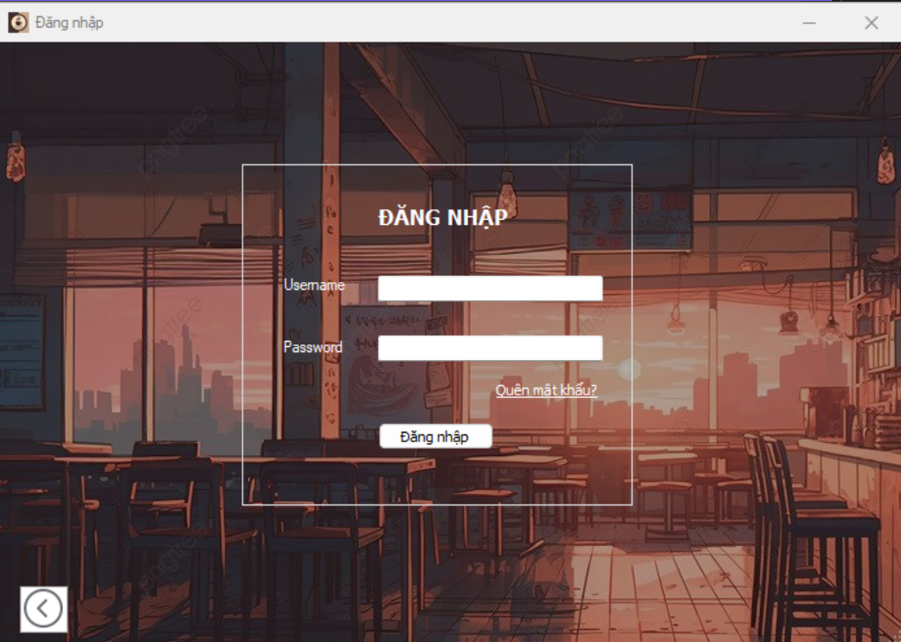

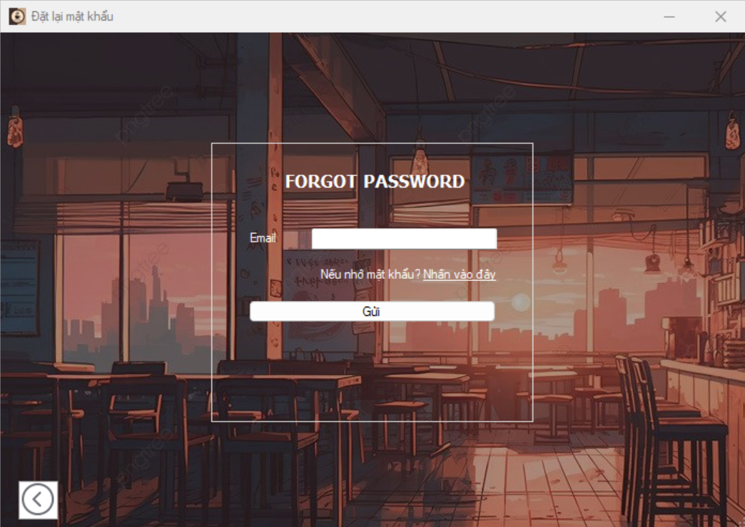

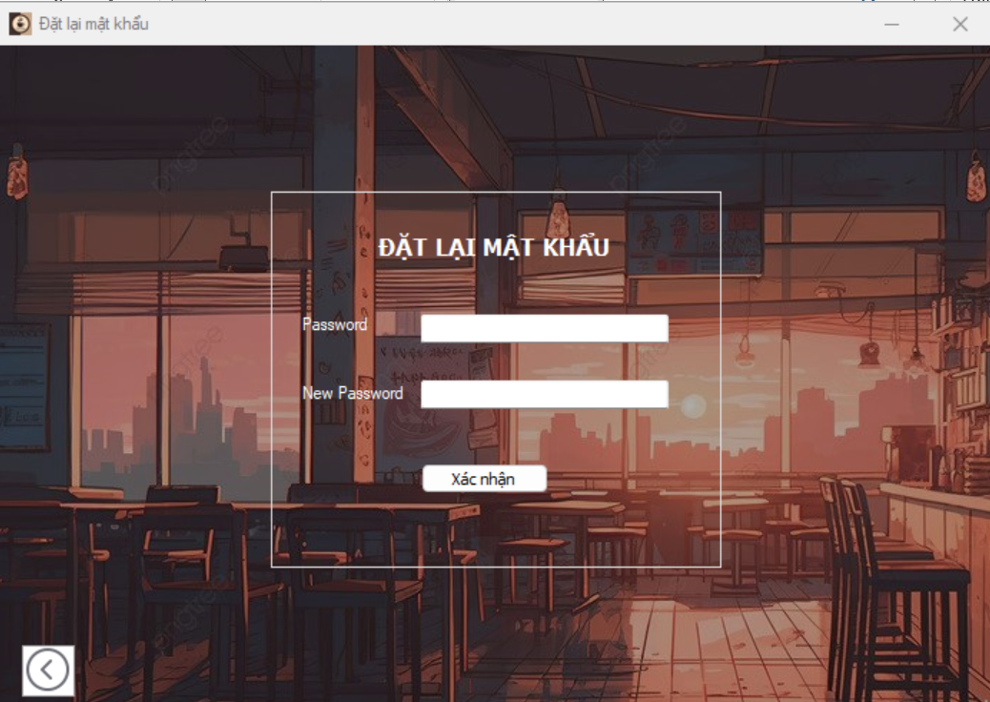

### *UC 09: Receiver service notifications*

|  |  |  |  |  |  |
| --- | --- | --- | --- | --- | --- |
| **Use Case ID** | UC.09 | | | | |
| **Use Case Name** | Receive notification of food service | | | | |
| **Created by** | Bao Nguyen | | **Last updated by** | | Bao Nguyen |
| **Date Created** | Dec 04, 2024 | | **Date last updated** | | Dec 04, 2024 |
| **Actors** | Waiter (user), Management system (System) | | | | |
| **Brief Description** | Waiter receives notification to serve the dish when the barista finishes making the dish | | | | |
| **Goal** | Notify the waiter promptly to bring the dish to the customer's table. | | | | |
| **Trigger** | The employee selects the " Thông báo phục vụ" button | | | | |
| **Pre-conditions** | * The system is operating normally. * Waiter has successfully logged into the system. * The customer's dish has been prepared. | | | | |
| **Post-conditions** | * Waiter receives notification that the dish is ready to serve. * • The dish is served to the guest in a timely manner and the status is updated as “Hoàn tất” | | | | |
| **Main Flow** | **Step** | **Actor Action** | | **System Response** | |
| **1** | The service staff selects the " Thông báo phục vụ" button. | | The system displays a list of completed dishes | |
| **2** | Select and tap the notification | | The system displays detailed information about the finished dish | |
| **3** | The waiter clicks "Xác nhận" when receiving the order. | | The system records and updates the status "Hoàn tất" | |
| **Alternative Flow** | **Alternative Flow 1: Waiter does not receive notification** | | | | |
| **Step** | **Actor Action** | | **System Response** | |
| **1** | The service staff selects the " Thông báo phục vụ" button | | The system cannot display the item notification list due to a problem | |
| **2** |  | | The system records errors and displays warnings:”**Thông báo đang lỗi. Vui lòng kiểm tra thủ công**” | |
| **3** | The waiter manually checks the list of completed dishes in the " Xem tình trạng order”" button. | | The system displays the table list interface with the corresponding table code number | |
| **4** | The employee selects a table and clicks on the table image of that color | | The system checks and retrieves order details from the database and displays a list of items in the order with the corresponding status. | |
| **5** | Employees can view and serve customers promptly | |  | |
| **Alternative Flow 2: Waiter switches to another function while in the "** **Thông báo phục vụ " function.** | | | | |
| **Step** | **Actor Action** | | **System Response** | |
| **1** | The service staff selects the " Thông báo phục vụ" button.” | | The system displays a list of completed dishes | |
| **2** | The employee chooses another function | | The system switches to the interface of that function and closes the interface of the " Thông báo phục vụ " function. | |
| **Exception Flow** | **Step** | **Actor Action** | | **System Response** | |
| **1** | The service staff selects the " Thông báo phục vụ" button. | | The system cannot update status or send notifications because of lost connection | |
| **2** |  | | Show error message: “**Hệ thống đang mất kết nối. Vui lòng thử lại khi kết nối ổn định**” | |
| **3** | The service staff reports the error status to the administrator. | |  | |
| **Priority** | High | | | | |
| **Business Rule** | * The notice must include the full name of the dish, order code, table number and completion time. * If the waiter does not receive the notification, the system must provide a list of completed dishes for the waiter to check manually. | | | | |

**- Prototype**

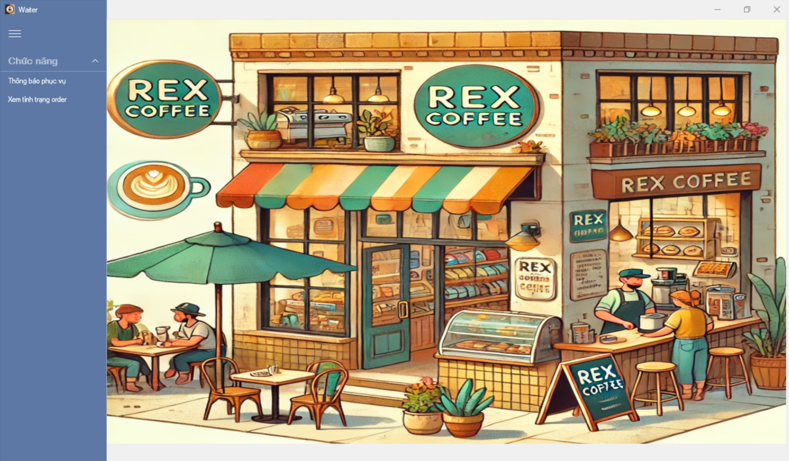

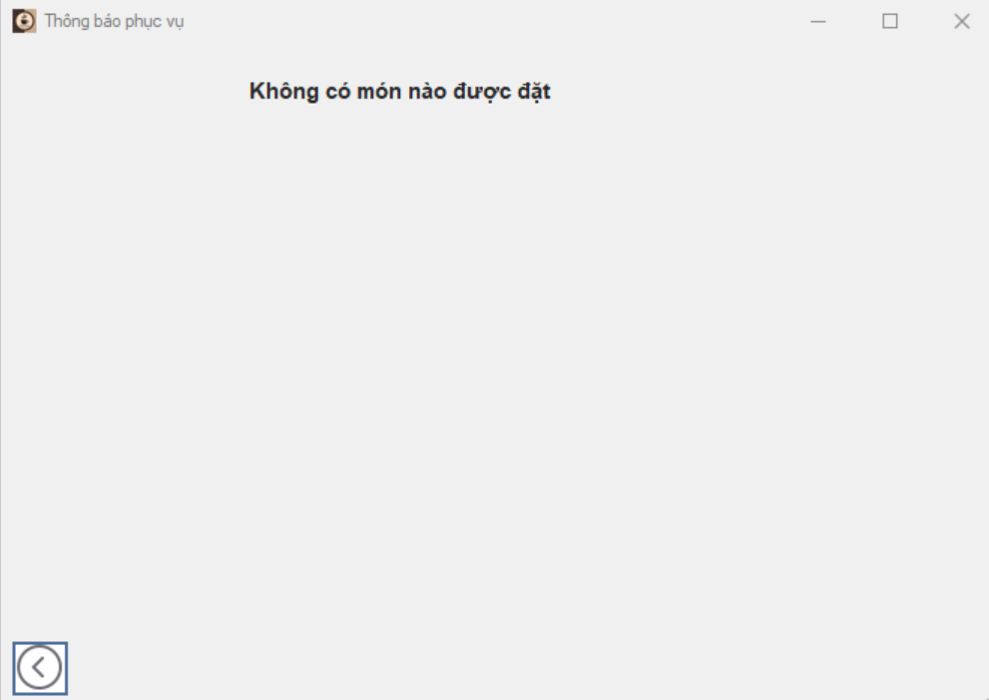

### *UC 10: View order status*

|  |  |  |  |  |  |
| --- | --- | --- | --- | --- | --- |
| **Use Case ID** | UC.10 | | | | |
| **Use Case Name** | View order status | | | | |
| **Created by** | Bao Nguyen | | **Last updated by** | | Bao Nguyen |
| **Date Created** | Dec 06, 2024 | | **Date last updated** | | Dec 06, 2024 |
| **Actors** | Waiter (user), Management system (System) | | | | |
| **Brief Description** | Allows service staff to track order status from the time it is placed until it is completed | | | | |
| **Goal** | Displays detailed current status of each item in the order, helping staff prepare to serve promptly. | | | | |
| **Trigger** | The employee selects the function " Xem tình trạng order” " from the system interface | | | | |
| **Pre-conditions** | * The system is operating normally. * Stored information about current orders and their respective statuses. * Waiter has successfully logged into the system. | | | | |
| **Post-conditions** | Waiters receive detailed information about the status of each item in the order. | | | | |
| **Main Flow** | **Step** | **Actor Action** | | **System Response** | |
| **1** | The employee selects the function " Xem tình trạng order " | | The system displays the table list interface with the corresponding table code number | |
| **2** | The employee selects the table and clicks on the image of the table with the color he wants to see | | The system checks and retrieves order details from the database | |
| **3** |  | | Displays a list of items in the order with the corresponding status (Bao gồm: **Hết nguyên liệu, Chờ xử lý, Đang xử lý, Chờ phục vụ, Hoàn tất**) | |
| **4** | Staff see detailed dish information | |  | |
| **Alternative Flow** | **Alternative Flow 1: Waiter exits the list of dishes for the table being viewed** | | | | |
| **Step** | **Actor Action** | | **System Response** | |
| **1** | The employee selects the function " Xem tình trạng order " | | The system displays the table list interface with the corresponding table code number | |
| **2** | The employee selects the table and clicks on the image of the table with the color he wants to see | | The system checks and retrieves order details from the database | |
| **3** |  | | Displays a list of items in the order with the corresponding status (Bao gồm: **Hết nguyên liệu, Chờ xử lý, Đang xử lý, Chờ phục vụ, Hoàn tất**) | |
| **4** | The employee presses the "Thoát" button in the table order | | The system returns to the table list interface with the corresponding table code number | |
| **5** | The employee selects another table and clicks on that table's image | | The system continues to check and retrieve (return to step 2 in the main thread) | |
| **Alternative Flow 2: Waiter switches to another function while in the function “Xem tình trạng order”** | | | | |
| **Step** | **Actor Action** | | **System Response** | |
| **1** | The employee selects the function " Xem tình trạng order " | | The system displays the table list interface with the corresponding table code number | |
| **2** | The employee chooses another function | | The system switches to that function's interface and closes the function's interface “**Xem tình trạng order**” | |
| **Alternative Flow 3: Order was cancelled** | | | | |
| **1** | The employee selects the function " Xem tình trạng order " | | The system displays the table list interface with the corresponding table code number | |
| **2** | The employee selects the table and clicks on the image of the table with the color he wants to see | | The system checks and retrieves order details from the database | |
| **3** |  | | Displays a list of items in the order with the corresponding status (Bao gồm: **Hết nguyên liệu, Chờ xử lý, Đang xử lý, Chờ phục vụ, Hoàn tất**) | |
| **4** | Staff see detailed information about the dish | | The system detects a cancellation notice from the customer | |
| **5** |  | | Show notification: “**Đơn hàng đã bị hủy. Vui lòng chọn bàn khác để xem tình trạng order**” | |
| **6** |  | | Switch back to the table list interface with the corresponding table code number | |
| **Alternative Flow 4: That table has no dishes** | | | | |
| **1** | The employee selects the function " Xem tình trạng order " | | The system displays the table list interface with the corresponding table code number | |
| **2** | The employee selects the table and clicks on the image of the table with the color he wants to see | | The system checks and retrieves order details from the database and detects that the table has no dishes | |
| **3** |  | | Displays an empty list | |
| **4** | The employee presses the "Thoát" button in the table order | | The system returns to the table list interface with the corresponding table code number | |
| **Show error message:** | **Step** | **Actor Action** | | **System Response** | |
| **1** | The employee selects the function " Xem tình trạng order ” | | The system displays the table list interface with the corresponding table code number | |
| **2** | The employee selects the table and clicks on the image of the table with the color he wants to see | | The system checks and cannot retrieve order details from the database due to lost connection | |
| **3** |  | | Show error message:: “**Hệ thống đang mất kết nối. Vui lòng thử lại khi kết nối ổn định**” | |
| **4** | The service staff reports the error status to the administrator. | |  | |
| **Priority** | High | | | | |
| **Business Rule** | * The system must update order status in real time. * Must display complete information about the items in the order | | | | |

**- Prototype**

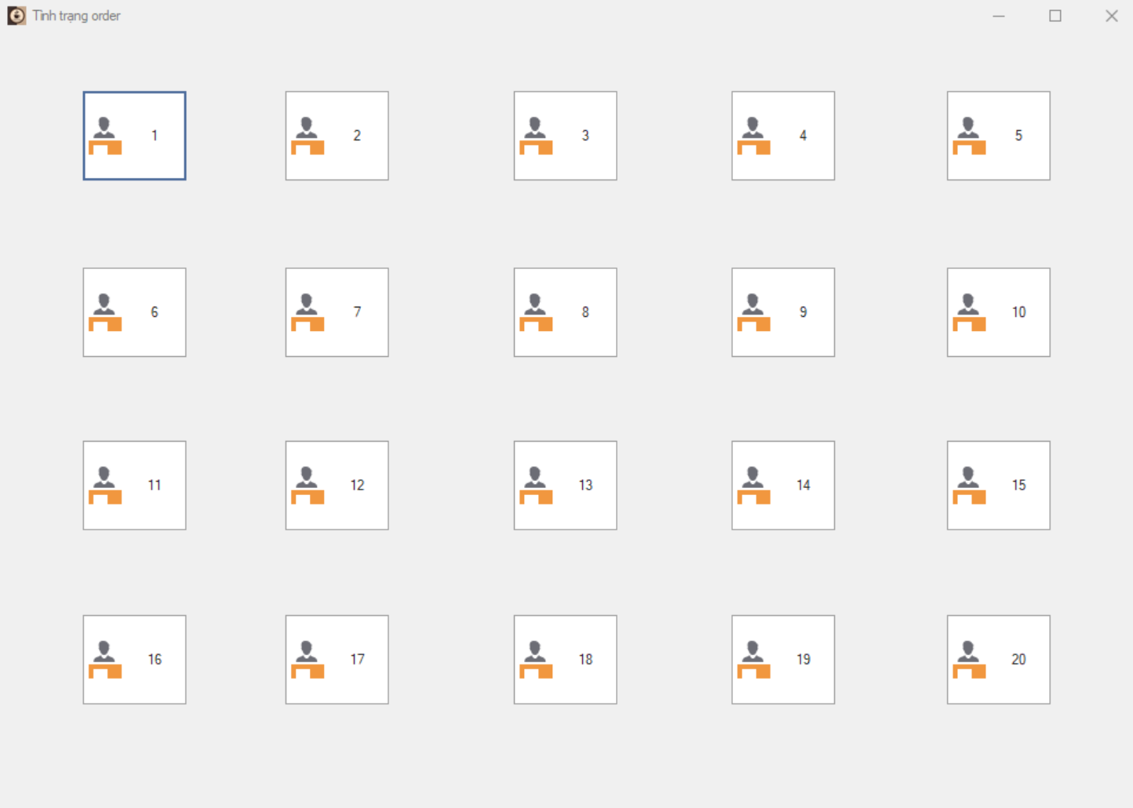

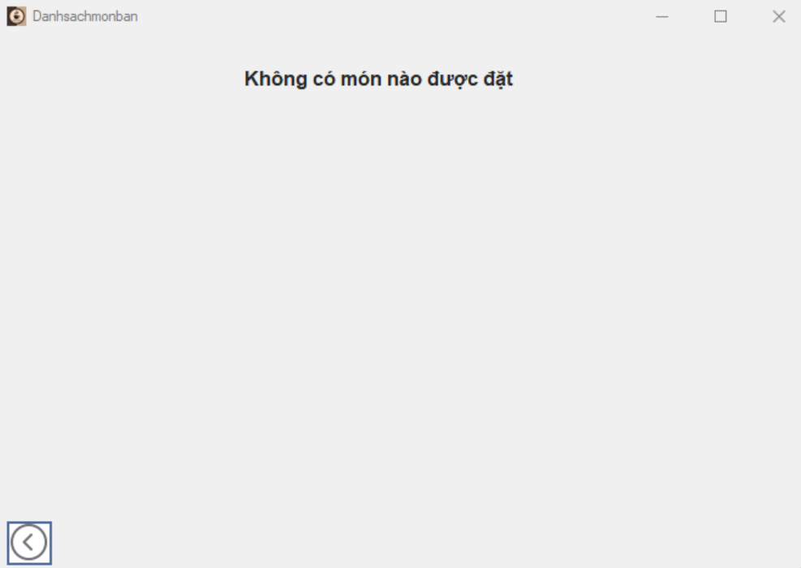

### *UC 11:* *Login (Barista)*

|  |  |  |  |  |  |
| --- | --- | --- | --- | --- | --- |
| **Use Case ID** | UC.11 | | | | |
| **Use Case Name** | Log in to the system | | | | |
| **Created by** | Bao Nguyen | | **Last updated by** | | Bao Nguyen |
| **Date Created** | Dec 06, 2024 | | **Date last updated** | | Dec 06, 2024 |
| **Actors** | Barista (User) , Authentication system (System) | | | | |
| **Brief Description** | Users log in to the system by providing a valid login name and password to use the functions corresponding to their authority. | | | | |
| **Goal** | This function allows users to log into the system | | | | |
| **Trigger** | The user selects the " **Pha chế**" button on the interface at first | | | | |
| **Pre-conditions** | * The user already has a valid account. * The system is active and connected to the database. | | | | |
| **Post-conditions** | * The user is successfully authenticated and has access to the system and is redirected to the functional interface corresponding to the authority. * User session is created for the user. | | | | |
| **Main Flow** | **Step** | **Actor Action** | | **System Response** | |
| **1** | The user selects the “**Pha chế**” button in the start interface | | Displays the login interface, including fields for entering login name and password | |
| **2** | Enter a valid username and password in the corresponding fields. | |  | |
| **3** | Click the " **Đăng nhập**" button to submit information. | | Check the user input information. The system sends a request to verify the login name and password to the database. | |
| **4** |  | | If the login name and password are valid, the system displays the functional interface corresponding to the authority | |
| **5** | Have access to the main interface and can use functions corresponding to their powers | |  | |
| **Alternative Flow** | **Alternative Flow 1: Login information is incorrect** | | | | |
| **Step** | **Actor Action** | | **System Response** | |
| **1** | The user selects the “**Pha chế**” button in the start interface | | Displays the login interface, including fields for entering login name and password | |
| **2** | The user entered the wrong login name or password | |  | |
| **3** | Click the " **Đăng nhập**" button to submit information. | | Check the user input information. The system sends a request to verify the login name and password to the database. | |
| **4** |  | | Verify the information and find that the login name or password is incorrect. | |
| **5** |  | | Show error message:"**Tên đăng nhập hoặc mật khẩu không đúng. Vui lòng thử lại**." | |
| **6** | Try re-entering your login information. | |  | |
| **7** | Click the " **Đăng nhập**" button to submit information. | | Continue verifying new information (return to step 3 of the main flow). | |
| **Alternative Flow 2: The user clicks on the forgot password link** | | | | |
| **Step** | **Actor Action** | | **System Response** | |
| **1** | The user selects the “**Pha chế**” button in the start interface | | Displays the login interface, including fields for entering login name and password | |
| **2** | Click the " **Quên mật khẩu**" link on the login page. | | Display the interface asking to enter the user's registered email address to recover the password. | |
| **3** | Enter email address | |  | |
| **4** | Press the "**Gửi**" button ". | | Check emails in the database. | |
| **5** |  | | If the email is valid, the system sends an email containing a password reset link. | |
| **6** | Open the email and tap the password reset link. | | Display the new password reset interface. | |
| **7** | Enter a new password | |  | |
| **8** | press the " **Xác nhận**" button. | | Update new password and display success message. | |
| **9** |  | | Switch back to the login interface | |
| **Exception Flow** | **Exception Flow 1: The system lost connection to the database** | | | | |
| **Step** | **Actor Action** | | **System Response** | |
| **1** | The user selects the “**Pha chế**” button in the start interface | | Displays the login interface, including fields for entering login name and password | |
| **2** | Enter a valid username and password in the corresponding fields. | |  | |
| **3** | Click the " **Đăng nhập**" button to submit information. | | Verified information but unable to access database due to lost connection. | |
| **4** |  | | Show error message:"**Lỗi kết nối với máy chủ. Vui lòng thử lại sau*.***" | |
| **5** | Contact and report to administrator | |  | |
| **Exception Flow 2: User does not enter User or Password** | | | | |
| **Step** | **Actor Action** | | **System Response** | |
| **1** | The user selects the “**Phục vụ**” button in the start interface | | Displays the login interface, including fields for entering login name and password | |
| **2** | User does not enter User or Password | |  | |
| **3** | Click the " **Đăng nhập**" button to submit information. | | Check the information the user entered. If the User or Password information is empty, display a message: “**Yêu cầu nhập User hoặc Password**” | |
| **4** | Enter full User and Password information | |  | |
| **5** | Click the " **Đăng nhập**" button to submit information. | | Continue verifying new information (return to step 3 of the main flow). | |
| **Priority** | High | | | | |
| **Business Rule** | Passwords must be at least 8 characters long, include both uppercase and lowercase letters, and at least one number. | | | | |

**- Prototype**

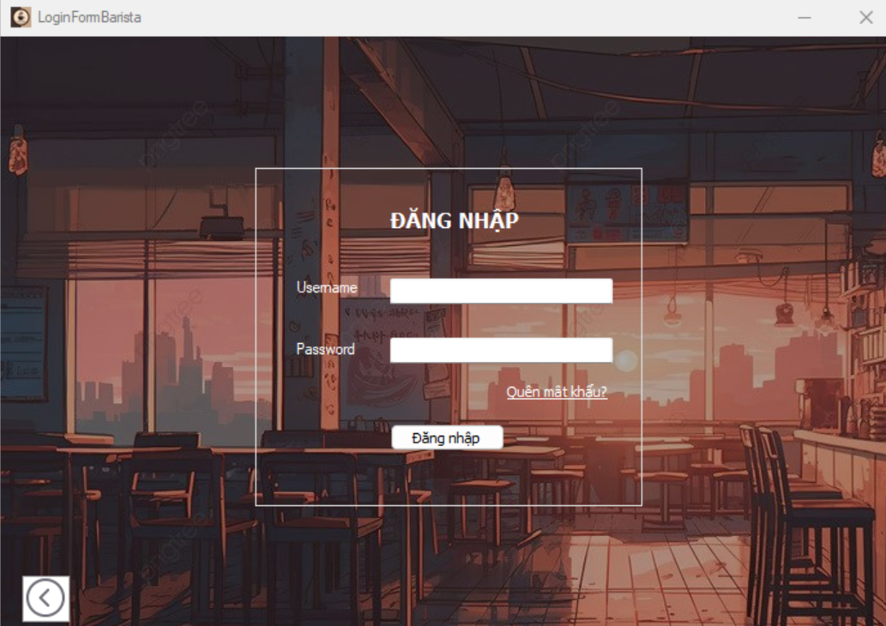

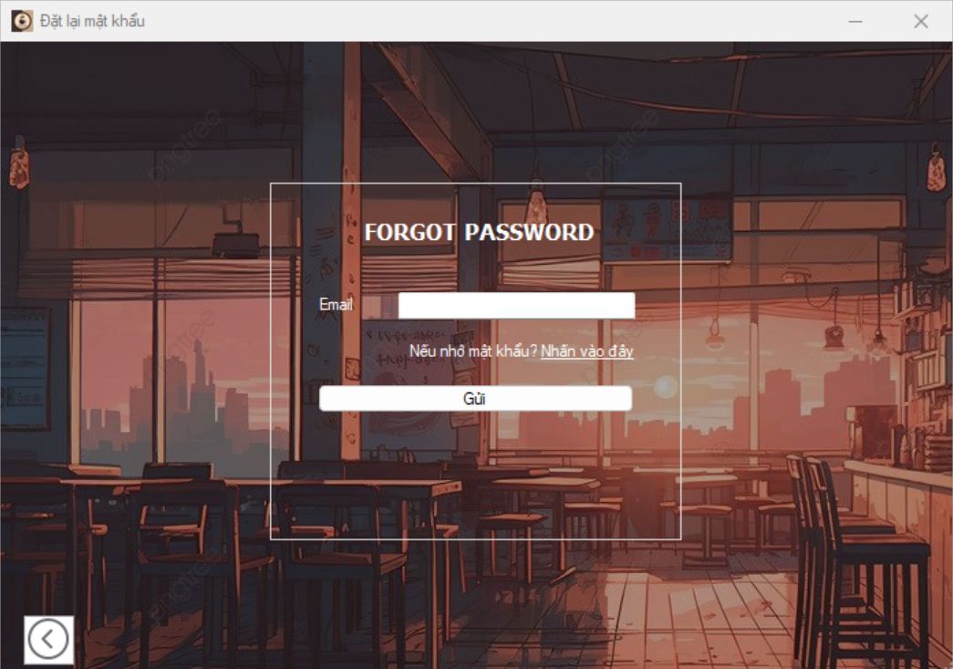

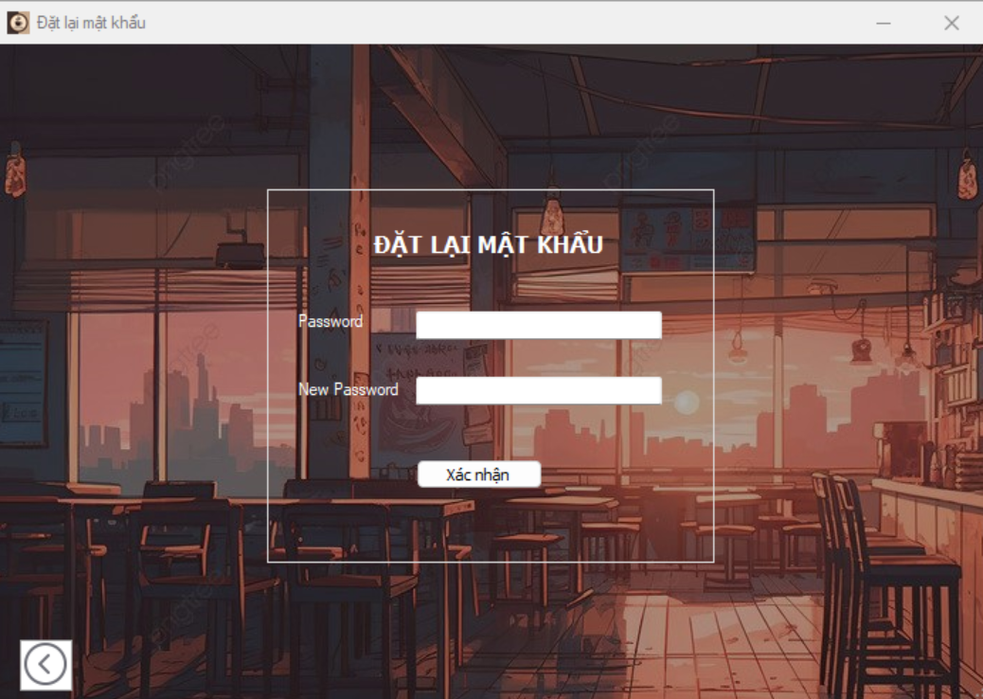

### *UC 12: See list of dishes ordered by customers*

|  |  |  |  |  |  |
| --- | --- | --- | --- | --- | --- |
| **Use Case ID** | UC.12 | | | | |
| **Use Case Name** | See list of dishes customers ordered | | | | |
| **Created by** | Bao Nguyen | | **Last updated by** | | Bao Nguyen |
| **Date Created** | Dec 08, 2024 | | **Date last updated** | | Dec 08, 2024 |
| **Actors** | Barista (User), Management system (System) | | | | |
| **Brief Description** | Users can view the list of orders in chronological order or by table to help them process and prepare dishes according to their requirements. | | | | |
| **Goal** | This function allows the barista to view a complete and detailed list of customer orders to prepare dishes promptly, accurately and minimize errors. | | | | |
| **Trigger** | Barista logs into the system and selects the function "**Xem danh sách món order**". | | | | |
| **Pre-conditions** | * Barista has successfully logged into the system. * The system has a database connection and stores information about customer orders. | | | | |
| **Post-conditions** | Barista can view the full order list with detailed information and order status. | | | | |
| **Main Flow** | **Step** | **Actor Action** | | **System Response** | |
| **1** | Barista selects the " **Xem danh sách món order** " function. | | The system displays a list of dishes customers have ordered in order of order time (newest at the top). | |
| **2** | Barista selects and clicks on the order he wants to view | | The system displays detailed information: dish name, quantity, table code, dish status. | |
| **3** | Barista presses the “Bắt đầu” button | | The system updates the item status to "**Đang xử lý**". | |
| **4** | After preparation is complete, the Barista clicks "**Hoàn tất**". | | The system updates the item status to "**Chờ phục vụ**". | |
| **Alternative Flow** | **Alternative Flow 1: No items were ordered** | | | | |
| **Step** | **Actor Action** | | **System Response** | |
| **1** | Barista selects the " **Xem danh sách món order** " function. | | The system checks the data and detects that no items have been ordered. | |
| **2** |  | | The system displays the message:*"***Hiện tại không có món nào được đặt**." | |
| **Alternative Flow 2: List of items has been cancelled** | | | | |
| **1** | Barista selects the " **Xem danh sách món order** " function. | | The system displays a list of dishes ordered by customers in chronological order or by table. | |
| **2** | Barista selects and clicks on the order he wants to view | | The system displays detailed information: dish name, quantity, table code, dish status with status: *"***Đã hủy bởi khách hàng.”** | |
| **3** | Select other order information to view | |  | |
| **Exception Flow** | **Step** | **Actor Action** | | **System Response** | |
| **1** | Barista selects the " **Xem danh sách món order** " function. | | The system cannot retrieve order information due to loss of database connection. | |
| **2** |  | | The system displays the error message:"**Không thể truy cập thông tin món order. Vui lòng thử lại.”** | |
| **3** | Contact and report to administrator | |  | |
| **Priority** | High | | | | |
| **Business Rule** | * The item list must be updated in real time. * Dishes are sorted by order time (pre-orders are displayed at the top). * Display full list of dishes ordered by customers | | | | |

**- Prototype**

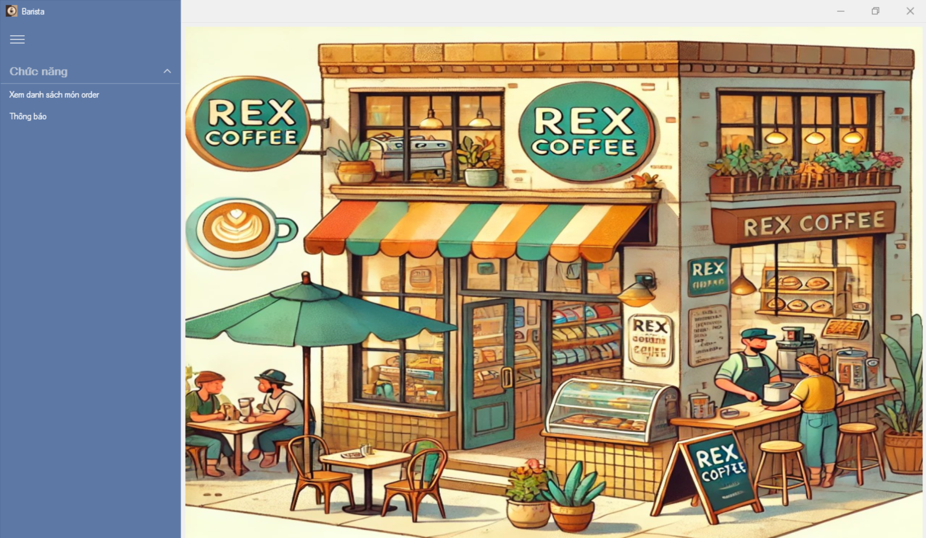

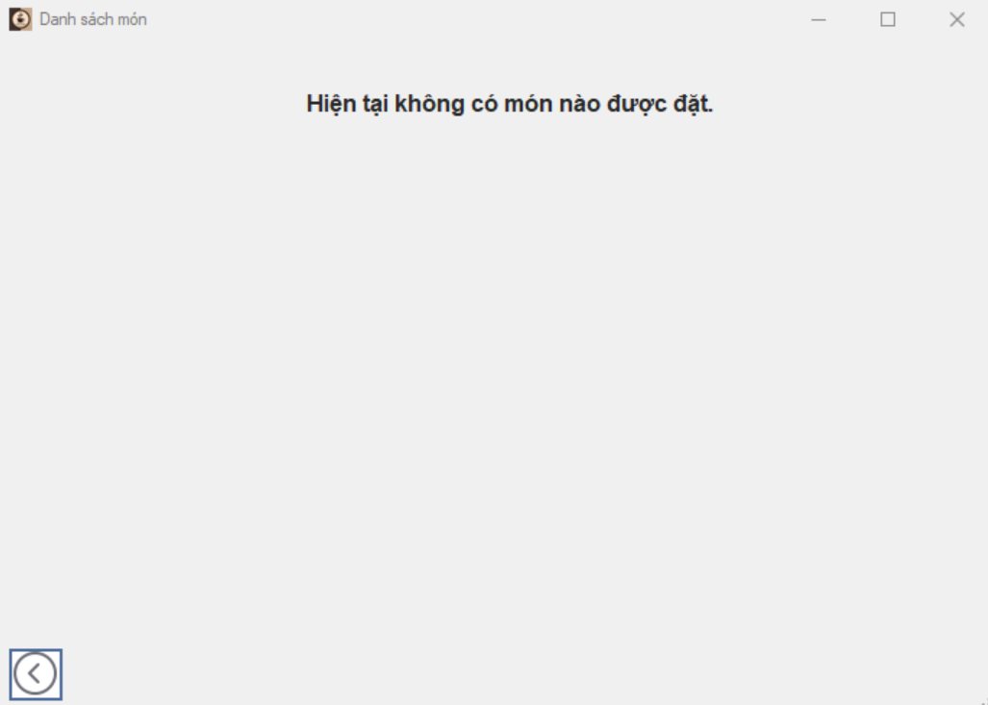

### *UC 13: Notice of out of stock*

|  |  |  |  |  |  |
| --- | --- | --- | --- | --- | --- |
| **Use Case ID** | UC.13 | | | | |
| **Use Case Name** | Notice of out of stock | | | | |
| **Created by** | Bao Nguyen | | **Last updated by** | | Bao Nguyen |
| **Date Created** | Dec 08, 2024 | | **Date last updated** | | Dec 08, 2024 |
| **Actors** | Barista,Waiter (User), Management system (System) | | | | |
| **Brief Description** | Users can notify that a dish is out of stock when the ingredients for that dish are not enough for waiters to interact with customers | | | | |
| **Goal** | This function allows baristas to quickly notify staff of "Hết món" status to interact with customers about adjusting or changing orders. | | | | |
| **Trigger** | Barista marks the item in the order list as "**Hết món**". | | | | |
| **Pre-conditions** | * Barista has successfully logged into the system. * The system has a database connection and stores information about customer orders. * The item has been ordered and is on the waiting list. * The dish you want to make is out of ingredients. | | | | |
| **Post-conditions** | * The system displays the message "Hết món" on the waiter interface. * The item status is updated to "Hết nguyên liệu". | | | | |
| **Main Flow** | **Step** | **Actor Action** | | **System Response** | |
| **1** | Barista selects the dish from the order list and marks "Hết món". | | The system updates the dish status to "Hết nguyên liệu". | |
| **2** |  | | The system sends the message "Hết món" to the waiter. | |
| **3** | The service staff receives the notice and reports it back to the customer. | |  | |
| **4** | Customers can choose to exchange or cancel the order through the interface or service staff | |  | |
| **Alternative Flow** | **Step** | **Actor Action** | | **System Response** | |
| **1** | Barista selects the dish from the order list and marks "Hết món". | | The system updates the dish status to "Hết nguyên liệu". | |
| **2** | The barista discovered that he had marked the wrong dish and selected " Hủy trạng thái Hết món" | | The system updates the dish status to "**Chờ xử lý**". | |
| **3** |  | | The system sends the message " Thông báo nhầm món hết món" to the waiter. | |
| **Exception Flow** | **Step** | **Actor Action** | | **System Response** | |
| **1** | Barista selects the dish from the order list and marks "Hết món". | | The system cannot update status and send notifications due to lost connection. | |
| **2** |  | | The system displays the error message:**"Không thể cập nhật trạng thái. Vui lòng thử lại sau."** | |
| **3** | Liên hệ và báo cáo với quản trị viên | |  | |
| **Priority** | High | | | | |
| **Business Rule** | * The barista can only announce that the dish is "Hết món" if the ingredients are really insufficient. * The system must immediately send notifications to service staff. | | | | |

**- Prototype**

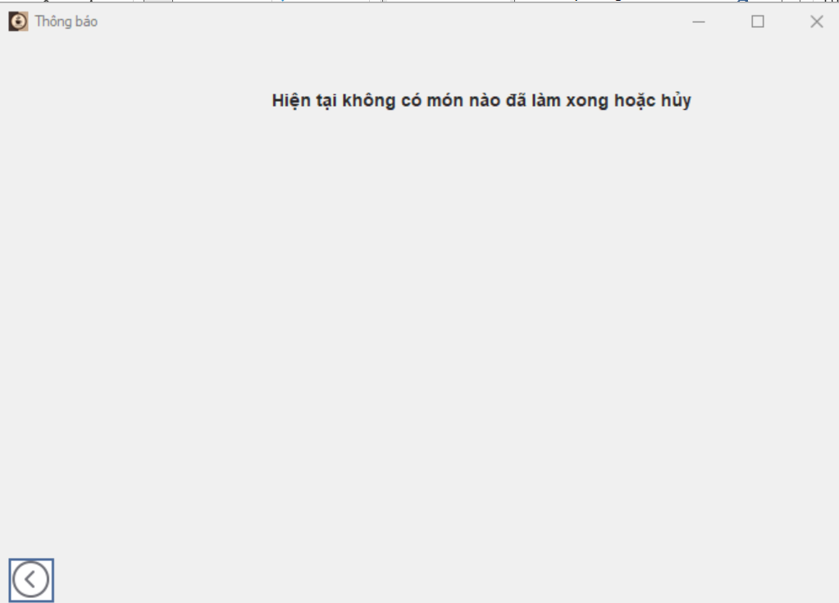

### *UC 14: Notify that the dish is done*

|  |  |  |  |  |  |
| --- | --- | --- | --- | --- | --- |
| **Use Case ID** | UC.14 | | | | |
| **Use Case Name** | Notify that the dish is done | | | | |
| **Created by** | Bao Nguyen | | **Last updated by** | | Bao Nguyen |
| **Date Created** | Dec 08, 2024 | | **Date last updated** | | Dec 08, 2024 |
| **Actors** | Barista (User), Management system (System) | | | | |
| **Brief Description** | Baristas use the system to announce that the dish is complete and ready to serve. The system will automatically send a notification to the service staff | | | | |
| **Goal** | This function allows the barista to quickly and accurately send notifications of finished dishes to the wait staff. | | | | |
| **Trigger** | The barista marks the item in the order list as "Hoàn tất". | | | | |
| **Pre-conditions** | * Barista has successfully logged into the system. * The dish has been prepared | | | | |
| **Post-conditions** | * The system sends a notification that the dish has been completed to the waiter. * Order status is updated to "**Chờ phục vụ**". | | | | |
| **Main Flow** | **Step** | **Actor Action** | | **System Response** | |
| **1** | Barista selects the item from the order list and marks "Hoàn tất". | | The system updates the dish status to "**Chờ phục vụ** ". | |
| **2** |  | | The system sends a notification to the waiter with dish information, table code and completion time. | |
| **3** | The service staff receives the notification | |  | |
| **4** | The waiter clicks "Xác nhận" when receiving the order. | | The system records and updates the status "Hoàn tất" | |
| **Alternative Flow** | **Step** | **Actor Action** | | **System Response** | |
| **1** | Barista selects the item from the order list and marks "Hoàn tất". | | The system updates the dish status to "**Chờ phục vụ** ". | |
| **2** |  | | The system sends a notification to the waiter with dish information, table code and completion time. | |
| **3** | Barista detected the wrong dish notification and selected  "Hủy trạng thái hoàn tất". | |  | |
| **4** |  | | The system updates the item status to "**Chờ xử lý**". | |
| **5** |  | | The system sends the message " Thông báo nhầm món hoàn tất " to the waiter | |
| **6** | Barista selects the item from the order list and marks "Hoàn tất". | | Continue updating (Go back to step 1 of main flow) | |
| **Exception Flow** | **Step** | **Actor Action** | | **System Response** | |
| **1** | Barista selects the item from the order list and marks "Hoàn tất". | | The system cannot update status and send notifications due to lost connection. | |
| **2** |  | | System error display:**"Không thể cập nhật trạng thái. Vui lòng thử lại sau."** | |
| **3** | Contact and report to administrator | |  | |
| **Priority** | High | | | | |
| **Business Rule** | * Only mark "Hoàn tất" when the dish is actually ready to serve. * The system must immediately send notifications to service staff. * The notice must include complete information: dish name, table number, and completion time. | | | | |

**- Prototype**



### *UC 15: Login (Cashier)*

|  |  |  |  |  |  |
| --- | --- | --- | --- | --- | --- |
| **Use Case ID** | UC.15 | | | | |
| **Use Case Name** | Log in to the system | | | | |
| **Created by** | Bao Nguyen | | **Last updated by** | | Bao Nguyen |
| **Date Created** | Dec 06, 2024 | | **Date last updated** | | Dec 06, 2024 |
| **Actors** | Cashier (User) , Authentication system (System) | | | | |
| **Brief Description** | Users log in to the system by providing a valid login name and password to use the functions corresponding to their authority. | | | | |
| **Goal** | This function allows users to log into the system | | | | |
| **Trigger** | The user selects the " **Thu ngân**" button on the interface at first | | | | |
| **Pre-conditions** | * The user already has a valid account. * The system is active and connected to the database. | | | | |
| **Post-conditions** | * The user is successfully authenticated and has access to the system and is redirected to the functional interface corresponding to the authority. * User session is created for the user. | | | | |
| **Main Flow** | **Step** | **Actor Action** | | **System Response** | |
| **1** | The user selects the “**Thu ngân**” button in the start interface | | Displays the login interface, including fields for entering login name and password | |
| **2** | Enter a valid username and password in the corresponding fields. | |  | |
| **3** | Click the " **Đăng nhập**" button to submit information. | | Check the user input information. The system sends a request to verify the login name and password to the database. | |
| **4** |  | | If the login name and password are valid, the system displays the functional interface corresponding to the authority | |
| **5** | Have access to the main interface and can use functions corresponding to their powers | |  | |
| **Alternative Flow** | **Alternative Flow 1: Login information is incorrect** | | | | |
| **Step** | **Actor Action** | | **System Response** | |
| **1** | The user selects the “**Thu ngân**” button in the start interface | | Displays the login interface, including fields for entering login name and password | |
| **2** | The user entered the wrong login name or password | |  | |
| **3** | Click the " **Đăng nhập**" button to submit information. | | Check the user input information. The system sends a request to verify the login name and password to the database. | |
| **4** |  | | Verify the information and find that the login name or password is incorrect. | |
| **5** |  | | Show error message:"**Tên đăng nhập hoặc mật khẩu không đúng. Vui lòng thử lại**." | |
| **6** | Try re-entering your login information. | |  | |
| **7** | Click the " **Đăng nhập**" button to submit information. | | Continue verifying new information (return to step 3 of the main flow). | |
| **Alternative Flow 2: The user clicks on the forgot password link** | | | | |
| **Step** | **Actor Action** | | **System Response** | |
| **1** | The user selects the “**Thu ngân**” button in the start interface | | Displays the login interface, including fields for entering login name and password | |
| **2** | Click the " **Quên mật khẩu**" link on the login page. | | Display the interface asking to enter the user's registered email address to recover the password. | |
| **3** | Enter email address | |  | |
| **4** | Press the "**Gửi**" button ". | | Check emails in the database. | |
| **5** |  | | If the email is valid, the system sends an email containing a password reset link. | |
| **6** | Open the email and tap the password reset link. | | Display the new password reset interface. | |
| **7** | Enter a new password | |  | |
| **8** | press the " **Xác nhận**" button. | | Update new password and display success message. | |
| **9** |  | | Switch back to the login interface | |
| **Exception Flow** | **Exception Flow 1: The system lost connection to the database** | | | | |
| **Step** | **Actor Action** | | **System Response** | |
| **1** | The user selects the “**Thu ngân**” button in the start interface | | Displays the login interface, including fields for entering login name and password | |
| **2** | Enter a valid username and password in the corresponding fields. | |  | |
| **3** | Click the " **Đăng nhập**" button to submit information. | | Verified information but unable to access database due to lost connection. | |
| **4** |  | | Show error message:"**Lỗi kết nối với máy chủ. Vui lòng thử lại sau*.***" | |
| **5** | Contact and report to administrator | |  | |
| **Exception Flow 2: User does not enter User or Password** | | | | |
| **Step** | **Actor Action** | | **System Response** | |
| **1** | The user selects the “**Thu ngân**” button in the start interface | | Displays the login interface, including fields for entering login name and password | |
| **2** | User does not enter User or Password | |  | |
| **3** | Click the " **Đăng nhập**" button to submit information. | | Check the information the user entered. If the User or Password information is empty, display a message: “**Yêu cầu nhập User hoặc Password**” | |
| **4** | Enter full User and Password information | |  | |
| **5** | Click the " **Đăng nhập**" button to submit information. | | Continue verifying new information (return to step 3 of the main flow). | |
| **Priority** | High | | | | |
| **Business Rule** | Passwords must be at least 8 characters long, include both uppercase and lowercase letters, and at least one number. | | | | |

**- Prototype**

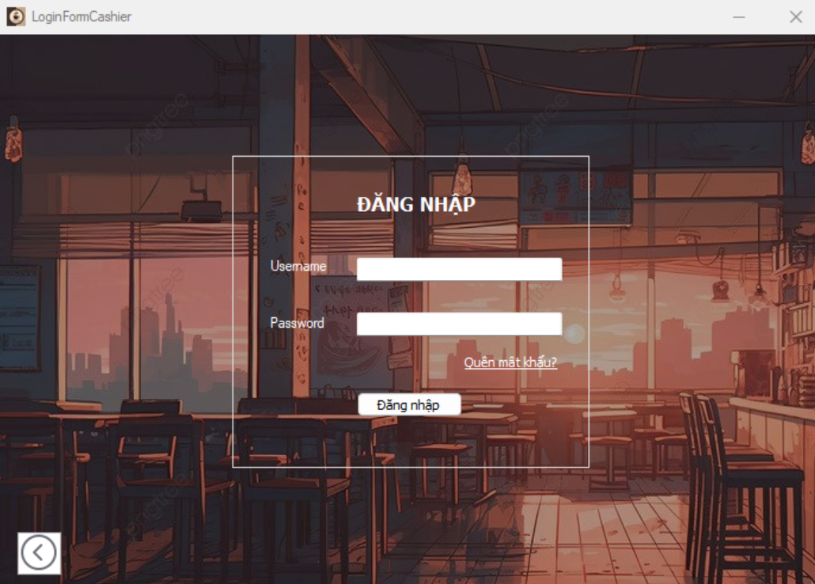





### *UC 16: See list of dishes ordered by customers*

|  |  |  |  |  |  |
| --- | --- | --- | --- | --- | --- |
| **Use Case ID** | UC.16 | | | | |
| **Use Case Name** | See list of dishes customers ordered | | | | |
| **Created by** | Bao Nguyen | | **Last updated by** | | Bao Nguyen |
| **Date Created** | Dec 09, 2024 | | **Date last updated** | | Dec 09, 2024 |
| **Actors** | Cashier (User), Management system (System) | | | | |
| **Brief Description** | Cashier uses the system to view a list of dishes ordered by customers by table, including detailed information about the dish, completion status and total quantity. Support Cashier in managing payments and ensuring accuracy in the service process. | | | | |
| **Goal** | This function allows Cashier to view the list of items customers have ordered for easy comparison and payment | | | | |
| **Trigger** | Cashier logs into the system and selects the " **Xem danh sách món order** " function. | | | | |
| **Pre-conditions** | * Cashier has successfully logged into the system. * The system has a database connection and stores information about customer orders. * The list of dishes has been updated in the system through the Barista and served | | | | |
| **Post-conditions** | Cashier can view the full order list with detailed information, order status and total amount in the invoice | | | | |
| **Main Flow** | **Step** | **Actor Action** | | **System Response** | |
| **1** | Cashier selects the " **Xem danh sách món order** " function. | | The system displays a list of dishes customers have ordered in order of order time (newest at the top). | |
| **2** | The cashier selects the table or order ID to view. | | The system filters and displays information about the table's ordered list or order ID | |
| **3** | The cashier sees details of the items in the order. | | The system displays detailed information for each item: item name, quantity, table number, item status, total amount | |
| **4** | Cashier confirms the item list with the customer. | |  | |
| **Alternative Flow** | **Alternative Flow 1: No items were ordered** | | | | |
| **Step** | **Actor Action** | | **System Response** | |
| **1** | Cashier selects the " **Xem danh sách món order** " function. | | The system checks the data and detects that no items have been ordered. | |
| **2** |  | | The system displays the message: *"***Hiện tại không có món nào được đặt**." | |
| **Alternative Flow 2: Cashier chooses to view another order** | | | | |
| **1** | Cashier selects the " **Xem danh sách món order** " function. | | The system displays a list of dishes ordered by customers in chronological order or by table. | |
| **2** | The cashier selects the table or order ID to view. | | The system filters and displays information about the table's ordered list or order ID | |
| **3** | The cashier sees details of the items in the order. | | The system displays detailed information for each item: item name, quantity, table number, item status, total amount | |
| **4** | Cashier selects the “Thoát” button to view other orders | | The system returns to the interface of the list of items ordered by customers | |
| **5** | The cashier selects another table or order ID to view. | | Continue filtering and displaying (Return to step 2 of main flow) | |
| **Exception Flow** | **Step** | **Actor Action** | | **System Response** | |
| **1** | Cashier selects the " **Xem danh sách món order** " function. | | The system cannot retrieve order information due to loss of database connection. | |
| **2** |  | | The system displays the error message: "**Không thể truy cập thông tin món order. Vui lòng thử lại.”** | |
| **3** | Contact and report to administrator | |  | |
| **Priority** | High | | | | |
| **Business Rule** | * The displayed list of items must include all information: Item name, quantity, price code, status. * Displayed information must be updated in real time if there is a change in item status. * The cashier can only view item list information and does not have the right to edit data. * Allows filtering and searching the list of dishes by table, order ID or dish status. | | | | |

**- Prototype**

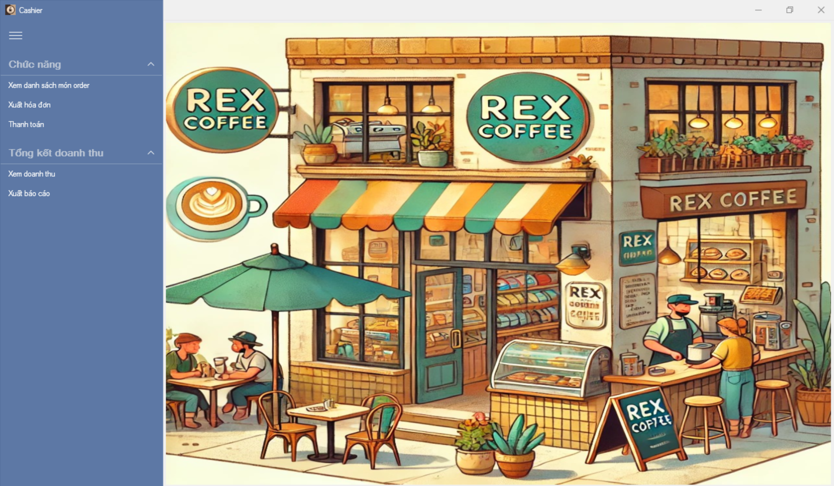

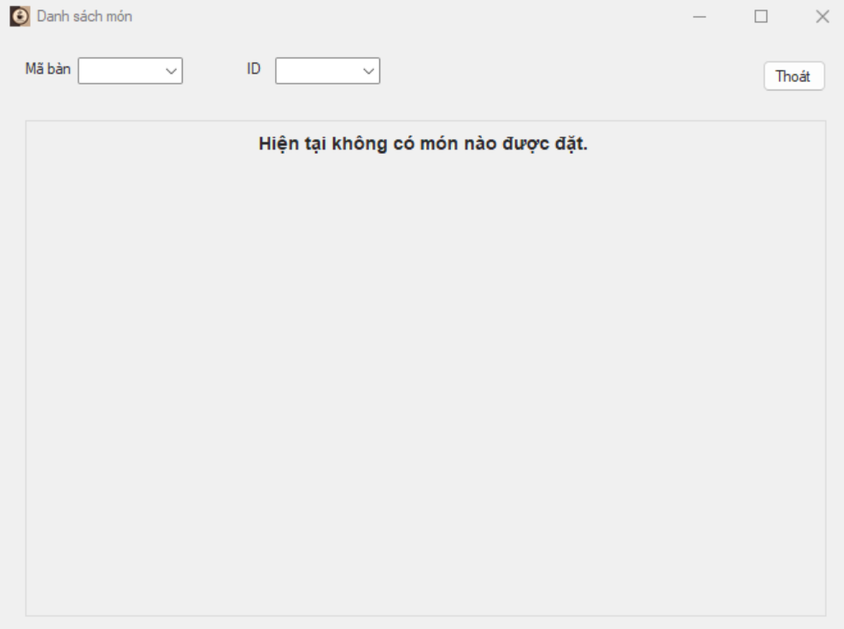

### *UC 17: Issue invoices*

|  |  |  |  |  |  |
| --- | --- | --- | --- | --- | --- |
| **Use Case ID** | UC.17 | | | | |
| **Use Case Name** | Issue invoices | | | | |
| **Created by** | Bao Nguyen | | **Last updated by** | | Bao Nguyen |
| **Date Created** | Dec 09, 2024 | | **Date last updated** | | Dec 09, 2024 |
| **Actors** | Cashier (User), Management system (System) | | | | |
| **Brief Description** | Cashier uses the system to create and print detailed invoices for customers based on the list of paid items. Invoice includes item information, quantity, price and total | | | | |
| **Goal** | This function allows Cashier to create detailed invoices for customers to complete the payment process | | | | |
| **Trigger** | Cashier logs into the system and selects the " **Xem danh sách món order** " function. | | | | |
| **Pre-conditions** | * Cashier has successfully logged into the system. * The customer's item list is confirmed "Hoàn tất". * The total payment amount has been calculated. | | | | |
| **Post-conditions** | The part was successfully created and printed; Invoice information is stored on the system | | | | |
| **Main Flow** | **Step** | **Actor Action** | | **System Response** | |
| **1** | Cashier selects the " **Xuất hóa đơn** " function. | | The system displays a list of tables or order IDs waiting for payment. | |
| **2** | The cashier selects the table or order ID that needs to issue an invoice. | | The system displays details of the items in the order, including: item name, quantity, unit price. | |
| **3** | Cashier presses the " **In hóa đơn** " button | | The system creates a detailed invoice, displaying a preview for Cashier to confirm. | |
| **4** | Cashier confirms and prints the invoice. | | The system prints the invoice via the printer and updates the order status to *“***Đã thanh toán***”*. | |
| **Alternative Flow** | **Step** | **Actor Action** | | **System Response** | |
| **1** | Cashier selects the " **Xuất hóa đơn** " function. | | The system displays a list of tables or order IDs waiting for payment. | |
| **2** | The cashier selects the table or order ID that needs to issue an invoice | | The system displays details of the items in the order, including: item name, quantity, unit price. | |
| **3** | Cashier presses the " **In hóa đơn** " button | | The system creates a detailed invoice, displaying a preview for Cashier to confirm. | |
| **4** | Cashier cancels the invoice issuance operation | | The system cancels the operation and returns to the order list screen. | |
| **Exception Flow** | **Step** | **Actor Action** | | **System Response** | |
| **1** | Cashier selects the " **Xuất hóa đơn** " function. | | The system displays a list of tables or order IDs waiting for payment. | |
| **2** | The cashier selects the table or order ID that needs to issue an invoice | | The system cannot display information about the items in the order because of connection loss | |
| **3** |  | | HThe system displays a notification:”**Mất kết nối. Vui lòng thử lại sau**” | |
|  | **4** | Cashier can contact the admin | |  | |
| **Priority** | High | | | | |
| **Business Rule** | * Invoices are only generated for tables that have completed payment. * All information on the invoice (item name, quantity, price, total) must be accurate with system data. * Detailed information must be available:   - Shop name, address, phone number.  - Name of item, quantity, price of each item. | | | | |

**- Prototype**

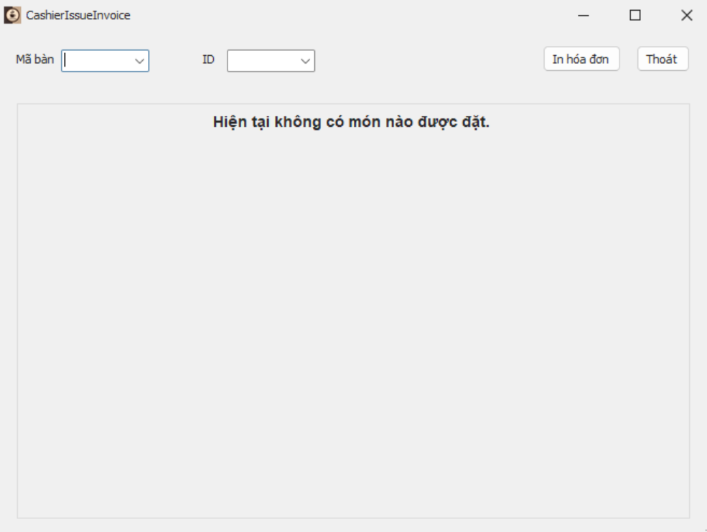

### *UC 18: Payment*

|  |  |  |  |  |  |
| --- | --- | --- | --- | --- | --- |
| **Use Case ID** | UC.18 | | | | |
| **Use Case Name** | Payment | | | | |
| **Created by** | Hien Nguyen | | **Last updated by** | | Hien Nguyen |
| **Date Created** | Oct 01, 2024 | | **Date last updated** | | Oct 05, 2024 |
| **Actors** | Cashier | | | | |
| **Brief Description** | The cashier can help customers pay directly at the cashier counter. | | | | |
| **Goal** | This use case allows the cashier to process payment transactions. | | | | |
| **Trigger** | The cashier selects the "Thanh toán ngay" button on the payment screen. | | | | |
| **Pre-conditions** | * The system is successfully logged in. * The customer has selected a product and the payment screen is displayed. | | | | |
| **Post-conditions** | The payment is successful and the receipt can be printed and given directly or emailed to the customer. | | | | |
| **Main Flow** | **Step** | **Actor Action** | | **System Response** | |
| **1** | The cashier clicks the "Thanh toán ngay" button on the payment screen. | | The system displays a page to show the payment method. | |
| **2** | The cashier will select the payment method. If cash is received, the money will be entered into the revenue book. | | The system validates the input information, calculates the change (if any) and confirms the payment. | |
| **3** |  | | Receives information from the cashier and displays "loading". | |
| **4** | The cashier confirms the payment. | | The system will process the payment and display the receipt details on the screen. | |
| **5** | The cashier sends the receipt to the customer. | | The system saves the transaction details. | |
| **6** | The cashier completes the payment process and exits. | |  | |
| **Alternative Flow 1** | **Step** | **Actor Action** | | **System Response** | |
| 1 | The cashier clicks the "Pay Now" button on the payment screen. | | The system displays the page showing available payment methods. | |
| 2 | The cashier selects a payment method. If payment is made in cash, the amount will be recorded in the revenue ledger. | | The system validates the input, calculates any change (if applicable), and confirms the payment. | |
| 3 | The user clicks the "Cancel" button. | | The system returns to the previous screen without saving any changes. | |
| **Alternative Flow 2** | **Step** | **Actor Action** | | **System Response** | |
|  | 1 | The cashier clicks the "Pay Now" button on the payment screen. | | The system displays the page showing available payment methods. | |
| 2 | The cashier skips selecting a payment method. | | The system validates the input, detects missing information, and displays the message: “You have not entered enough information.” | |
| 3 |  | | The system returns to the previous screen without saving any changes. | |
| **Exception Flow** | **Step** | **Actor Action** | | **System Response** | |
| 1 | The cashier clicks the "Pay Now" button on the payment screen. | | The system displays the page showing available payment methods. | |
| 2 | The cashier selects a payment method. If payment is made in cash, the amount will be recorded in the revenue ledger. | | The system validates the input, calculates any change (if applicable), and confirms the payment. | |
| 3 |  | | The system validates the input and displays an error message for incorrect or incomplete information on the payment screen. | |
| 4 | The cashier can choose to re-enter payment information or click the "Cancel" button. | | The system revalidates the input or returns to the previous screen without saving any changes. | |
| **Priority** | High | | | | |
| **Business Rule** | * All payments must be recorded in the revenue ledger. * Change calculation must be accurate for cash transactions. * Receipts must be available for both print and email. | | | | |

**- Prototype**

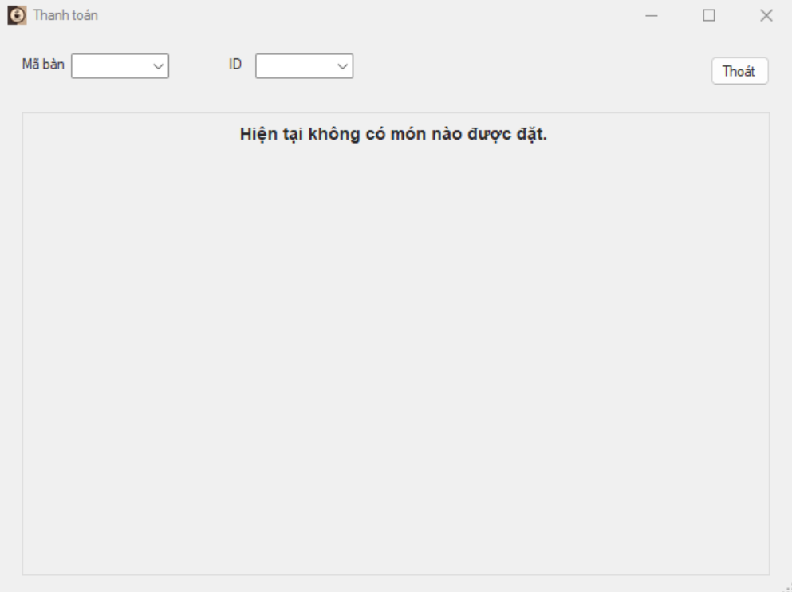

### *UC 19: Summary of revenue*

|  |  |  |  |
| --- | --- | --- | --- |
| **Use Case ID** | UC.19 | | |
| **Use Case Name** | Summary of renvenue. | | |
| **Created by** | Hien Nguyen | **Last updated by** | Hien Nguyen |
| **Date Created** | Oct 01, 2024 | **Date last updated** | Oct 05, 2024 |
| **Actors** | Cashier | | |
| **Brief Description** | The cashier can summarize sales revenue for specific time periods. | | |
| **Goal** | This Use Case allows the cashier to view and export revenue reports. | | |
| **Trigger** | Cashier selects the “Summary” button on the payment screen. | | |
| **Pre-conditions** | Logged into system successfully.  Transaction information or receipts already in the system. | | |
| **Post-conditions** | Revenue reports are displayed and exported at any time. | | |
| **Main Flow** | **Step** | **Actor Action** | **System Response** |
| 1 | The cashier clicks on the "Summary" button on the payment screen. | The system displays options to filter revenue summaries by time period, payment method, or category. |
| 2 | The cashier selects the desired filters. | The system processes the information and matches it with the data. |
| 3 |  | The system generates a summary report based on the selected filters and displays total revenue for the specified time period (daily, weekly, monthly, or per shift). |
| 4 | The cashier clicks on the detailed view option next to the summary report. | The report includes total sales, the number of invoices, average revenue per invoice, and best-selling items, displayed on the screen. |
| 5 | The cashier confirms the report export (downloads it as an Excel, PDF, or directly saves it). | The system exports the report and saves the information. |
| 6 | The cashier finishes viewing the report and exits. |  |
| **Alternative Flow** | **Alternative flow 1:**  **Do not select a filter for summary** | | |
| **Step** | **Actor Action** | **System Response** |
| 1 | The cashier clicks on the "Summary" button on the payment screen. | The system displays options to filter revenue summaries by time period, payment method, or category. |
| 2 | The cashier decides not to apply any filters. | The system generates a default summary report for the current day and displays the total revenue. |
| 3 | The user clicks the "Cancel" button. | The system returns to the main dashboard without saving any changes. |
| **Alternative flow 2:**  **select dates that have not been aggregated in the filter.** | | |
| **Step** | **Actor Action** | **System Response** |
| 1 | The cashier applies filters for specific dates and tries to generate or export a report. | The system detects an error and displays: “Data for the selected dates has not been aggregated.” |
| 2 |  | The system displays the error message: “Revenue data for these dates is unavailable. Please select other dates.” |
| 3 | The cashier selects different dates or cancels the filters. | The system returns to the main dashboard without saving any changes. |
| **Exception Flow** | **Exception flow 1: local network connection lost.** | | |
| **Step** | **Actor Action** | **System Response** |
| 1 | The cashier clicks the "Summary" button on the payment screen. | The system attempts to retrieve data from the server. |
| 2 | The local network connection is lost during the process. | The system displays an error message about the lost connection and prompts the cashier to retry later. |
| 3 | The cashier can choose to retry the operation or exit. | The system attempts to reconnect or returns to the previous screen without making changes. |
| **Priority** | High | | |
| **Business Rule** | * Filters must align with predefined revenue categories and time periods. * Reports must include total revenue, the number of invoices, and key statistics (e.g., average revenue per invoice). * Exported reports must support multiple formats, including Excel and PDF | | |

**- Prototype**

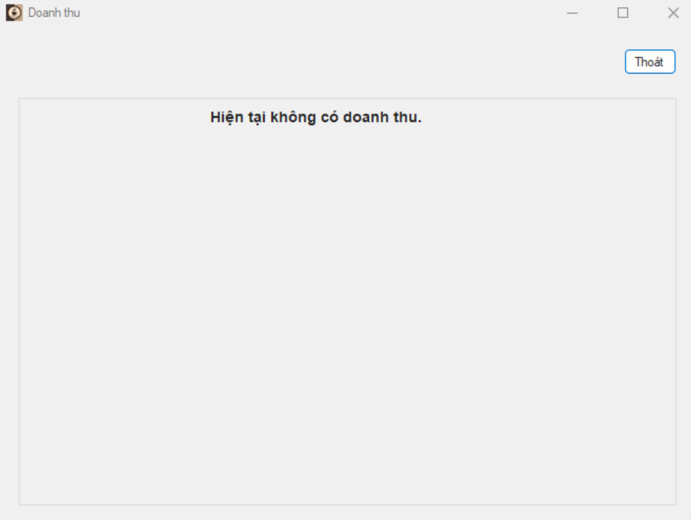

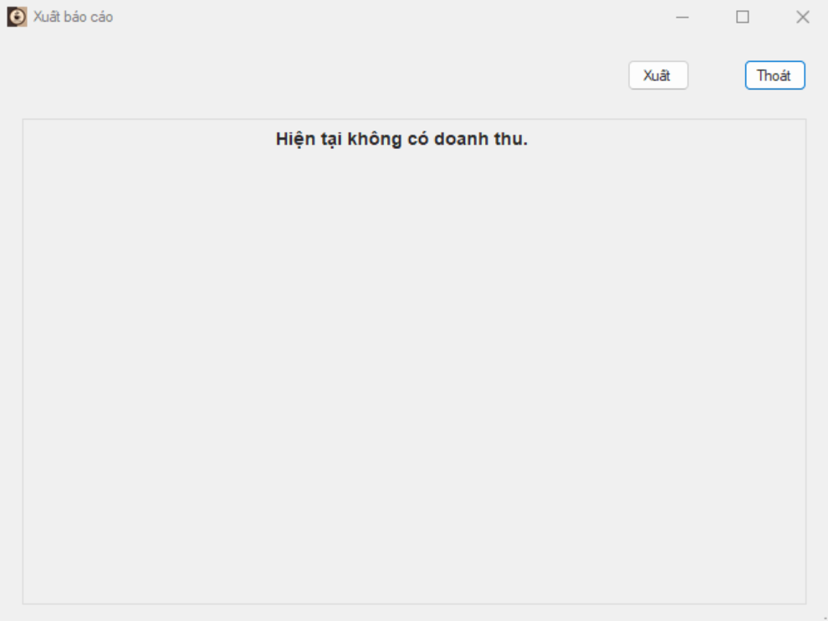

### *UC 20: Login (Admin)*

|  |  |  |  |  |  |
| --- | --- | --- | --- | --- | --- |
| **Use Case ID** | UC.20 | | | | |
| **Use Case Name** | Đăng nhập vào hệ thống | | | | |
| **Created by** | Bao Nguyen | | **Last updated by** | | Bao Nguyen |
| **Date Created** | Dec 06, 2024 | | **Date last updated** | | Dec 06, 2024 |
| **Actors** | Admin (User) , Hệ thống xác thực (System) | | | | |
| **Brief Description** | Người dùng đăng nhập vào hệ thống bằng cách cung cấp tên đăng nhập và mật khẩu hợp lệ để sử dụng các chức năng tương ứng với quyền hạn của mình. | | | | |
| **Goal** | Chức năng này cho phép user đăng nhập vào hệ thống | | | | |
| **Trigger** | Người dùng chọn nút “**Admin**” trên giao diện lúc đầu | | | | |
| **Pre-conditions** | * Người dùng đã có tài khoản hợp lệ. * Hệ thống đang hoạt động và có kết nối với cơ sở dữ liệu. | | | | |
| **Post-conditions** | * Người dùng được xác thực thành công và được truy cập vào hệ thống và được chuyển đến giao diện chức năng tương ứng với quyền hạn. * Phiên làm việc (user session) được tạo cho người dùng. | | | | |
| **Main Flow** | **Step** | **Actor Action** | | **System Response** | |
| **1** | Người dùng chọn nút “**Admin”** trong giao diện bắt đầu | | Hiển thị giao diện đăng nhập, bao gồm các trường để nhập tên đăng nhập và mật khẩu | |
| **2** | Nhập tên đăng nhập và mật khẩu hợp lệ vào các trường tương ứng. | |  | |
| **3** | Nhấn nút "**Đăng nhập**" để gửi thông tin. | | Kiểm tra thông tin người dùng nhập vào. Hệ thống gửi yêu cầu xác minh tên đăng nhập và mật khẩu tới cơ sở dữ liệu. | |
| **4** |  | | Nếu tên đăng nhập và mật khẩu hợp lệ, hệ thống hiển thị giao diện chức năng tương ứng với quyền hạn | |
| **5** | Được truy cập vào giao diện chính và có thể sử dụng các chức năng tương ứng với quyền hạn của mình | |  | |
| **Alternative Flow** | **Luồng phụ 1: Thông tin đăng nhập không chính xác** | | | | |
| **Step** | **Actor Action** | | **System Response** | |
| **1** | Người dùng chọn nút “**Admin**” | | Hiển thị giao diện đăng nhập, bao gồm các trường để nhập tên đăng nhập và mật khẩu | |
| **2** | Người dùng nhập sai tên đăng nhập hoặc mật khẩu | |  | |
| **3** | Nhấn nút "**Đăng nhập**" để gửi thông tin. | | Kiểm tra thông tin người dùng nhập vào. Hệ thống gửi yêu cầu xác minh tên đăng nhập và mật khẩu tới cơ sở dữ liệu. | |
| **4** |  | | Xác minh thông tin và phát hiện rằng tên đăng nhập hoặc mật khẩu không chính xác. | |
| **5** |  | | Hiển thị thông báo lỗi: "**Tên đăng nhập hoặc mật khẩu không đúng. Vui lòng thử lại**." | |
| **6** | Thử nhập lại thông tin đăng nhập. | |  | |
| **7** | Nhấn nút "Đăng nhập" để gửi thông tin. | | Tiếp tục xác minh thông tin mới (quay lại bước 3 của luồng chính). | |
| **Luồng phụ 2: Người dùng kích vào liên kết quên mật khẩu** | | | | |
| **Step** | **Actor Action** | | **System Response** | |
| **1** | Người dùng chọn nút “**Admin**” | | Hiển thị giao diện đăng nhập, bao gồm các trường để nhập tên đăng nhập và mật khẩu | |
| **2** | Nhấn vào liên kết "**Quên mật khẩu**" trên trang đăng nhập. | | Hiển thị **giao diện yêu cầu nhập địa chỉ email** đã đăng ký của người dùng để khôi phục mật khẩu. | |
| **3** | Nhập địa chỉ email | |  | |
| **4** | Nhấn nút "**Gửi**". | | Kiểm tra email trong cơ sở dữ liệu. | |
| **5** |  | | Nếu email hợp lệ, hệ thống gửi một email chứa liên kết đặt lại mật khẩu. | |
| **6** | Mở email và nhấn vào liên kết đặt lại mật khẩu. | | Hiển thị giao diện đặt lại mật khẩu mới. | |
| **7** | Nhập mật khẩu mới | |  | |
| **8** | nhấn nút "**Xác nhận**". | | Cập nhật mật khẩu mới và hiển thị thông báo thành công. | |
| **9** |  | | Chuyển về giao diện đăng nhập | |
| **Exception Flow** | **Luồng ngoại lệ 1: Hệ thống mất kết nối với cơ sở dữ liệu** | | | | |
| **Step** | **Actor Action** | | **System Response** | |
| **1** | Người dùng chọn nút “**Admin**” | | Hiển thị giao diện đăng nhập, bao gồm các trường để nhập tên đăng nhập và mật khẩu | |
| **2** | Người dùng nhập tên đăng nhập hoặc mật khẩu | |  | |
| **3** | Nhấn nút "**Đăng nhập**" để gửi thông tin. | | Xác minh thông tin nhưng không thể truy cập cơ sở dữ liệu do mất kết nối. | |
| **4** |  | | Hiển thị thông báo lỗi: "**Lỗi kết nối với máy chủ. Vui lòng thử lại sau*.***" | |
| **5** | Liên hệ và báo cáo với quản trị viên | |  | |
| **Luồng ngoại lệ 2: Người dùng không nhập User hoặc Pasword** | | | | |
| **Step** | **Actor Action** | | **System Response** | |
| **1** | Người dùng chọn nút “**Admin**” | | Hiển thị giao diện đăng nhập, bao gồm các trường để nhập tên đăng nhập và mật khẩu | |
| **2** | Người dùng không nhập User hoặc Password | |  | |
| **3** | Nhấn nút "**Đăng nhập**" để gửi thông tin. | | Kiểm tra thông tin người dùng nhập vào, nếu thông tin User hoặc Password rỗng(trống) thì hiển thị thông báo “**Yêu cầu nhập User hoặc Password**” | |
| **4** | Nhập đầy đủ thông tin User và Pasword | |  | |
| **5** | Nhấn nút "**Đăng nhập**" để gửi thông tin. | | Tiếp tục xác minh thông tin mới (quay lại bước 3 của luồng chính). | |
| **Priority** | High | | | | |
| **Business Rule** | Mật khẩu phải có độ dài tối thiểu 8 ký tự, bao gồm cả chữ hoa và chữ thường, và ít nhất một số. | | | | |

**- Prototype**

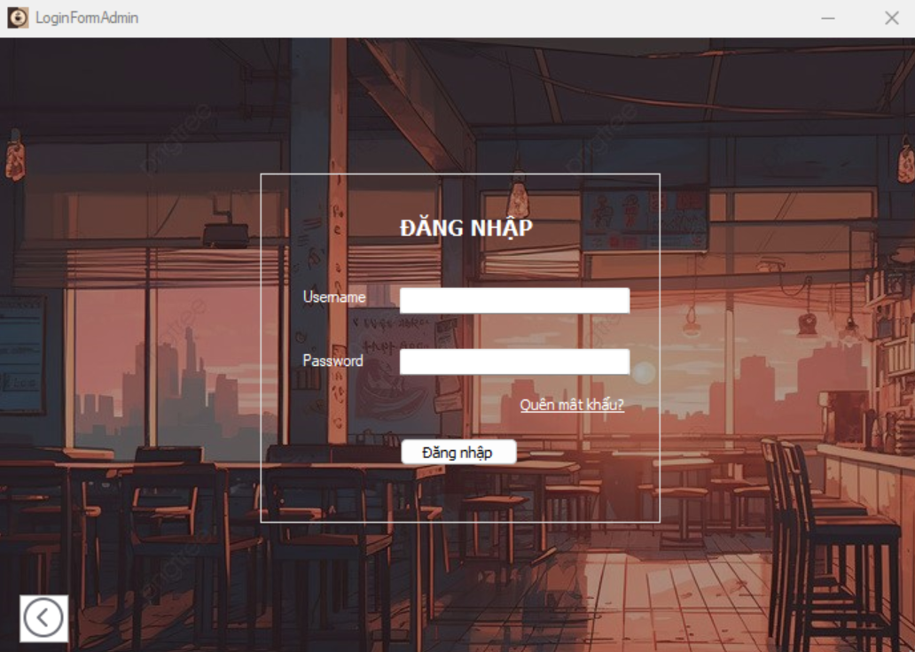





### *UC 21: Manage customer booking*

|  |  |  |  |
| --- | --- | --- | --- |
| **Use Case ID** | UC.21 | | |
| **Use Case Name** | Manage customer bookings | | |
| **Created by** | Huy Nguyen | **Last updated by** | Huy Nguyen |
| **Date Created** | Oct 01, 2024 | **Date last updated** | Oct 05, 2024 |
| **Actors** | Cashier | | |
| **Brief Description** | Cashier can book, edit, and cancel reservations customer reservations through the system. | | |
| **Goal** | This function allows managing customer reservations more easily and flexibly with the ability to add, update, delete and view the customer reservation information. | | |
| **Trigger** | Cashier selects "Manage Reservations" from the system menu. | | |
| **Pre-conditions** | Logged into system successfully.  Users have the right to perform functions such as adding, editing, deleting or viewing details of customer booking management. | | |
| **Post-conditions** | Customer reservation management information is updated in the system. The system reflects the exact status of booking, editing, and canceling reservations customer reservation information. | | |
| **Main Flow A** | **A. View list of customer information and reservation status.**  **Trigger**: The user clicks on the table information profile list tab to display the list of available profiles.  **result**: Users can view a list of customer booking information | | |
|  | **Step** | **Actor Action** | **System Response** |
| 1 | Cashier selects "Manage Reservations" from the menu. | The system displays the reservation management interface with the list of existing profiles, along with options for booking, editing, and canceling reservations. |
| 2 | Cashier selects the desired search criteria. | The system processes the input criteria. |
| 3 |  | Filters or searches reservation information based on criteria such as customer name, reservation time, and table location. Displays a list of results. |
| **Main Flow B** | **B. Book a table for a customer**  **Trigger**: Cashier selects "Manage Reservations" or "New Reservation" from the system menu.  **Result**: Booking information is updated or created successfully. | | |
| **Step** | **Actor Action** | **System Response** |
| 1 | Cashier selects "Manage Reservations" from the menu. | The system displays a new reservation form requesting customer details (e.g., name, phone number) and the number of tables. |
| 2 | Fills in the required information in the form. | The system checks table availability for the selected time. |
| 3 | Clicks the "Save" button after completing the form. | Validates all fields and ensures there are no errors. |
| 4 |  | Saves the booking information to the database. |
| 5 |  | Displays the message: "Table booking successful." |
| 6 | Updates the reservation details and sends confirmation to the customer. |  |
| **Main Flow C** | **C. Cancel customer reservation**  **Trigger**: The user selects a booking item they want to delete and double-clicks on it, then clicks the button to delete the status and previous booking information from the system.  **Result**: The reservation information and status are removed from the data.. | | |
| **Step** | **Actor Action** | **System Response** |
| 1 | Cashier selects "Manage Reservations" from the menu. | The system displays the reservation management interface. |
| 2 | Finds the reservation to delete and clicks the "Delete" button. | The system displays a confirmation dialog. |
| 3 | Confirms the deletion by clicking "OK" in the dialog. | The system validates the deletion request. |
| 4 |  | Deletes the reservation information from the database. |
| 5 |  | Displays the message: "Reservation deleted successfully." |
| 6 | Updates the reservation list to exclude the deleted reservation. |  |
| **Main Flow D** | Main Flow D: Update Customer Reservation Information **Trigger:** The user double-clicks on the reservation they want to edit.  **Result:** The reservation information is successfully updated and reflected in the list. | | |
| **Step** | **Actor Action** | **System Response** |
| 1 | Cashier selects "Manage Reservations" from the menu. | The system displays the reservation management interface. |
| 2 | Finds the reservation to update and clicks "Edit" or "Update." | The system displays a form with the reservation details for editing. |
| 3 | Modifies the required fields (e.g., changes table location, number of customers, or reservation date). | Validates the updated data. |
| 4 |  | Displays the valid updated information. |
| 5 | Clicks the "Update" button to save changes. | Ensures all edited fields are valid and error-free. |
| 6 |  | Updates the reservation details in the database. |
| **Alternative Flow** | **Step** | **Actor Action** | **System Response** |
| 1 | Clicks "Create Reservation" in the reservation management interface. | The system displays a new reservation form requesting customer details. |
| 2 | Leaves required fields blank or enters incorrect data. | Displays error messages for invalid fields and prompts the user to correct the information. |
| 3 | Corrects the information and continues saving the data. |  |
| **Exception Flow** | **Exception flow : local network connection lost.** | | |
| **Step** | **Actor Action** | **System Response** |
| 1 | Performs a reservation-related action. | The system cannot connect to the database. |
| 2 |  | Displays an error message: "Unable to connect to the database. Please try again later." |
| 3 | The cashier retries the operation or exits. | The system attempts to reconnect or returns to the previous screen without changes. |
| **Priority** | High | | |
| **Business Rule** | * All reservation data must be accurate and synced with the database. * The system must provide real-time updates for table availability. * Reservation confirmation must be communicated promptly to customers. | | |

**- Prototype**

### *UC 22: Account management*

|  |  |  |  |
| --- | --- | --- | --- |
| **Use Case ID** | UC.22 | | |
| **Use Case Name** | Account management | | |
| **Created by** | Hien Nguyen | **Last updated by** | Hien Nguyen |
| **Date Created** | Oct 01, 2024 | **Date last updated** | Oct 05, 2024 |
| **Actors** | Admin. | | |
| **Brief Description** | The admin can view, add, edit, or delete user accounts through the management system. | | |
| **Goal** | Support managing the account list to ensure system stability and security. | | |
| **Trigger** | Admin selects "Account Management" from the system menu. | | |
| **Pre-conditions** | Logged into system successfully.  User has appropriate access rights to perform functions such as adding, editing, deleting, or viewing accounts. | | |
| **Post-conditions** | The account list is updated successfully, or no changes are made if the action is canceled. | | |
| **Main Flow A** | Main Flow A: View the Account List **Trigger:** Admin clicks on the "Account List" tab to display existing accounts.  **Result:** Admin can view the list of accounts displayed on the screen. | | |
|  | **Step** | **Actor Action** | **System Response** |
| 1 | Admin selects "Account Management" from the menu. | The system displays the list of user accounts. |
| 2 | Admin selects an account to view details. | The system retrieves the account's information. |
| 3 |  | The system displays detailed information about the account. |
| 4 | Admin finishes viewing and exits. |  |
| **Main Flow B** | Main Flow B: Add a New Account **Trigger:** Admin clicks the "Add New" button to create a new user account.  **Result:** A new account is successfully created and displayed in the account list. | | |
| **Step** | **Actor Action** | **System Response** |
| 1 | Admin selects "Account Management" from the menu. | The system displays the account management page. |
| 2 | Admin clicks "Add New Account." | The system displays a form requiring account details (e.g., full name, address, email, phone number). |
| 3 | Admin fills in the required information in the form. | The system validates the entered data. |
| 4 |  | Confirm all fields are valid and there are no errors. |
| 5 | Admin clicks "Save" after completing the form. | The system saves the new account to the database. |
| 6 |  | Displays the message: "Account created successfully." |
| 7 |  | Updates the account list to include the new account. |
| **Main Flow C** | **Main Flow C: Delete an Account**  **Trigger:** Admin clicks the "Delete Account" button to remove a user account.  **Result:** The selected user account is successfully deleted from the system. | | |
| **Step** | **Actor Action** | **System Response** |
| 1 | Admin selects "Account Management" from the menu. | The system displays the account management page. |
| 2 | Admin finds the account to delete and clicks "Delete." | The system validates the input. |
| 3 |  | The system displays a confirmation dialog. |
| 4 | Admin confirms deletion by clicking "Yes" in the dialog. | The system deletes the account from the database. |
| 5 |  | Displays the message: "Account deleted successfully." |
| 6 |  | Updates the account list to exclude the deleted account. |
| **Main Flow D** | Main Flow D: Update Account Information **Trigger:** Admin double-clicks on an account to edit its information.  **Result:** The account information is updated successfully and reflected in the account list. | | |
| **Step** | **Actor Action** | **System Response** |
| 1 | Admin selects "Account Management" from the menu. | The system displays the account management page. |
| 2 | Admin searches for the account to update and clicks "Edit" or "Update." | The system retrieves the account's information. |
| 3 |  | The system displays a form with the account's details for editing. |
| **4** | Change the information fields that need to be edited. | Check data validity when user makes changes. |
| 5 | Admin modifies the necessary fields. | The system validates the updated data. |
| 6 | Admin clicks "Update" to save changes. | The system updates the account information in the database. |
| 7 |  | Displays the message: "Account updated successfully." |
| **Alternative Flow** | **Alternative flow :** Admin leaves required fields blank or enters invalid information while adding or updating an account. | | |
| **Step** | **Actor Action** | **System Response** |
| 1 | Admin clicks "Add New Account." | The system displays a form requiring account details (e.g., full name, address, email, phone number). |
| 2 | Admin omits required information or enters invalid data. | The system displays error messages for invalid fields and prompts the user to correct them. |
| 3 | Admin corrects the errors and submits the data again. |  |
| **Exception Flow** | **Exception flow : local network connection lost.** | | |
|  | **Step** | **Actor Action** | **System Response** |
| 3 | Admin performs an action (e.g., add, update, delete). | The system fails to connect to the database. |
| 4 |  | Displays an error message: "Unable to connect to the database. Please try again later." |
| 5 | |  | | --- | |  |      |  | | --- | | Cashier can choose to retry the operation or exit. | | System attempts to reconnect or returns to the previous screen without changes. |
| **Priority** | High | | |
| **Business Rule** | * All account data must be validated and error-free before saving. * The system must ensure only authorized users can manage accounts. * Changes to accounts must be logged for auditing purposes. | | |

**- Prototype**

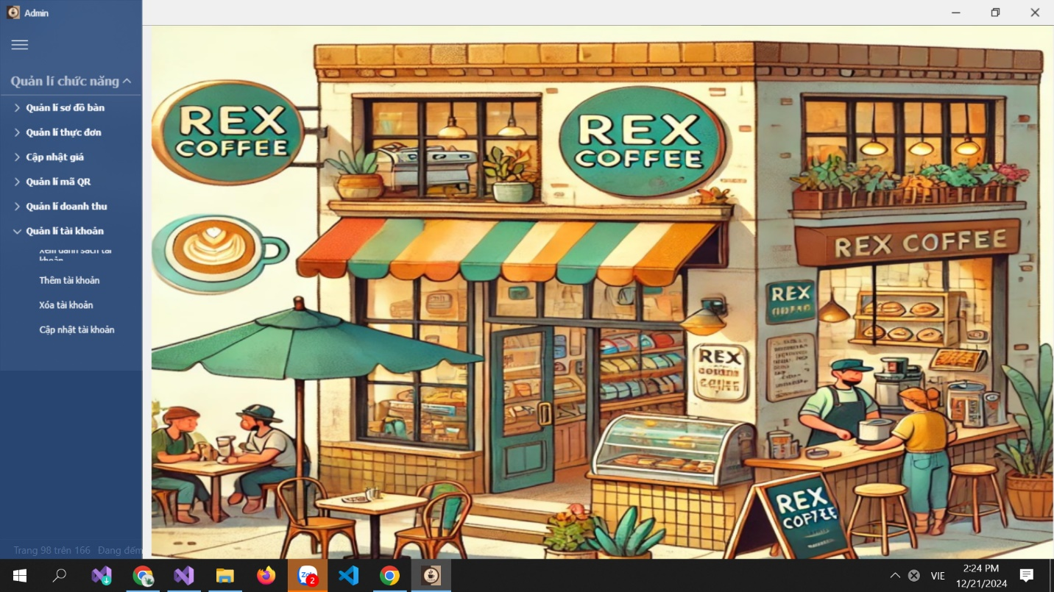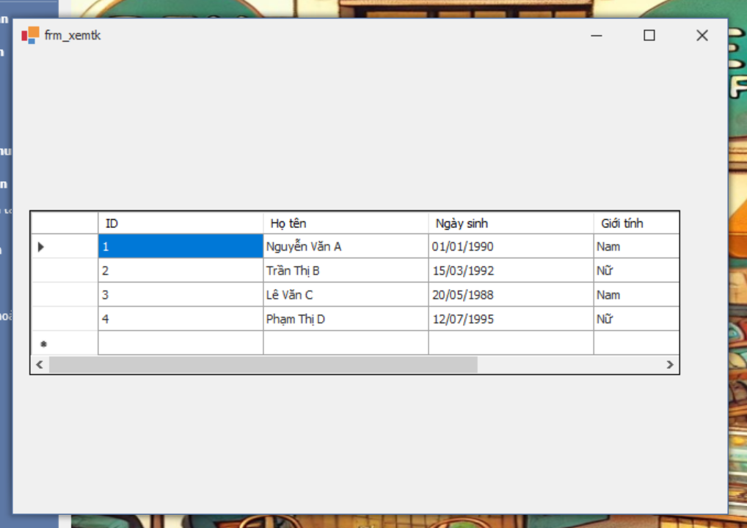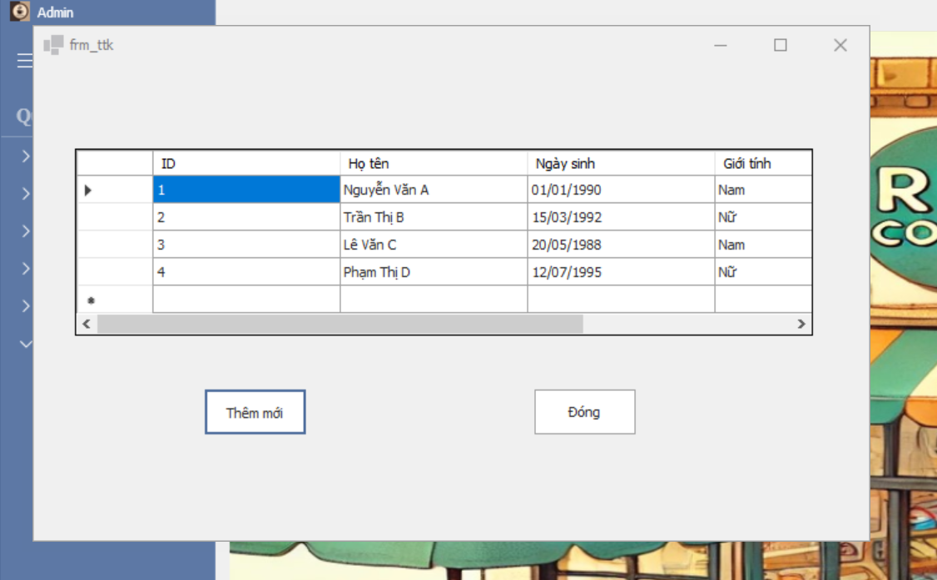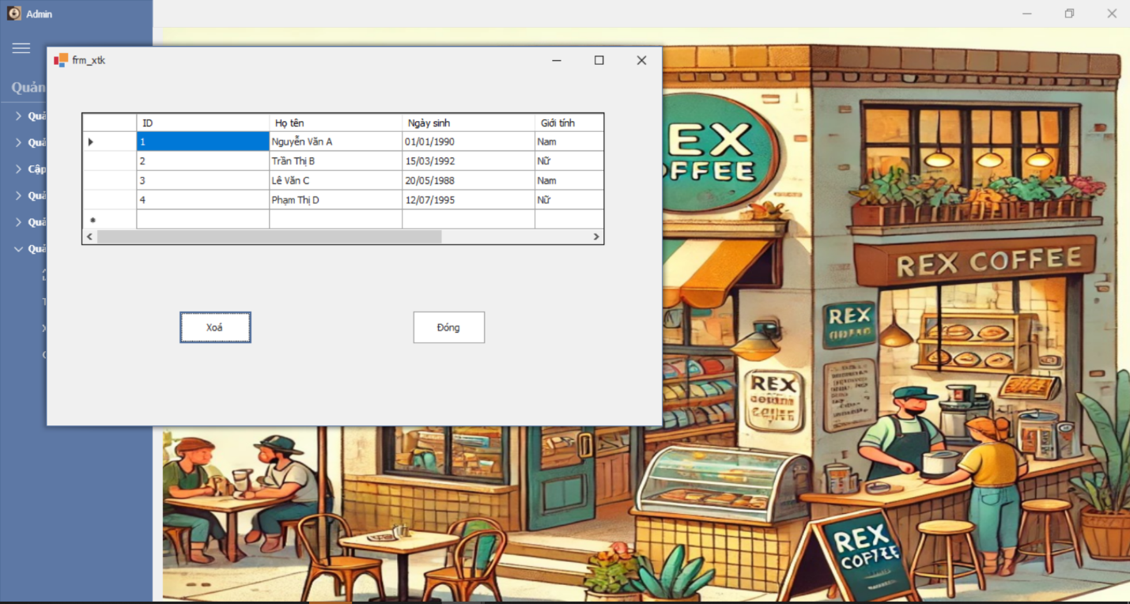

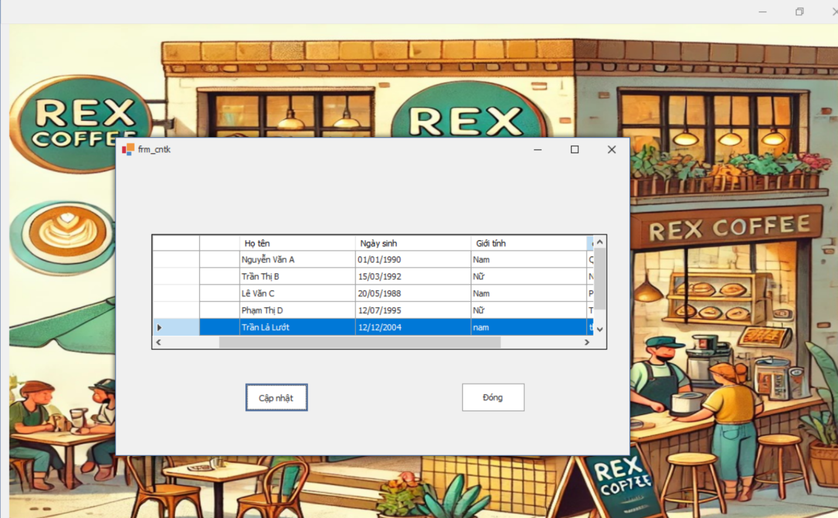

### *UC 23: Menu management*

|  |  |  |  |
| --- | --- | --- | --- |
| **Use Case ID** | UC.23 | | |
| **Use Case Name** | Menu management | | |
| **Created by** | Hien Nguyen | **Last updated by** | Hien Nguyen |
| **Date Created** | Oct 01, 2024 | **Date last updated** | Oct 05, 2024 |
| **Actors** | Admin. | | |
| **Brief Description** | The admin can view, add, edit, or delete menu items through the management system. | | |
| **Goal** | Ensure the menu is always up-to-date and accurate. | | |
| **Trigger** | Admin selects "Quản lí Menu" from the system menu. | | |
| **Pre-conditions** | Logged into system successfully.  The user has access rights to perform functions such as adding, editing, deleting, or viewing the menu list. | | |
| **Post-conditions** | Menu item information is successfully updated, added, or deleted. | | |
| **Main Flow A** | Main Flow A: View the List of Menu Items **Trigger:** Admin selects the tab to display the menu list.  **Result:** The system displays the current menu items. | | |
| **Step** | **Actor Action** | **System Response** |
| 1 | Admin selects "Menu Management" from the menu. | The system displays the list of menu items. |
| 2 | Admin selects an item from the list to view details. | The system retrieves the item's information. |
| 3 |  | The system displays the details of the selected item. |
| 4 | Admin finishes viewing the information and exits. |  |
| **Main Flow B** | Main Flow B: Add a New Menu Item **Trigger:** Admin clicks the "Add New Item" button.  **Result:** A new menu item is added and displayed in the menu list. | | |
| **Step** | **Actor Action** | **System Response** |
| 1 | Admin selects "Menu Management" from the menu. | The system displays the list of menu items. |
| 2 | Admin selects "Add New Item." | The system displays a form to enter new item details (name, price, description, status). |
| 3 | Admin fills in the required information in the form. | The system validates the data as it is entered. |
| 4 | Admin clicks "Save" after completing the form. | The system saves the new item to the database. |
| 5 |  | Displays the message: "New item added successfully." |
| 6 |  | Updates the menu list to display the new item. |
| 7 | Admin selects "Add New Item." | The system displays a form to enter new item details (name, price, description, status). |
| **Main Flow C** | Main Flow C: Delete a Menu Item **Trigger:** Admin selects "Delete" for a menu item from the list.  **Result:** The menu item is removed from the menu list. | | |
| **Step** | **Actor Action** | **System Response** |
| 1 | Admin selects "Menu Management" from the menu. | The system displays the list of menu items. |
| 2 | Admin selects an item to delete and clicks "Delete." | The system validates the input. |
| 3 |  | A confirmation dialog appears. |
| 4 | Admin confirms deletion by clicking "Yes" in the confirmation dialog. | The system deletes the item from the database. |
| 5 |  | Displays the message: "Item deleted successfully." |
| 6 |  | Updates the menu list to remove the deleted item. |
| **Main Flow D** | Main Flow D: Update Menu Item Information **Trigger:** Admin clicks "Edit" or "Update" for a menu item in the list.  **Result:** The menu item information is updated successfully. | | |
| **Step** | **Actor Action** | **System Response** |
| 1 | Admin selects "Menu Management" from the menu. | The system displays the list of menu items. |
| 2 | Admin selects an item to edit and clicks "Edit." | The system retrieves the item details. |
| 3 |  | The system displays a form with the item's current details. |
| 4 | Admin modifies the necessary fields. | The system validates the updated data. |
| 5 | Admin confirms changes by clicking "Update." | The system saves the changes to the database. |
| 6 |  | Displays the message: "Item updated successfully." |
| **Alternative Flow** | **Alternative flow : Admin leaves required fields blank when adding or editing a menu item.** | | |
| **Step** | **Actor Action** | **System Response** |
| 1 | Admin selects "Add New Item." | The system displays the form to enter new item details. |
| 2 | Admin omits required information or enters invalid data. | Displays error messages for invalid fields and prompts the user to correct them. |
| 3 | Admin corrects the errors and submits the data again. |  |
| **Exception Flow** | **Exception flow : local network connection lost.** | | |
| **Step** | **Actor Action** | **System Response** |
| 1 | Admin performs an operation (add, edit, delete). | The system cannot connect to the database and displays an error: "Unable to connect to the database. Please try again later." |
| 2 | Admin retries or exits. | The system attempts to reconnect or reverts to the previous state. |
| **Priority** | High | | |
| **Business Rule** | * All menu item data must be validated before saving. * Only authorized users can manage menu items. * Changes to the menu must be logged for auditing purposes | | |

**- Prototype**

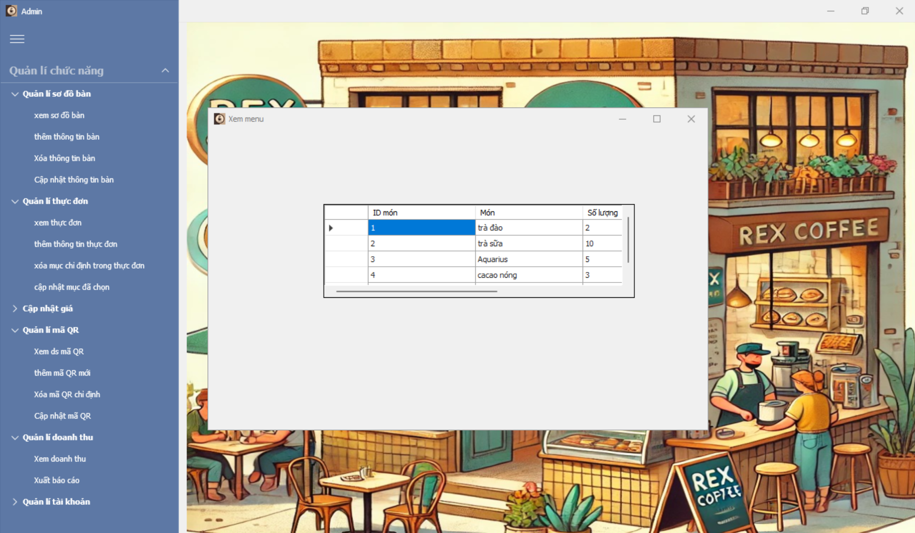

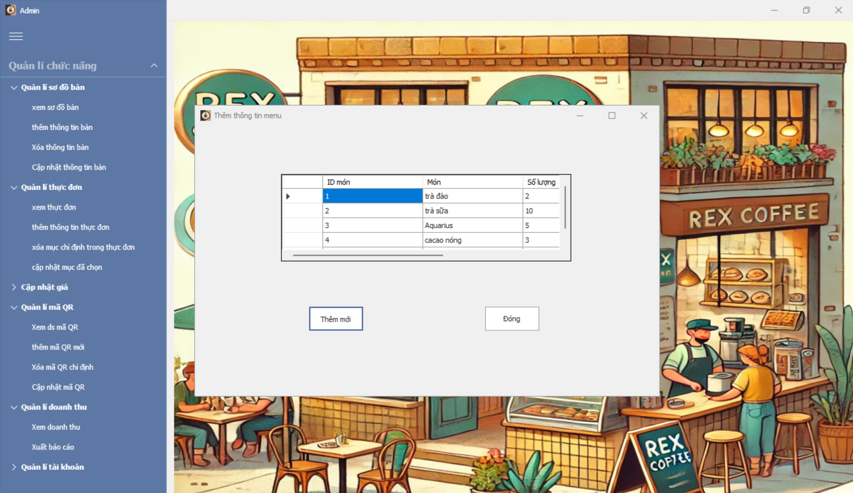

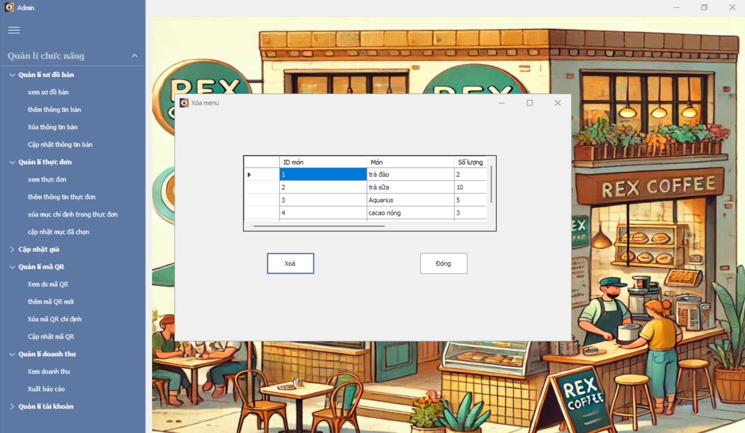

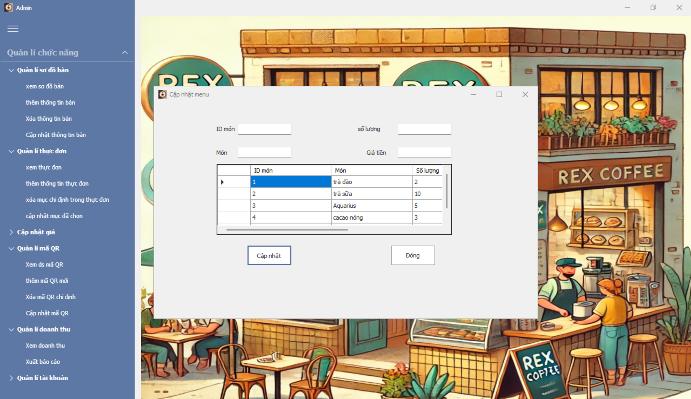

### *UC 24: Update price*

|  |  |  |  |
| --- | --- | --- | --- |
| **Use Case ID** | UC.24 | | |
| **Use Case Name** | Update price. | | |
| **Created by** | Hien Nguyen | **Last updated by** | Hien Nguyen |
| **Date Created** | Oct 01, 2024 | **Date last updated** | Oct 05, 2024 |
| **Actors** | Admin. | | |
| **Brief Description** | The admin can update the prices of menu items, including increasing prices for bestsellers or decreasing prices for items with low revenue. | | |
| **Goal** | Ensure menu item prices are reasonable, optimizing revenue and customer experience. | | |
| **Trigger** | Admin selects "Update Menu Item Price" from the system menu. | | |
| **Pre-conditions** | Logged into system successfully. | | |
| **Post-conditions** | Menu item prices are successfully updated, or no changes are made if the action is canceled. | | |
| **Main Flow A** | **A. View the List of Menu Items to Adjust Prices**  **Trigger**: Admin clicks the "**Menu Item List**" tab to view current price information.  **Result:** The system displays the list of menu items and their prices on the screen. | | |
| Step | Actor Action | System Response |
| 1 | Admin selects "Update Menu Item Price." | The system displays the list of menu items and their current prices. |
| 2 | Admin selects a specific item to adjust the price. | The system retrieves the current price of the selected menu item. |
| 3 | Admin completes adjustments or exits the process. |  |
| **Main Flow B** | **B. Increase the Price of a Specified Menu Item**  **Trigger:** Admin selects an item from the list and clicks "Increase Price."  **Result:** The menu item's price is increased and updated in the system. | | |
| **Step** | **Actor Action** | **System Response** |
| 1 | Admin selects "Update Menu Item Price." | The system displays the list of menu items and their current prices. |
| 2 | Admin selects an item from the list and clicks "Increase Price." | The system displays a form to enter the new price. |
| 3 | Admin enters the new price and clicks "Confirm." | The system validates the new price. |
| 4 |  | The system saves the new price to the database. |
| 5 |  | Displays a message: "Price updated successfully." |
| 6 |  | The system updates the menu item list to show the new price. |
| **Main Flow C** | Main Flow C: Decrease the Price of Less Popular Menu Items **Trigger:** Admin selects a low-revenue item and clicks "Decrease Price."  **Result:** The less popular item's price is reduced and updated in the system. | | |
| **Step** | **Actor Action** | **System Response** |
| 1 | Admin selects "Update Menu Item Price." | The system displays the list of menu items and their current prices. |
| 2 | Admin selects an item to decrease the price and clicks "Decrease Price." | The system displays a form to enter the new price. |
| 3 | Admin enters the new price and clicks "Confirm." | The system validates the new price. |
| 4 |  | The system saves the new price to the database. |
| 5 |  | Displays a message: "Price updated successfully." |
| 6 |  | The system updates the menu item list to show the new price. |
| **Alternative Flow** | Alternative Flow: **Scenario:** Admin enters an invalid price (e.g., a negative price or leaves the price field empty). | | |
| **Step** | **Actor Action** | **System Response** |
| 1 | Admin selects "Update Price" for a menu item. | The system displays a form to input the new price (name, price, description, status). |
| 2 | Admin enters incomplete information or an invalid price format. | Displays an error message for invalid fields and prompts the user to re-enter valid information. |
| 3 | Admin corrects the information and continues saving the data. |  |
| **Exception Flow** | **Exception flow : local network connection lost.** | | |
| **Step** | **Actor Action** | **System Response** |
| 1 | Admin clicks "Confirm" after entering the new price. | The system cannot connect to the database and displays an error: "Unable to connect to the database. Please try again later." |
| 2 | Admin retries or exits the process. | The system attempts to reconnect or returns to the previous state. |
| **Priority** | High | | |
| **Business Rule** | * Menu item prices must be positive numbers. * The new price must differ from the current price. * Price change history must be stored for tracking purposes. | | |

**- Prototype**

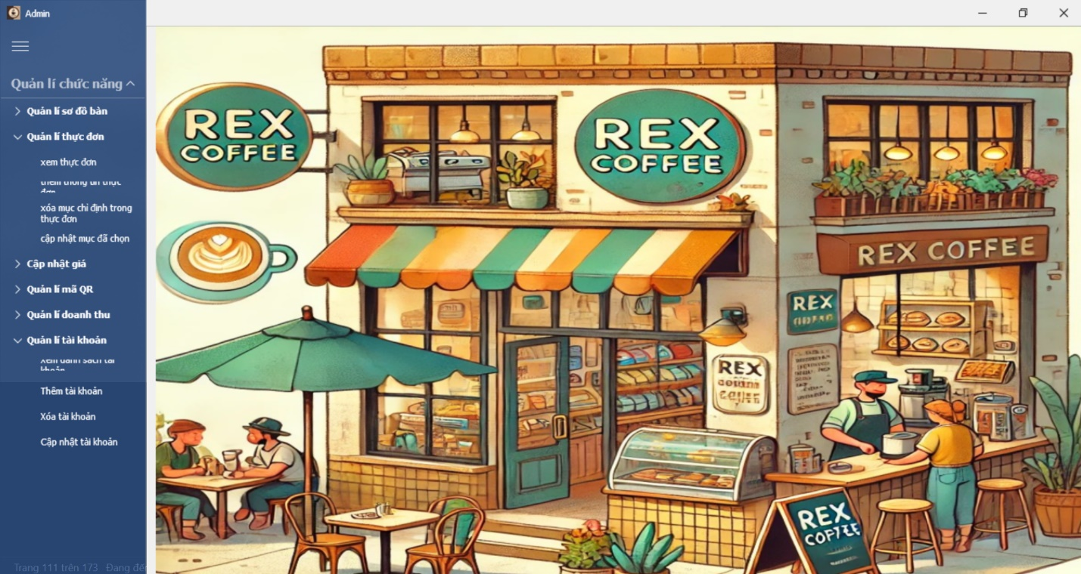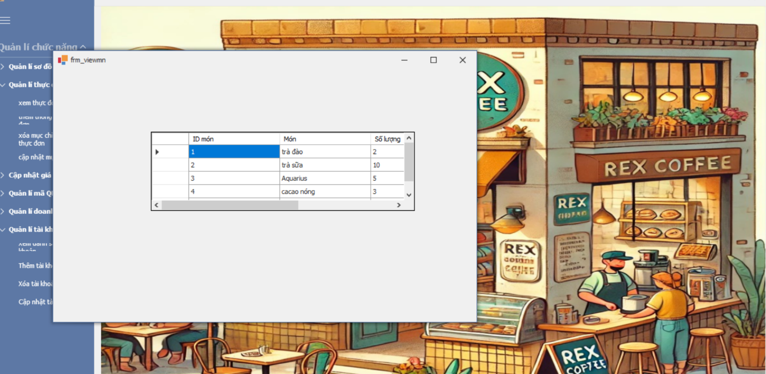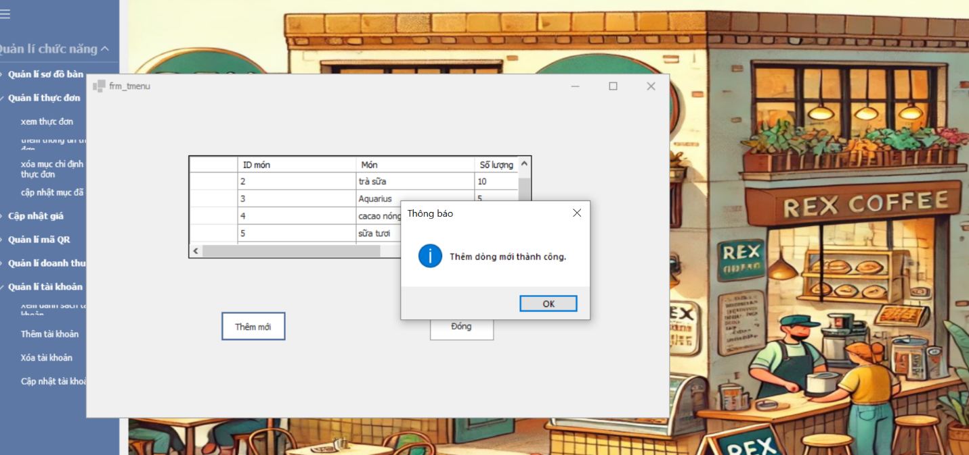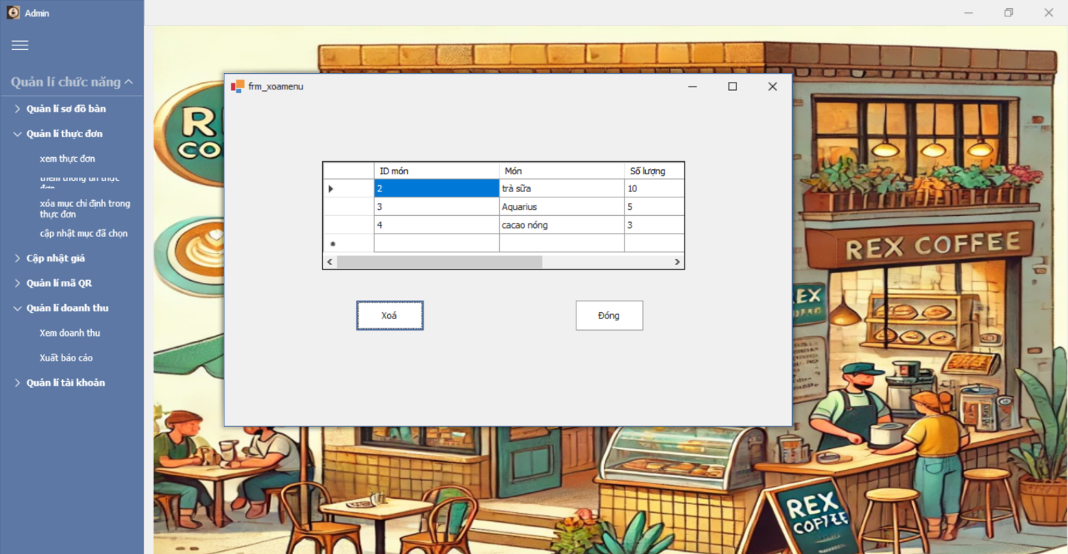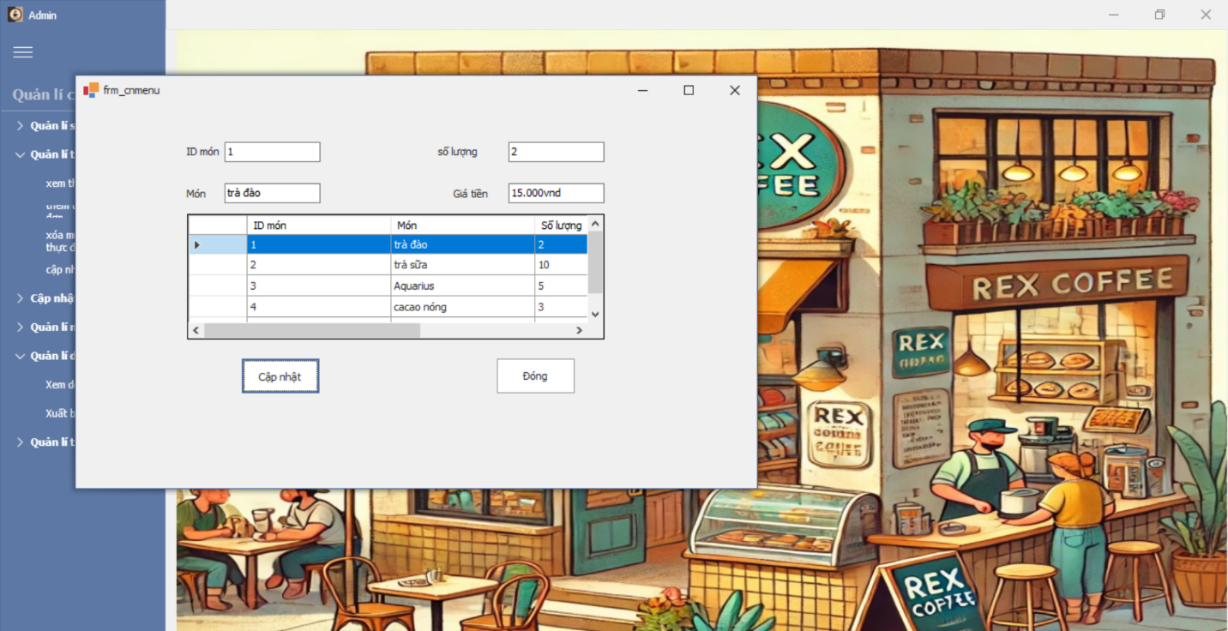

### *UC 25: Revenue management*

|  |  |  |  |
| --- | --- | --- | --- |
| **Use Case ID** | UC.25 | | |
| **Use Case Name** | Revenue Management | | |
| **Created by** | Hien Nguyen | **Last updated by** | Hien Nguyen |
| **Date Created** | Oct 01, 2024 | **Date last updated** | Oct 05, 2024 |
| **Actors** | Admin. | | |
| **Brief Description** | The admin can view and filter revenue by time, export revenue reports, and view detailed transactions. | | |
| **Goal** | Support effective revenue management to optimize business strategies. | | |
| **Trigger** | Admin selects "Revenue Management" from the system menu. | | |
| **Pre-conditions** | Successfully logged into the system.  The user has access rights to perform functions such as viewing, filtering revenue by time, exporting revenue reports, and viewing transaction details. | | |
| **Post-conditions** | Revenue data is displayed, or reports are successfully exported. | | |
| **Main Flow A** | Main Flow A: View Revenue Overview **Trigger:** Admin selects "View Revenue."  **Result:** The system displays a revenue overview on the screen. | | |
| Step | Actor Action | System Response |
| 1 | Admin accesses the revenue section from the homepage. | The system navigates the user to the revenue page. |
| 2 | Admin selects "View Revenue" from the menu. | The system displays an overview of revenue (daily/monthly). |
| 3 | Admin filters revenue by day, month, or time range. | The system validates the input details. |
| 4 |  | The system displays the filtered transaction information. |
| 5 | Admin selects a specific transaction to view details. | The system displays detailed information about the selected transaction. |
| **Main Flow B** | Main Flow B: Export Revenue Report **Trigger:** Admin clicks the "Export Report" button.  **Result:** A revenue report is successfully generated and downloaded. | | |
| Step | Actor Action | System Response |
| 1 | Admin accesses the revenue section from the homepage. | The system navigates the user to the revenue page. |
| 2 | Admin selects "Export Report" on the revenue interface. | The system displays a form to select the report type (daily/monthly). |
| 3 | Admin chooses a time range and report format (PDF, Excel). | The system validates the data and begins generating the report. |
| 4 | Admin clicks "Confirm" to export the report. | The system generates the report and displays a success notification. |
| 5 |  | The report is downloaded or emailed (if selected). |
| **Alternative Flow** | Alternative Flow **Admin does not select criteria or enters an invalid time range.** | | |
|  | Step | Actor Action | System Response |
| 1 | Admin selects "View Revenue" from the menu. | The system displays an overview of revenue (daily/monthly). |
| 2 | Admin selects criteria or enters an invalid time range. | Displays an error message for invalid fields and prompts the user to re-enter valid information. |
| 3 | Admin corrects the information and continues to save the data. |  |
| **Exception Flow** | **Exception flow : local network connection lost.** | | |
| Step | Actor Action | System Response |
| 1 | Admin performs an action (filtering, exporting reports). | The system cannot connect to the database and displays an error: "Unable to connect to the database. Please try again later." |
| 2 | Admin retries or exits the process. | The system attempts to reconnect or returns to the previous state. |
| **Priority** | High | | |
| **Business Rule** | * The system must allow filtering revenue by at least three criteria: date, month, and transaction type. * Revenue reports must support popular formats (PDF, Excel). * Store the history of exported reports for traceability. | | |

**- Prototype**

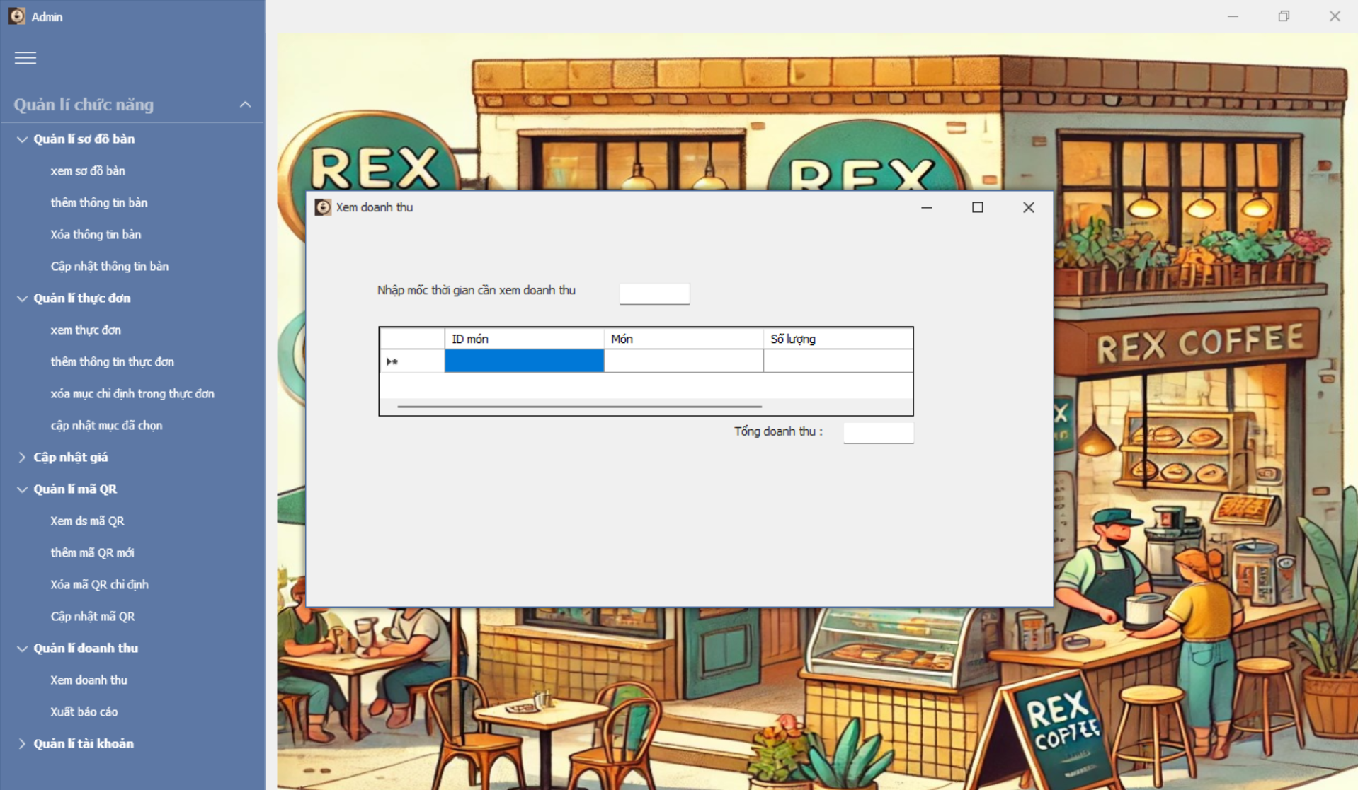

### *UC 26: Manage Desk layout*

|  |  |  |  |  |  |
| --- | --- | --- | --- | --- | --- |
| **Use Case ID** | UC.26 | | | | |
| **Use Case Name** | Manage Desk Layouts. | | | | |
| **Created by** | Hien Nguyen | **Last updated by** | | | Hien Nguyen |
| **Date Created** | Oct 01, 2024 | **Date last updated** | | | Oct 05, 2024 |
| **Actors** | Quản trị viên (Admin). | | | | |
| **Brief Description** | The user (administrator) can add new, edit, delete, or view desk layouts. | | | | |
| **Goal** | Facilitate effective desk layout management by setting up, editing, and deleting desk arrangements. | | | | |
| **Pre-conditions** | The user (Admin or HR Staff) has logged into the system.  The user has access rights to perform functions related to desk layouts. | | | | |
| **Post-conditions** | Desk layout information is updated in the system.  The system accurately reflects the latest status of the desk layout after adding, editing, or deleting operations. | | | | |
| **Main Flow A** | **A. View Desk Layout**  **Trigger:** The user clicks on the desk layout tab to display the current arrangement.  **Result:** The user can view the complete or filtered list of the displayed desk layouts. | | | | |
| **Step** | | **Actor Action** | **System Response** | |
| **1** | | Navigate to the "Manage Desk Layout" page from the dashboard. | Displays the desk layout interface with established desks and options to add, edit, and delete. | |
| **2** | | Filter or search for desks using criteria such as desk ID. | |  | | --- | |  |      |  | | --- | | Checks if the input information is valid. | | |
| **3** | |  | Displays the desk list based on search or filter criteria. | |
| **Main Flow B** | **B. Add New Desk Layout**  **Trigger:** The user clicks the "Add New" button to create a new desk.  **Result:** A new desk is successfully created and displayed in the desk layout list. | | | | |
| **Step** | | **Actor Action** | **System Response** | |
| **1** | | Navigate to the "Manage Desk Layout" page from the dashboard. | Displays the desk layout interface with established desks and options to add, edit, and delete. | |
| **2** | | Click the "Add New" button on the desk layout management interface. | Displays the form to create a new desk, including fields such as QR code, position, size, etc. | |
| **3** | | Enter necessary information into the form. | Validates the data (e.g., the QR code must be unique). | |
| **4** | | Click the "Save" button after completing data entry. | Confirms that all fields are valid and error-free. | |
| **5** | |  | Saves the new desk layout information to the database. | |
| **6** | |  | Displays a notification: "Desk successfully added." | |
| **7** | |  | Updates the interface to display the new desk layout. | |
| **Main Flow C** | **C. Edit Desk Layout**  **Trigger:** The user clicks the "Edit" button to modify desk information.  **Result:** Desk layout information is successfully updated and displayed in the desk layout list. | | | | |
| **Step** | | **Actor Action** | **System Response** | |
| 1 | | Navigate to the "Manage Desk Layout" page from the dashboard. | Displays the desk layout interface with established desks and options to add, edit, and delete. | |
| 2 | | Find the desk to be edited in the list and click the "Edit" button. | Displays the form to edit desk information. | |
| 3 | | Modify necessary fields (e.g., position, QR code, or start date of desk booking). | Validates the entered data. | |
| 4 | |  | Confirms that all edited fields are valid and error-free. | |
| 5 | | Click the "Update" button to save changes. | Updates the desk layout information in the database. | |
| 6 | |  | Displays a notification: "Desk layout updated successfully." | |
| 7 | |  | Updates the interface to reflect the new information. | |
| **Main Flow D** | Main Flow D: Delete Desk **Trigger:** The user selects a desk from the layout, double-clicks its information, and clicks the delete button to remove the desk from the system.  **Result:** The specified desk is successfully removed from the system. | | | | |
| **Step** | | **Actor Action** | **System Response** | |
| 1 | | Navigate to the "Manage Desk Layout" page from the dashboard. | Displays the desk layout interface with established desks and options to add, edit, and delete. | |
| 2 | | Find the desk to be deleted in the list and click the "Delete" button. | Displays a confirmation dialog for deletion. | |
| 3 | | Confirm deletion by clicking "Agree" in the confirmation dialog. | Checks the validity of the desk list. | |
| 4 | |  | If the record can be deleted, the system removes the specified desk from the database. | |
| 5 | |  | Displays a notification: "Desk successfully deleted." | |
| 6 | |  | Updates the desk layout list to exclude the deleted record. | |
| **Alternative Flow** | **Luồng phụ 1:** Incomplete Information for Adding or Editing | | | | |
| **Step** | | **Actor Action** | **System Response** | |
| 1 | | Click the "Add New" button on the interface. | Displays the form to create a new desk, including fields like QR code, position, size, etc. | |
| 2 | | Fails to fill in required fields or enters incorrect formats. | Displays an error message for invalid fields and prompts the user to re-enter correct information. | |
| 3 | | Correct the information as required and continue saving. |  | |
| **Alternative Flow** | **Step** | | **Actor Action** | **System Response** | |
|  | 3 | | Adding, editing, or deleting desks. | Fails to connect to the database during saving or deletion. | |
| 4 | |  | Displays an error message: "Unable to connect to the database. Please try again later." | |
| 5 | | Wait and try again when the system is back online. |  | |
| **Priority** | High | | | | |
| **Business Rule** | * Desk ID must be unique. * Deleting desk records must be carefully verified to ensure the deleted record does not affect other processes. | | | | |

**- Prototype**

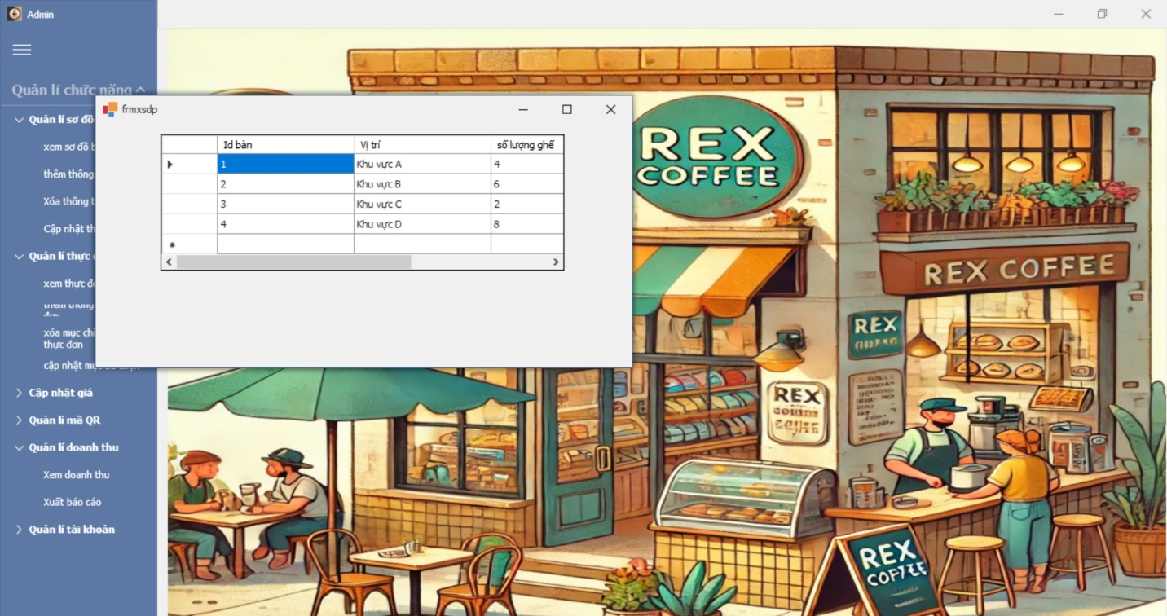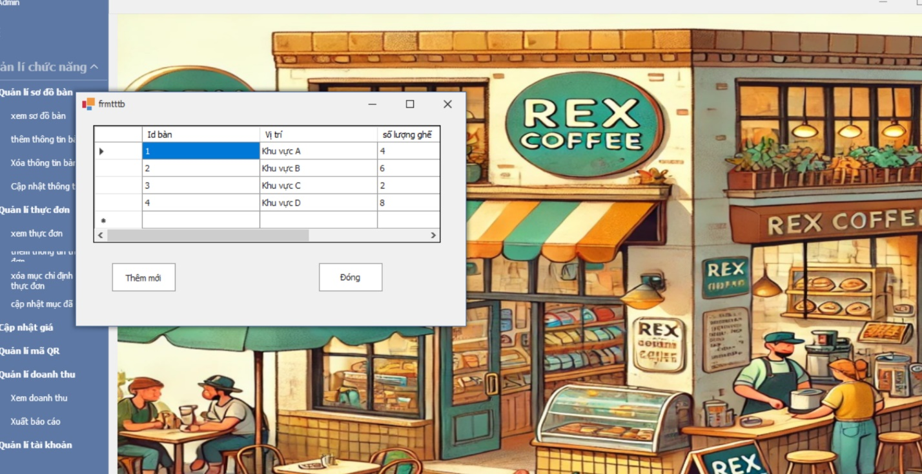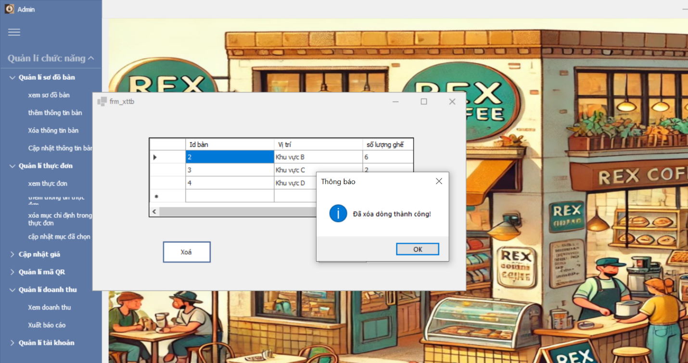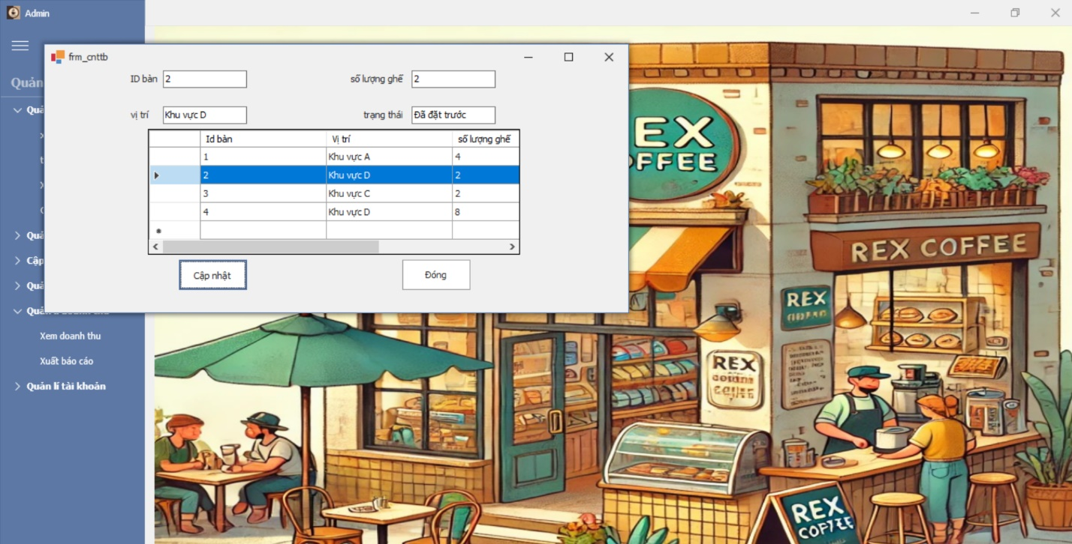

### *UC 27: Manage QR codes for each table.*

|  |  |  |  |
| --- | --- | --- | --- |
| **Use Case ID** | UC.27 | | |
| **Use Case Name** | Manage QR Codes for Each Table | | |
| **Created by** | Hien Nguyen | **Last updated by** | Hien Nguyen |
| **Date Created** | Oct 01, 2024 | **Date last updated** | Oct 05, 2024 |
| **Actors** | Administrator (Admin) | | |
| **Brief Description** | The user (Admin) can create, edit, delete, and view QR Codes for each workspace table. QR Codes contain information linked to the respective table, enabling quick access to table details. | | |
| **Goal** | To create and manage QR Codes for each workspace table for easy access to information | | |
| **Pre-conditions** | The user has logged into the system.  The user has permissions to perform functions such as creating, editing, deleting, or viewing the list of QR Codes for each table. | | |
| **Post-conditions** | QR Codes are created and linked to their respective tables.  The system reflects the latest status of QR Codes for each table. | | |
| **Main Flow A** | **A. Viewing the List of QR Codes**  **Trigger**: The user navigates to the QR Code tab on the workspace management interface.  **Kết quả**: The user can view a complete or filtered list of QR Codes for each table. | | |
| **Step** | **Actor Action** | **System Response** |
| **1** | Navigate to the "Manage QR Codes" page from the dashboard. | Display the current list of QR Codes with table IDs and options to add, edit, or delete. |
| **2** | Filter or search QR Codes by table ID or status. | Validate input criteria. |
| **3** |  | Display the list of QR Codes matching the filter/search criteria. |
| **Main Flow B** | **B. Creating a New QR Code**  **Trigger**: **The user clicks the "Tạo mới QR code" button.**  **Kết quả**: **A new QR Code is successfully created and displayed in the list of table QR Codes.** | | |
| **Step** | **Actor Action** | **System Response** |
| **1** | Navigate to the "Manage QR Codes" page from the dashboard. | Display the current list of QR Codes with table IDs and options to add, edit, or delete. |
| **2** | Click the "Create New" button on the QR Code management interface. | Display a form allowing the user to select a workspace table for the QR Code. |
| **3** | Select a table from the table layout to input the table ID. | Verify that the table exists in the database. |
| **4** |  | Confirm all fields are valid and error-free. |
| **5** | Click the "Create QR Code" button. |  |
| **6** |  | Save the new QR Code information to the database. |
| **7** |  | Display a notification: "QR Code created successfully." |
| **8** |  | Update the list of QR Codes with the newly created QR Code. |
| **Main Flow C** | **C. Editing a QR Code**  **Trigger: The user double-clicks on a QR Code they wish to edit.**  **Result: The table's QR Code information is successfully edited and displayed in the list.** | | |
| **Step** | **Actor Action** | **System Response** |
| **1** | Navigate to the "Manage QR Codes" page from the dashboard. | |  | | --- | | Display the current list of QR Codes with table IDs and options to add, edit, or delete. |      |  | | --- | |  | |
| **2** | Find the QR Code to edit and click the "Edit" button. | Display the QR Code edit form. |
| **3** | Make the necessary changes (if any). | Validate the input and apply changes. |
| **4** | Click the "Update" button. | Confirm all edited fields are valid and error-free. |
| **5** |  | Update the information in the database. |
| **6** |  | Display a notification: "QR Code updated successfully." |
| **7** |  | Update the QR Code list to reflect the latest changes. |
| **Main Flow D** | **D Deleting a QR Code**  **Trigger**: **The user selects a table's QR Code to delete, double-clicks it, and clicks the delete button to remove it from the system**.  **Result**: **The QR Code is successfully deleted from the system.** | | |
| **Step** | **Actor Action** | **System Response** |
| **1** | Navigate to the "Manage QR Codes" page from the dashboard. | Display the current list of QR Codes with table IDs and options to add, edit, or delete. |
| **2** | Select the QR Code to delete and click the "Delete" button. | Display a confirmation dialog for the deletion. |
| **3** | Confirm deletion by clicking "Agree" in the confirmation dialog. | Validate constraints and delete the QR Code from the database. |
| **4** |  | If the QR Code can be deleted, remove its record from the database. |
| **5** |  | Display a notification: "QR Code deleted successfully." |
| **6** |  | Update the QR Code list to no longer display the deleted QR Code. |
| **Alternative Flow** | **Luồng phụ 1: Not Selecting a Table While Creating a QR Code.** | | |
| **Step** | **Actor Action** | **System Response** |
| **1** | Click the "Create New" button on the QR Code management interface. | Display a form allowing the user to select a workspace table for the QR Code. |
| **2** | Do not select a table from the table layout to input the table ID. | Display an error message for invalid fields and prompt the user to enter valid information. |
| **3** | Correct the information as prompted and proceed to save. | Confirm all fields are valid and error-free. |
| **Exception Flow** | **Luồng ngoại lệ: System Loses Connection to the Database** | | |
| **Step** | **Actor Action** | **System Response** |
| 3 | (Create, edit, delete, or view existing QR Codes) | Unable to connect to the database during save or delete operations. |
| 4 |  | Display an error message: "Unable to connect to the database. Please try again later." |
| 5 | Wait and retry when the system becomes available. |  |
| **Priority** | High | | |
| **Business Rule** | * Table IDs must be unique. * QR Codes cannot be deleted if the linked table is active or used in other processes. * eating a workspace table must ensure it does not affect overall layout or related data. | | |

**- Prototype**

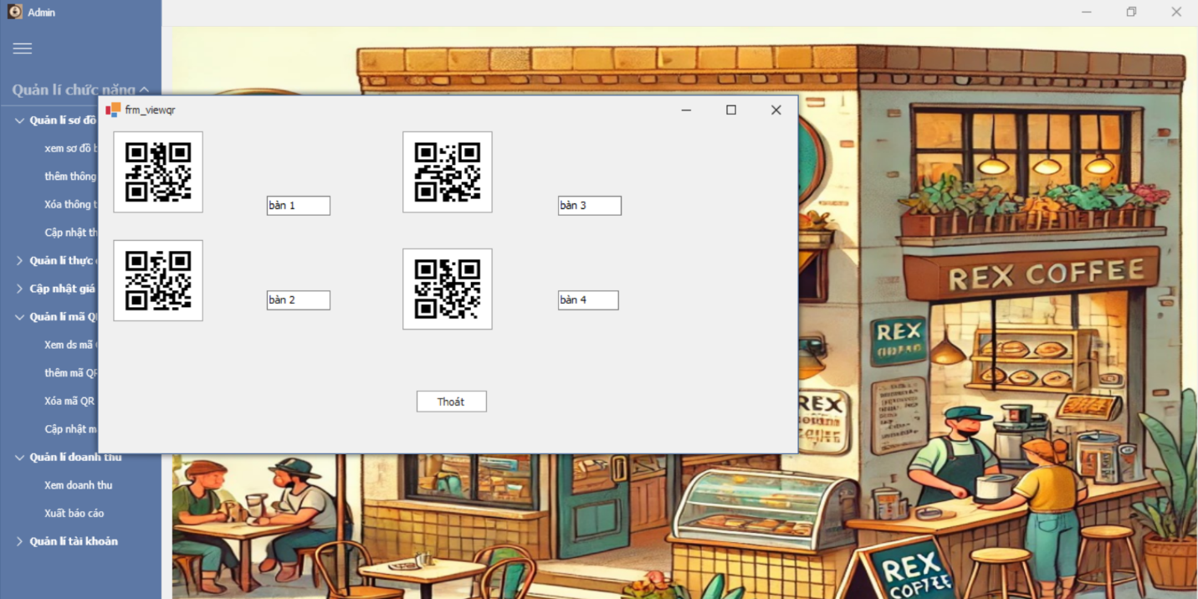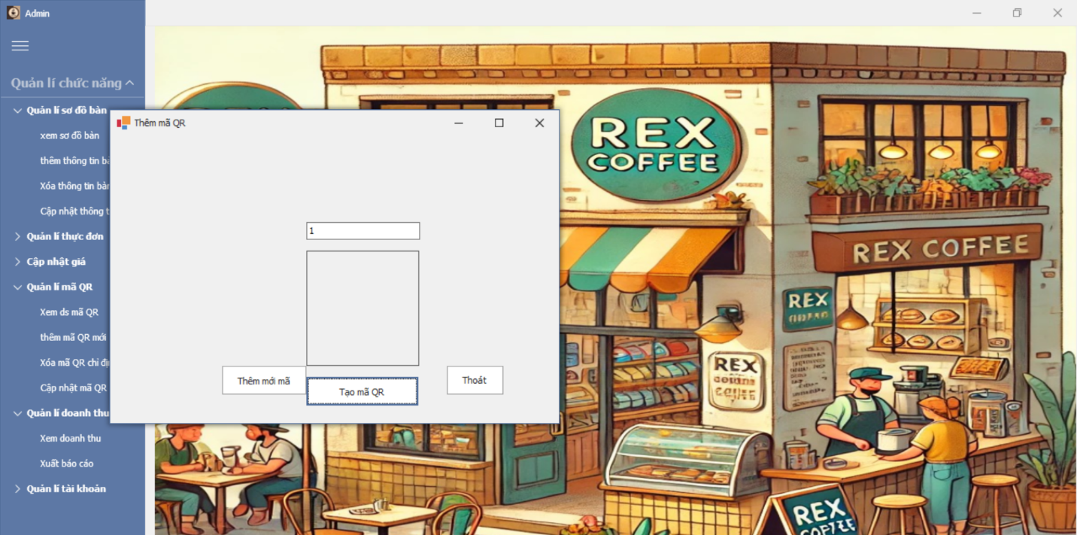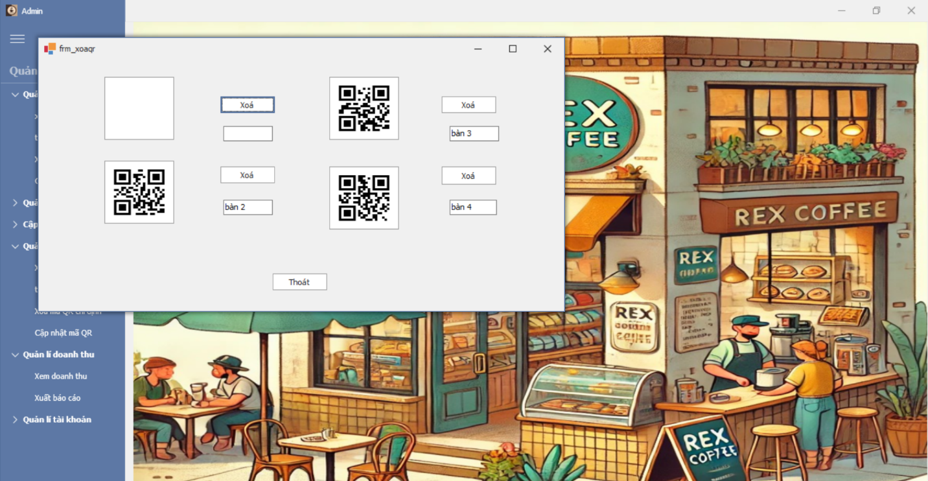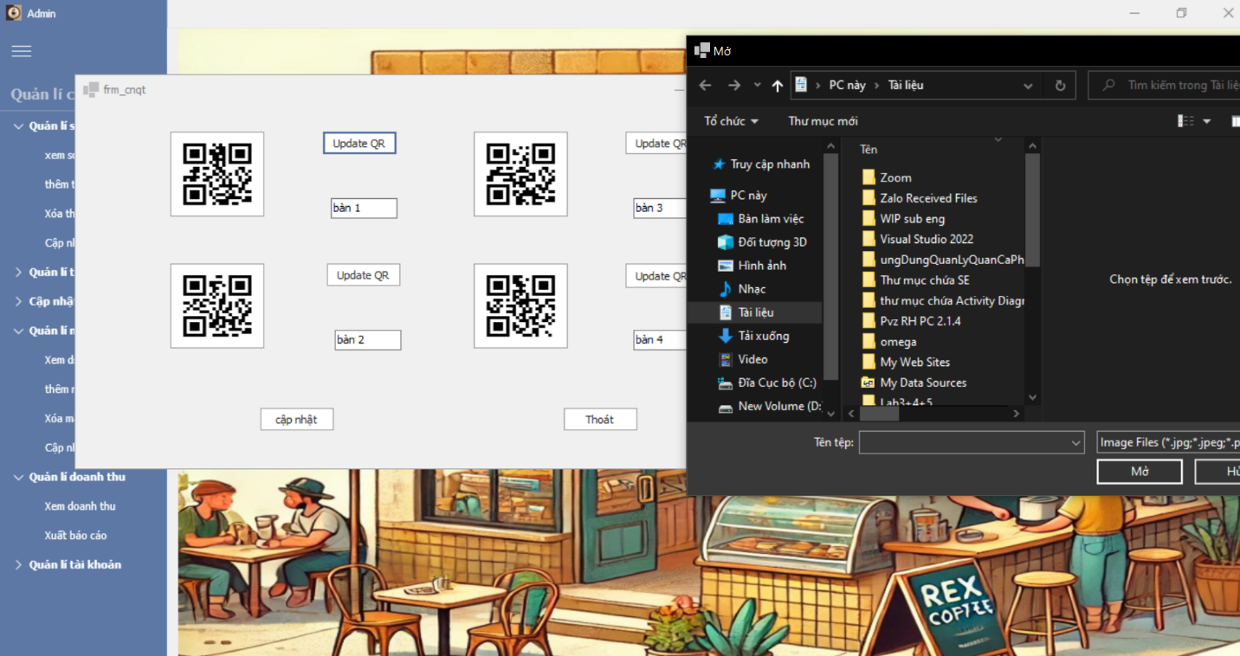

## Software Quality Attributes

## Usability

**GUI**

- All the text, image text and help documents should be in Vietnamese.

- The interface should be elegant, simple and out‐standing.

**Usability**

- Users(customers) can use main functionality of the system without logging in to the system.

- The operating process is designed to be simple to minimize errors and increase working speed.

The user interface is friendly and easy to understand, allowing employees (such as cashiers, waiters, managers) to use it effectively.

## Reliability

- Initial data must be collected carefully and correctly

- The database must be backed up regularly and can be recovered if necessary

- Not conflict with other software

- The system must operate stably in the environment where operations are executed, even during high periods of time.

## Security

- Privacy: the system should provide protection method for protecting user information from

outside or from other users. All the information of users must not be available for anyone or

software that is not part of the system. User password is also invisible for the system

administrator.

- The system must provide secure methods for users to retrieve passwords, including

system administrator intervention.

## Maintainability

**Coding standards and naming conventions**

- Output of the project must include coding standards and naming conventions

documentations. Implementation code must be easy to maintain.

- All code must be clearly commented, including class, method documentations.

- If some components are reused, the documentations of those components must also be

included.

- The source code is written in a way that is easy to understand and easy to update when changes occur.

**Logging**

- All the errors should be logged, supporting for bug fixing and maintenance.

## Performance

- Every page should be completely displayed within: average 1.5 second and maximum 5

seconds.

- Searching should return and display the result within 2 seconds.

- Frequently accessed data must be cached

- Ability to process multiple concurrent transactions in high time without affecting performance.

## Software Design Description

## Sequence Diagrams

### Scan QR code

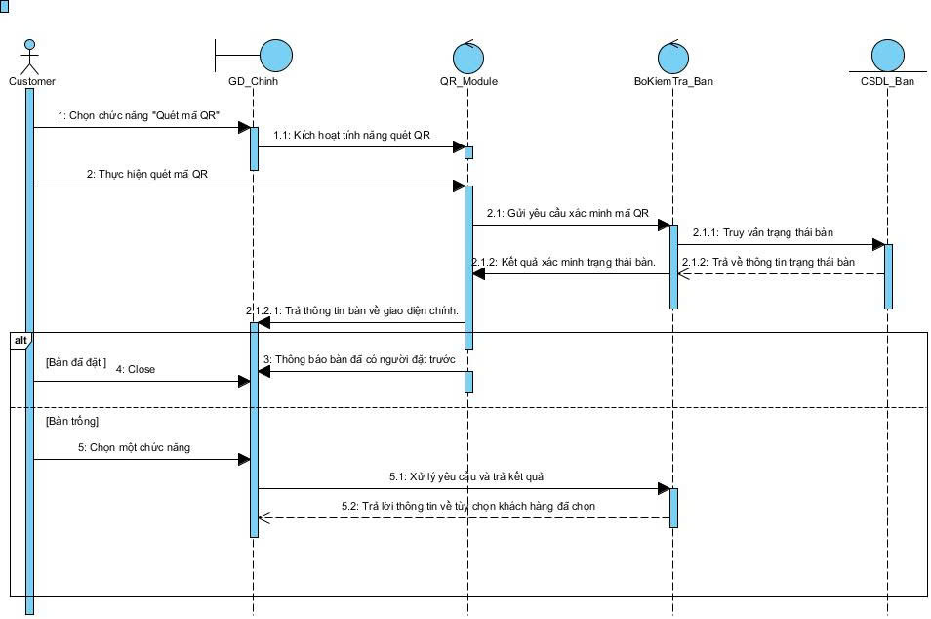

### View menu

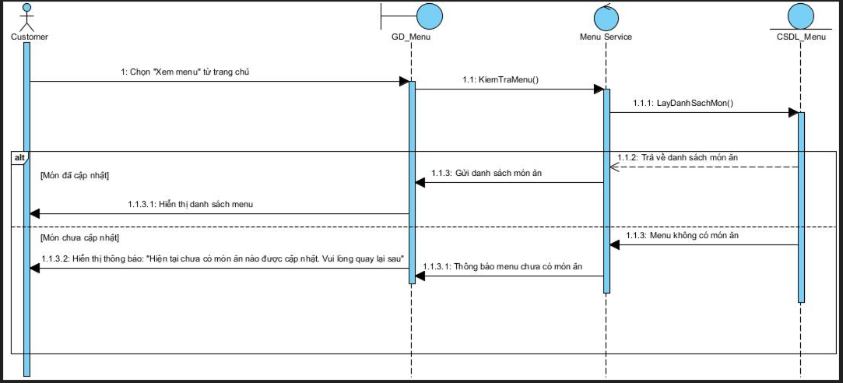

### Order

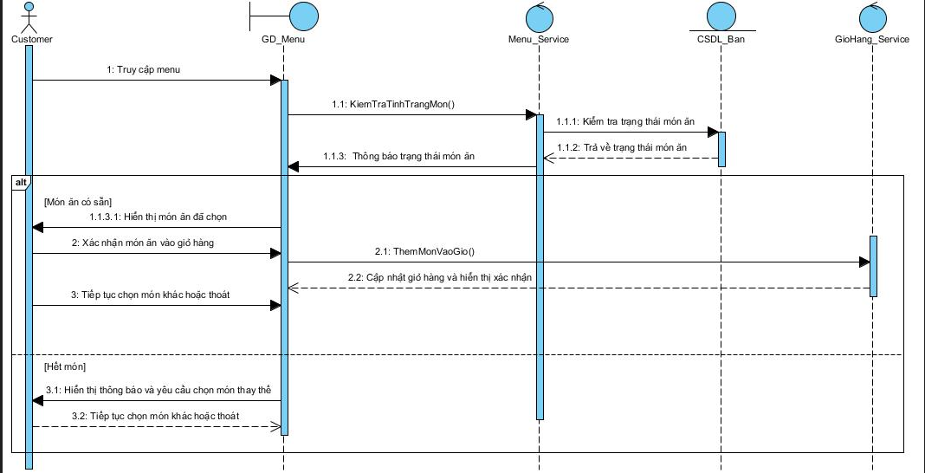

### View order status

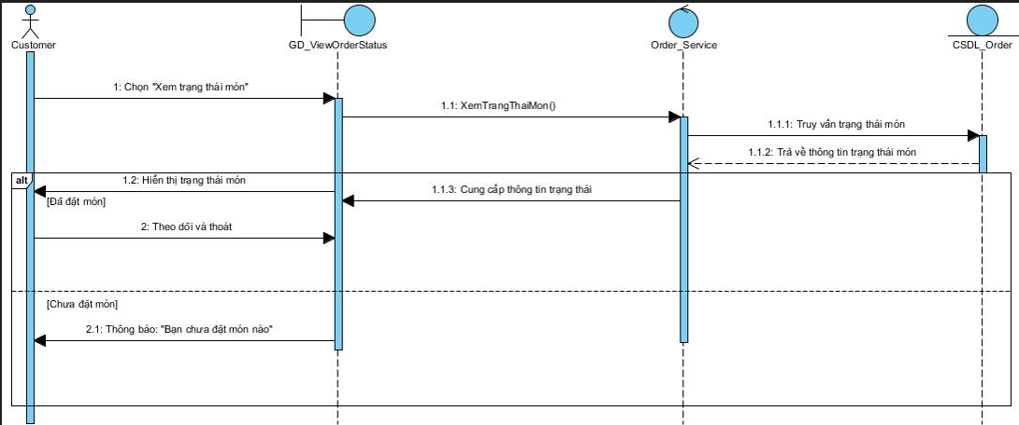

### Cancel the dish

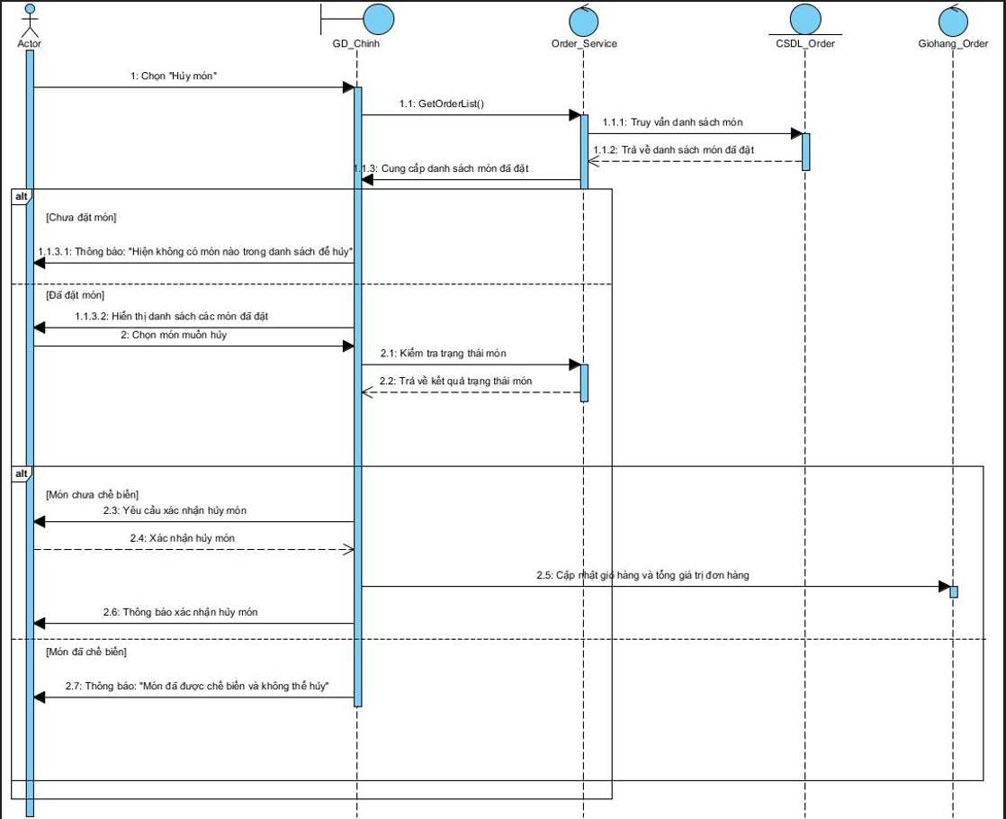

### Payment

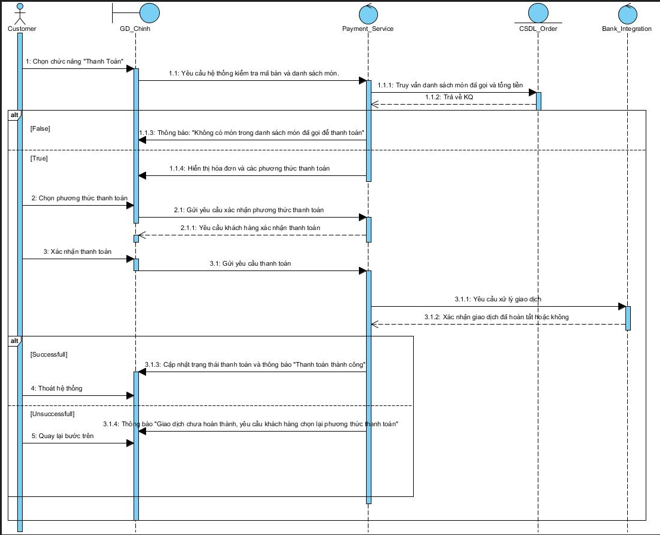

### Book

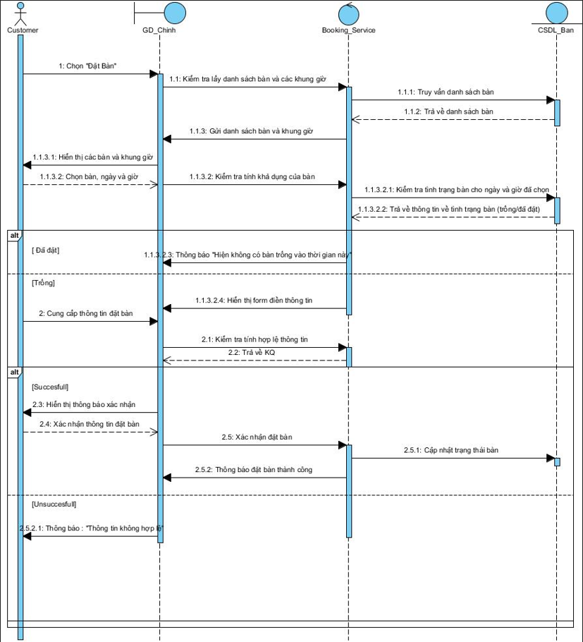

### Login (Waiter)

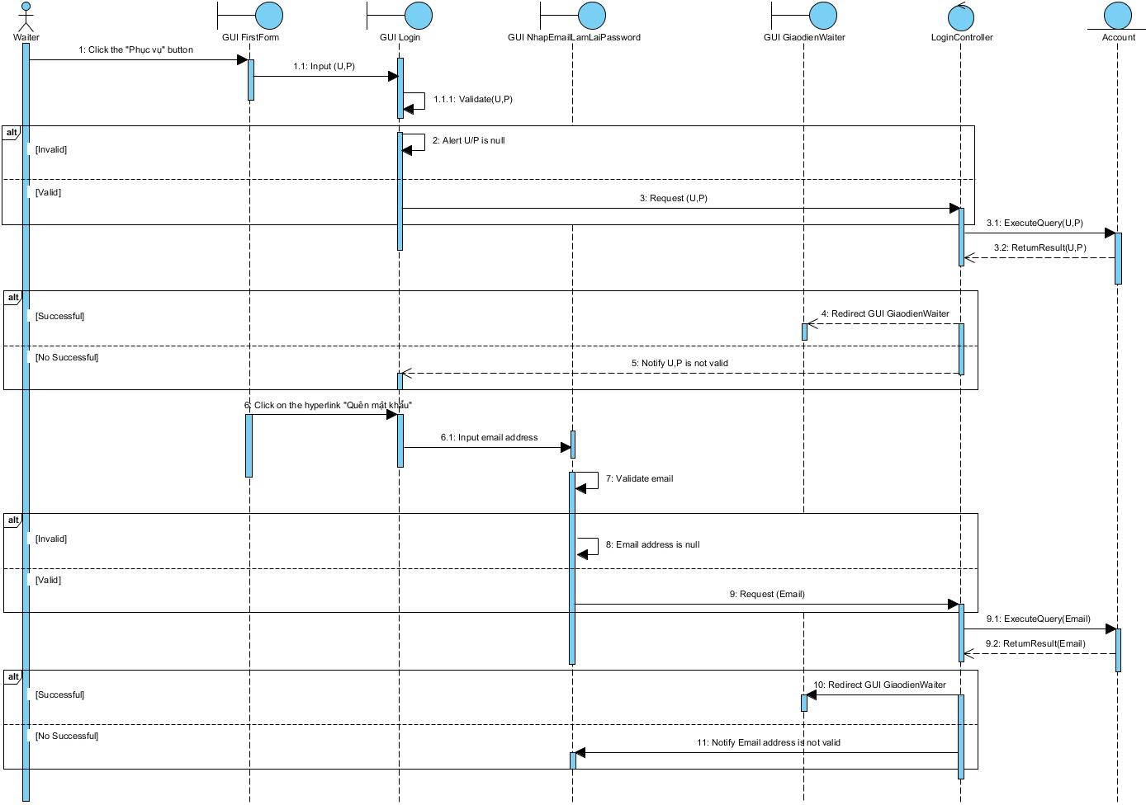

### Receive service notifications

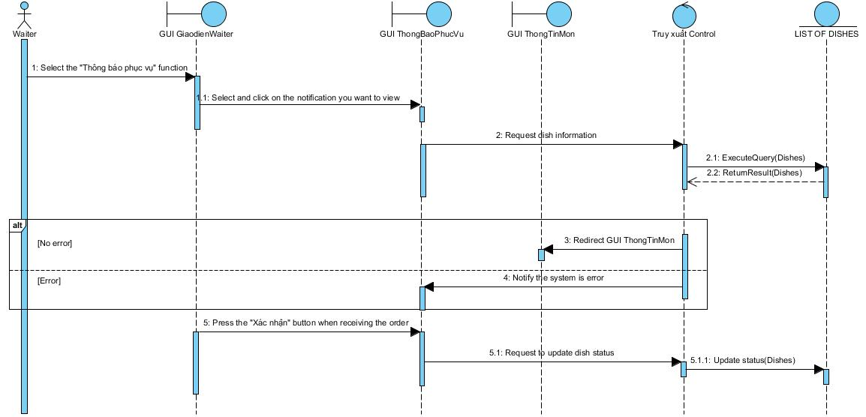

### View order status

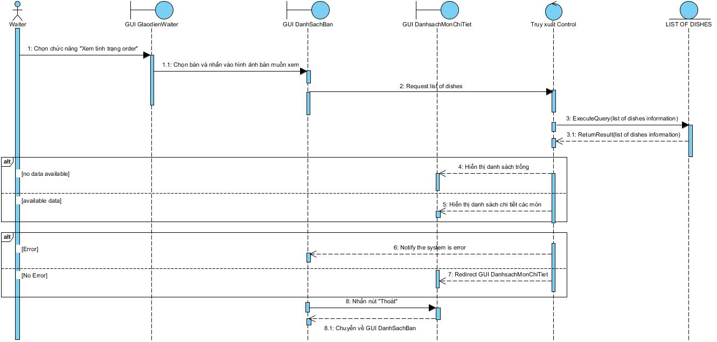

### Login (Barista)

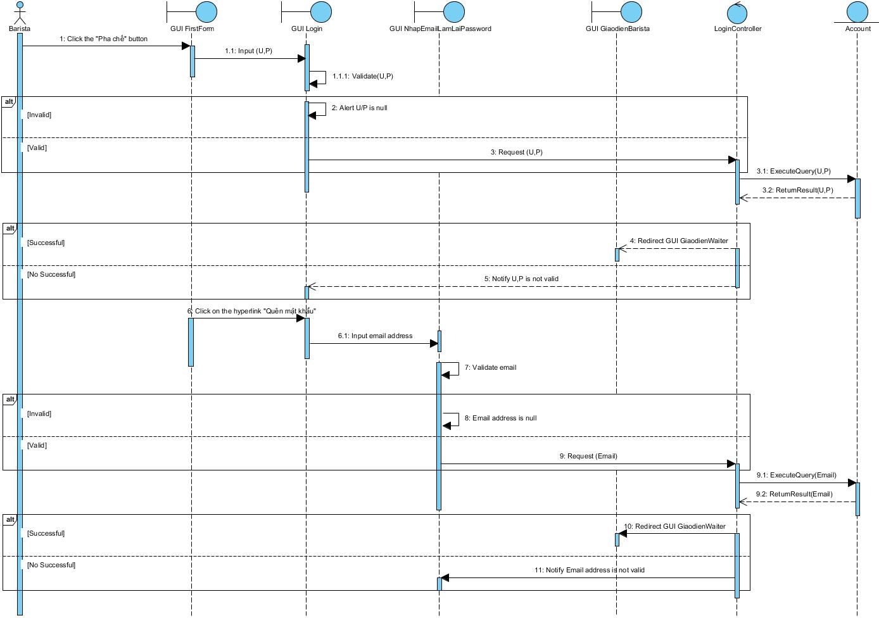

### See list of dishes ordered by customers (Barista)

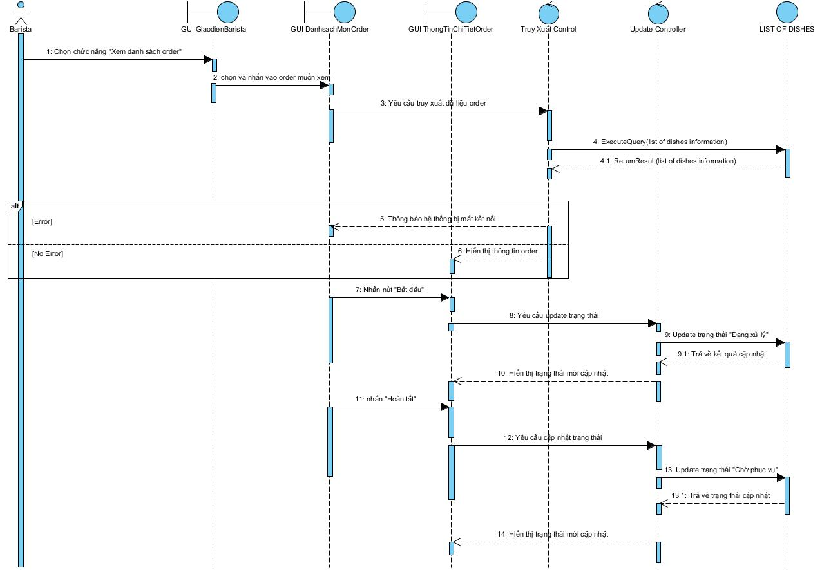

### Notice of out of stock

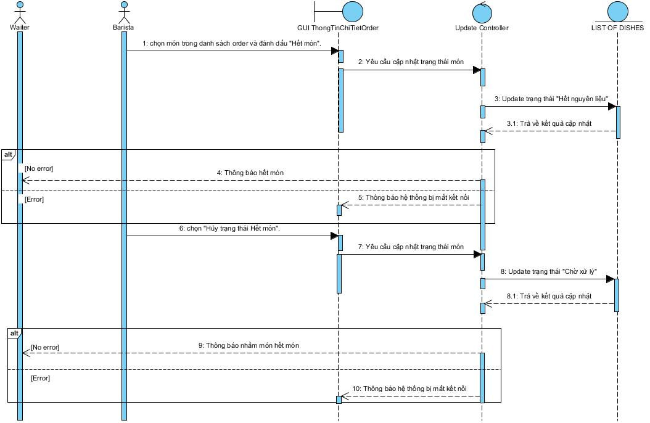

### Notify that the dish is done

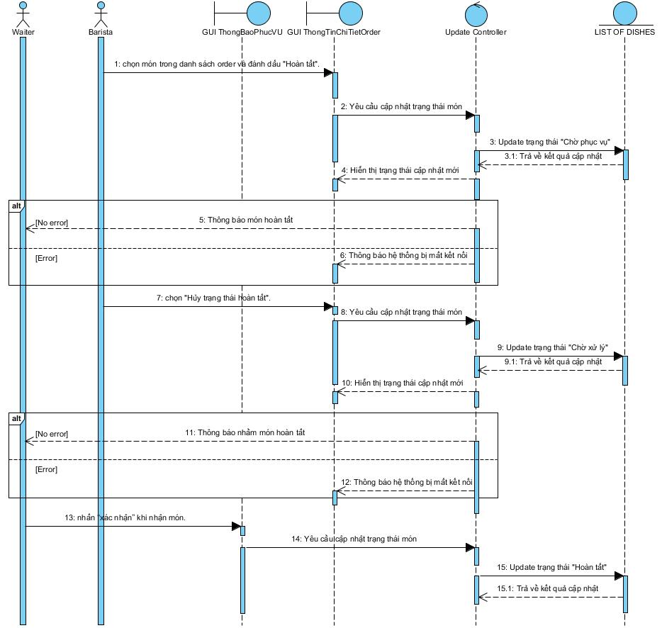

### Login (Cashier)

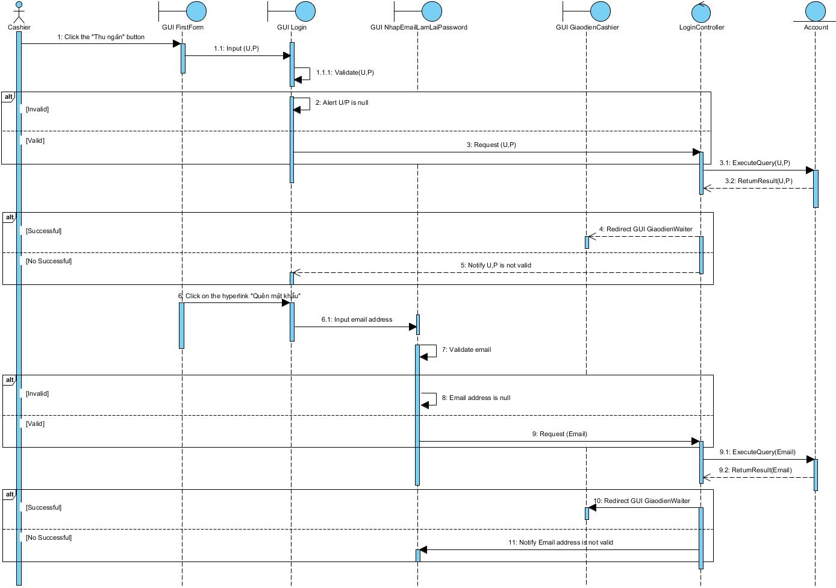

### See list of dishes ordered by customers (Cashier)

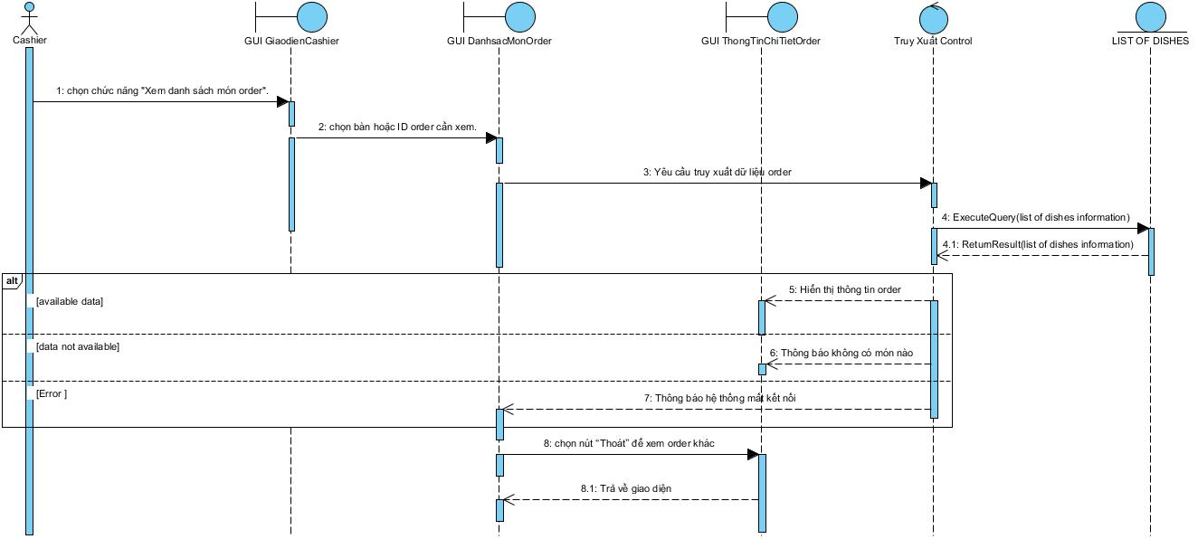

### Issue invoices

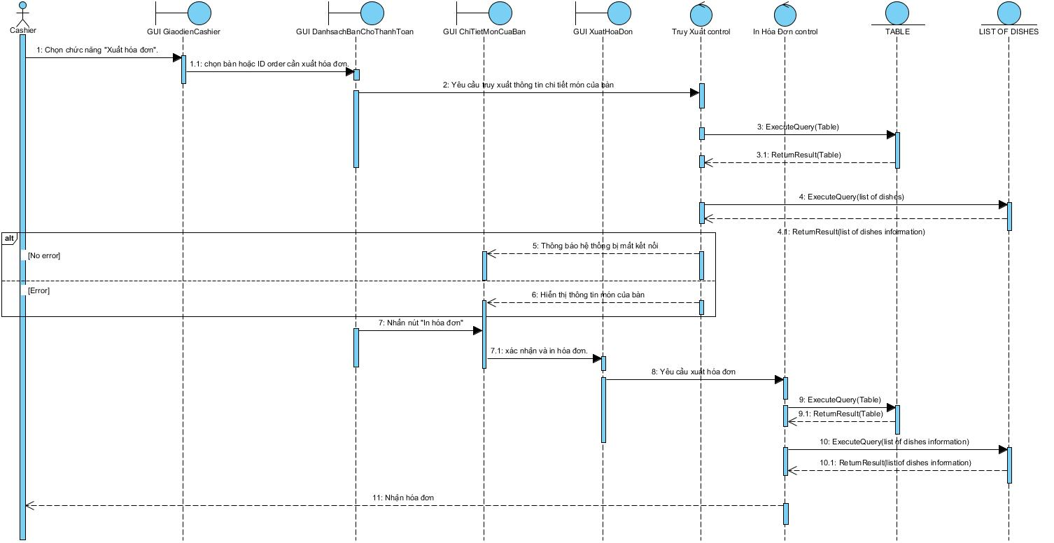

### Payment (Cashier)

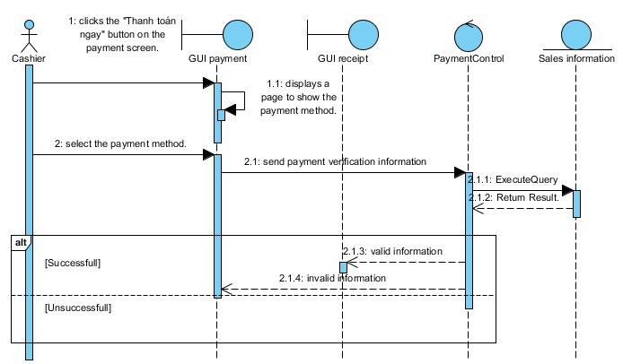

### Summary of revenue

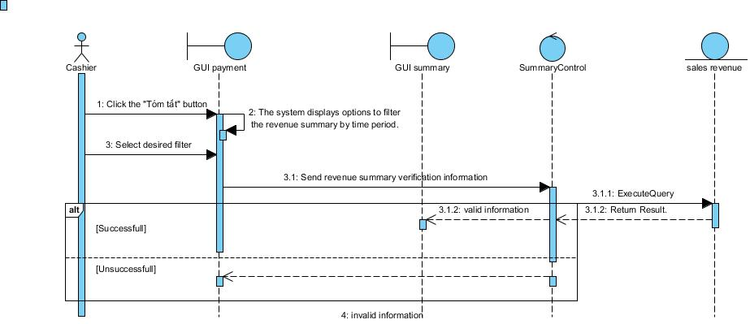

### Manage customer bookings

Login (Admin)  
a) xem danh sách đặt lịch:

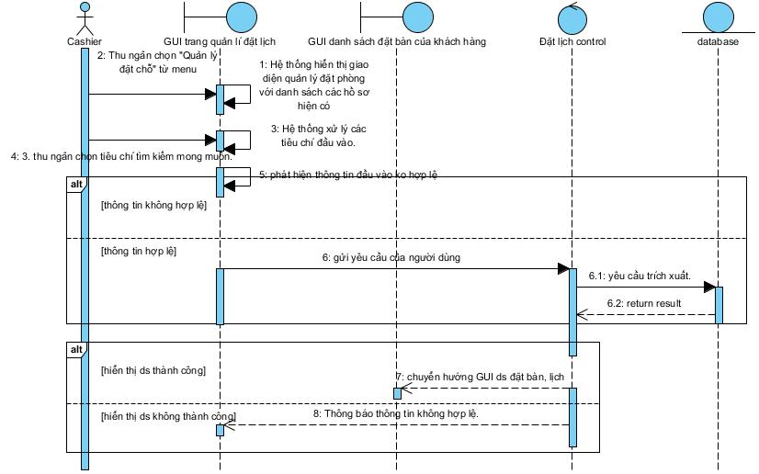 b) đặt lịch cho khách:

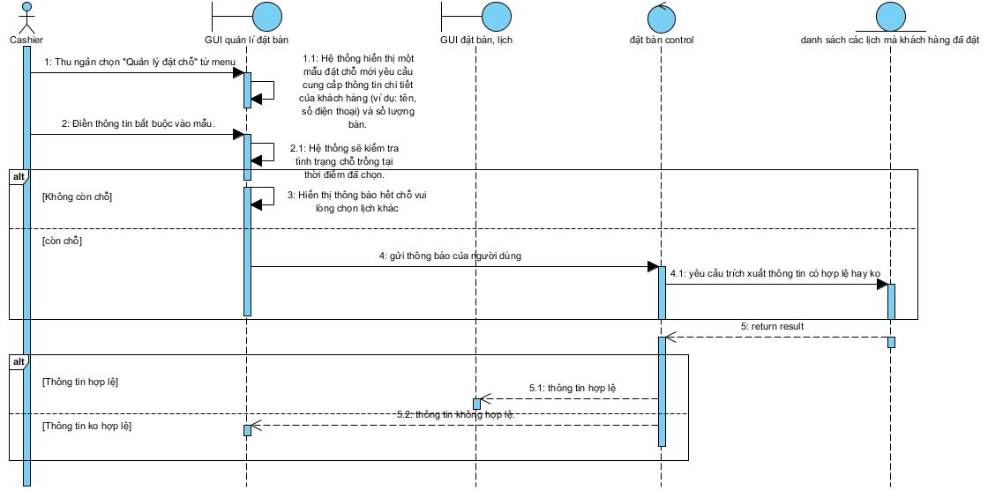 c) xóa lịch đặt:

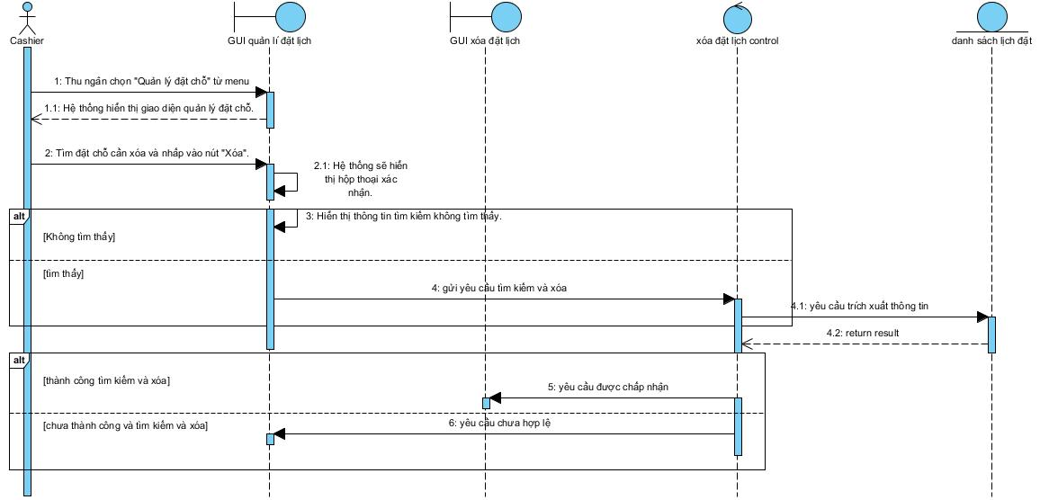 d) cập nhật lịch:

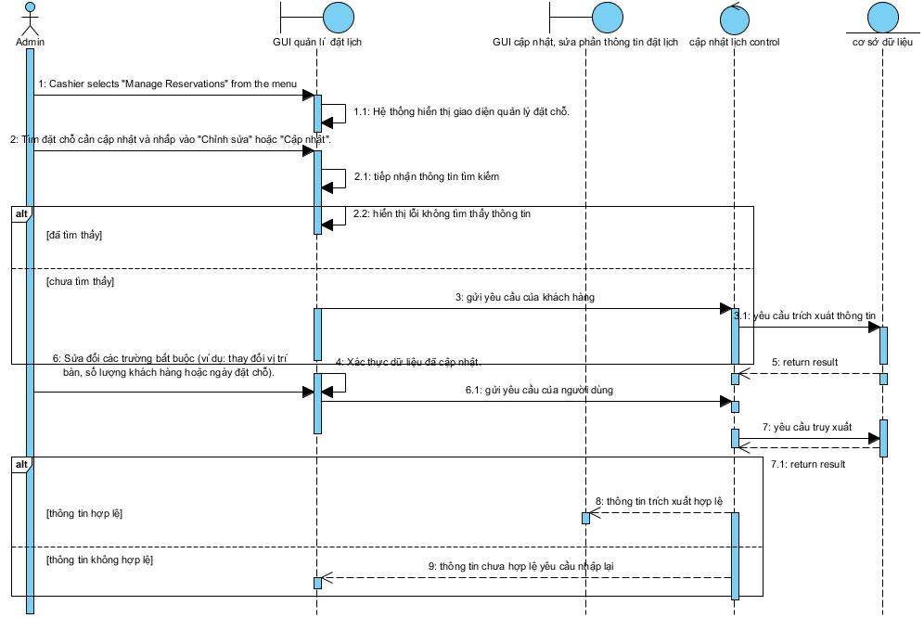

### Manage desk plans

a) Xem sơ đồ bàn:

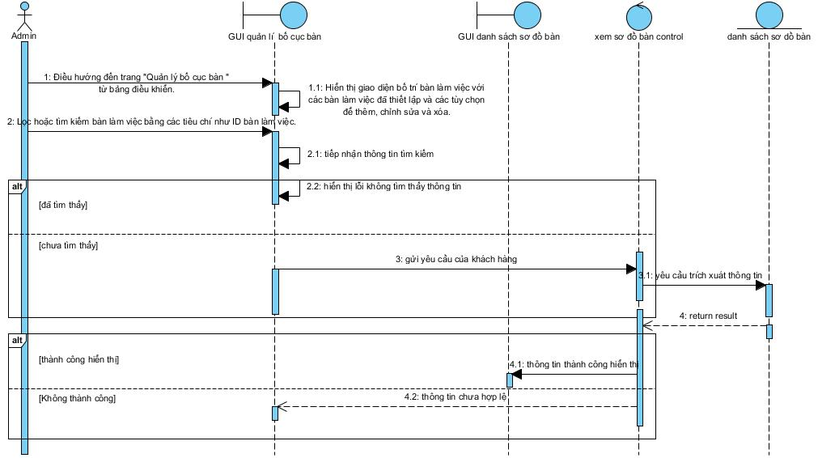

b) thêm bàn mới :

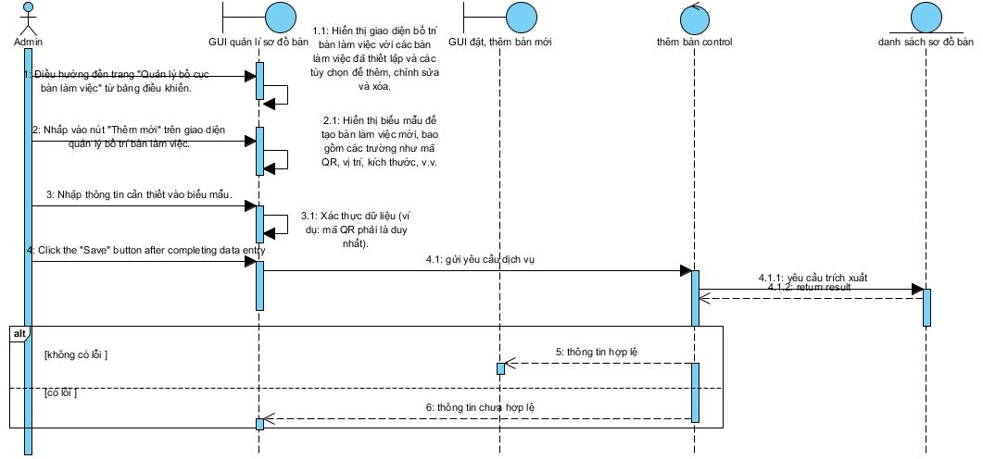

c) xóa bàn được chỉ định:

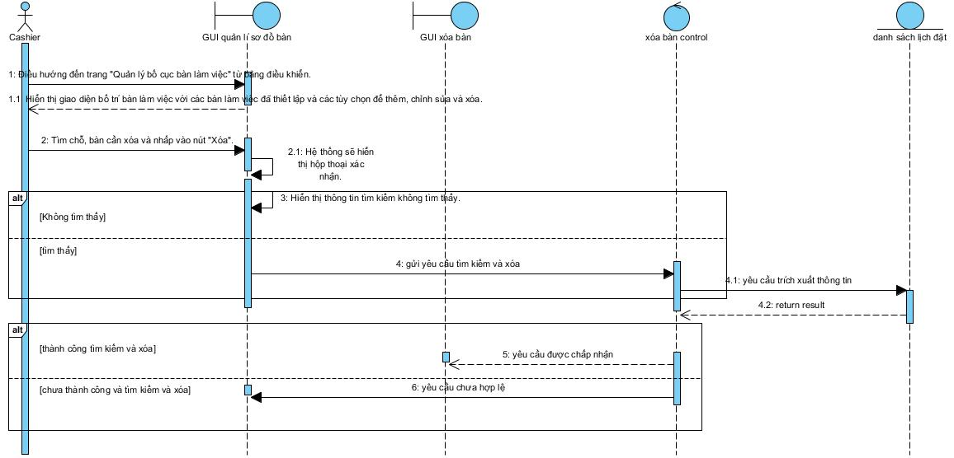 d) Cập nhật sơ đồ bàn:

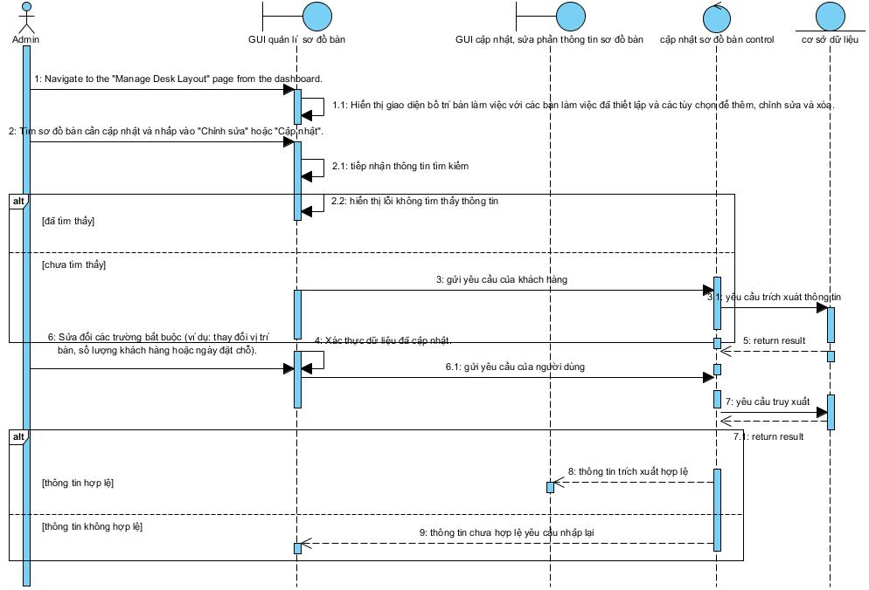

### Menu management

a)Xem tình trạng các mục có trong thực đơn:

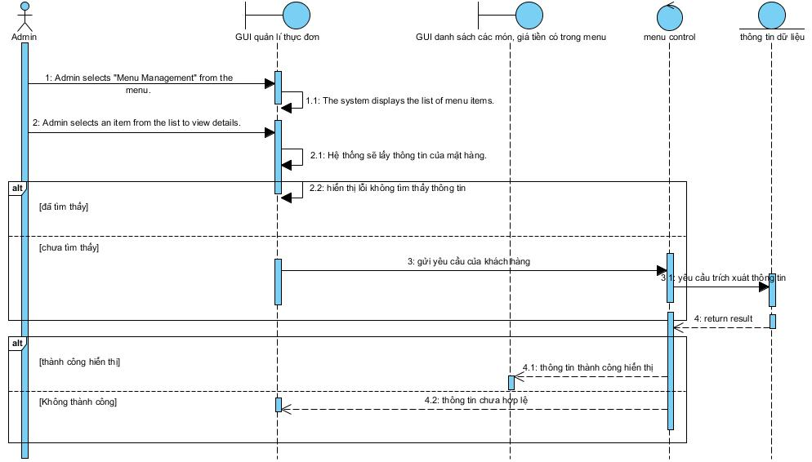 b) Thêm mục cho thực đơn:

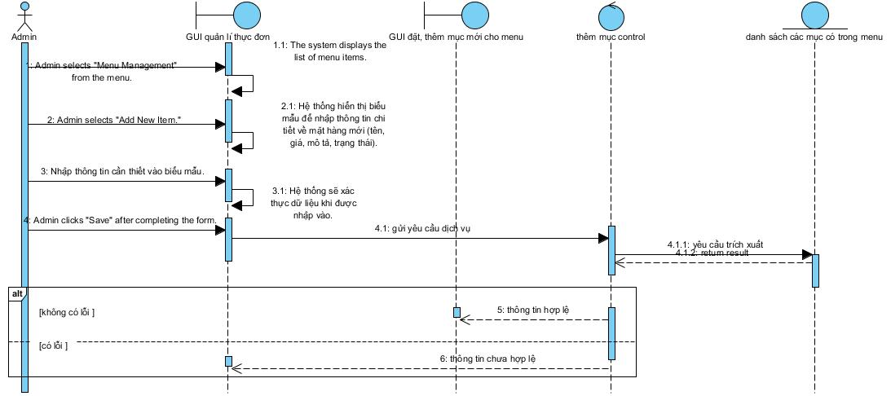 c) Xóa mục đã chỉ định trong menu:

### Update price

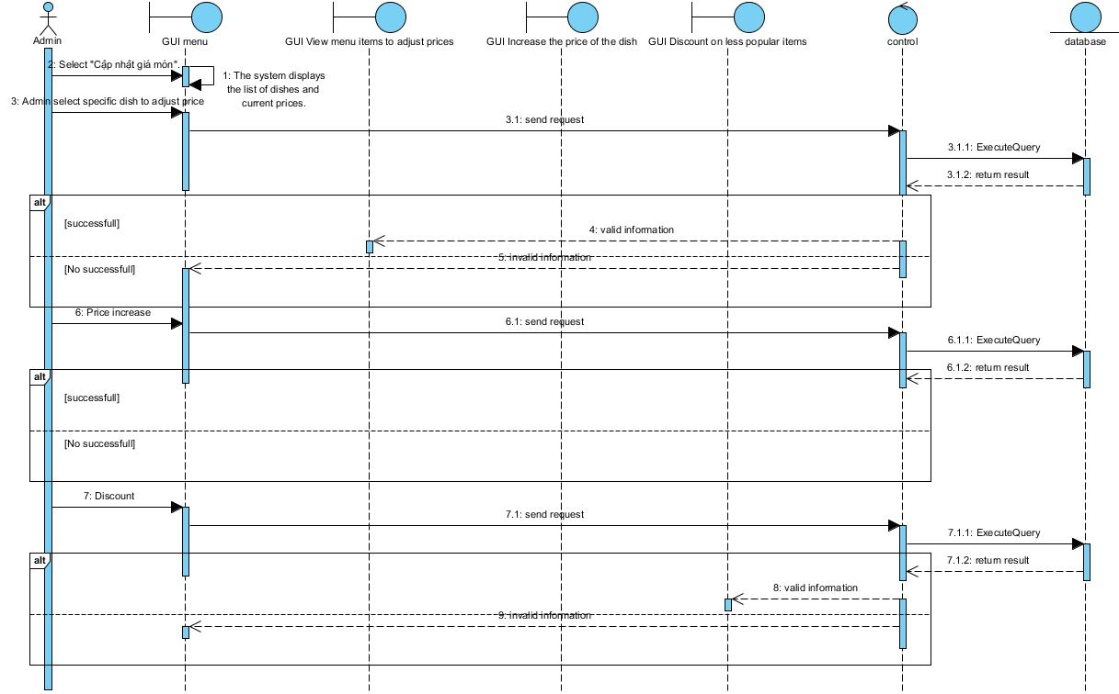

### Manage QR codes of each tables

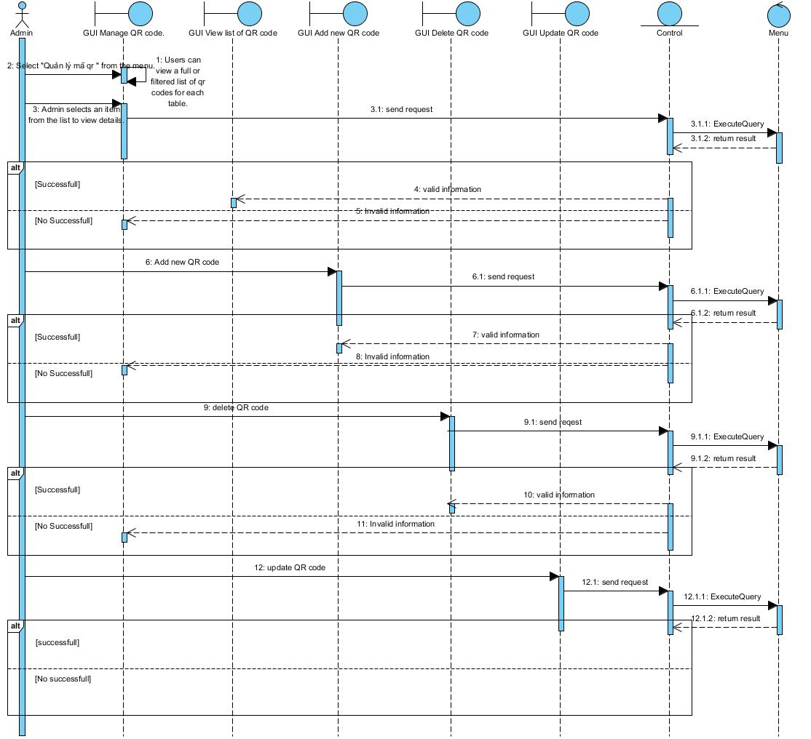

### Revenue management

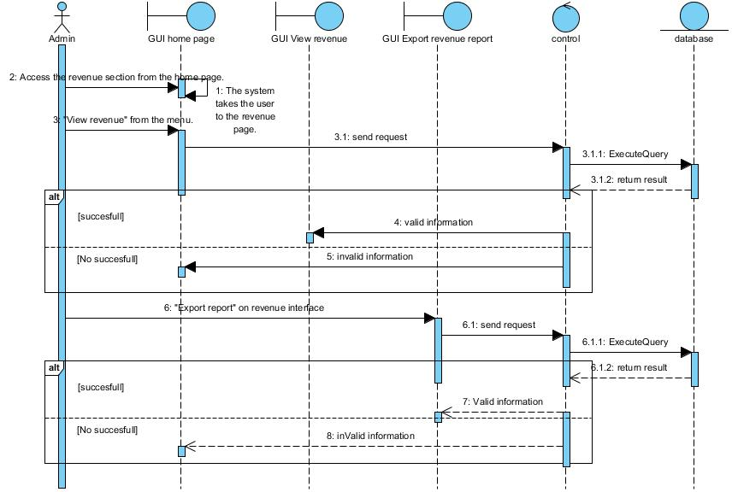

### Account management

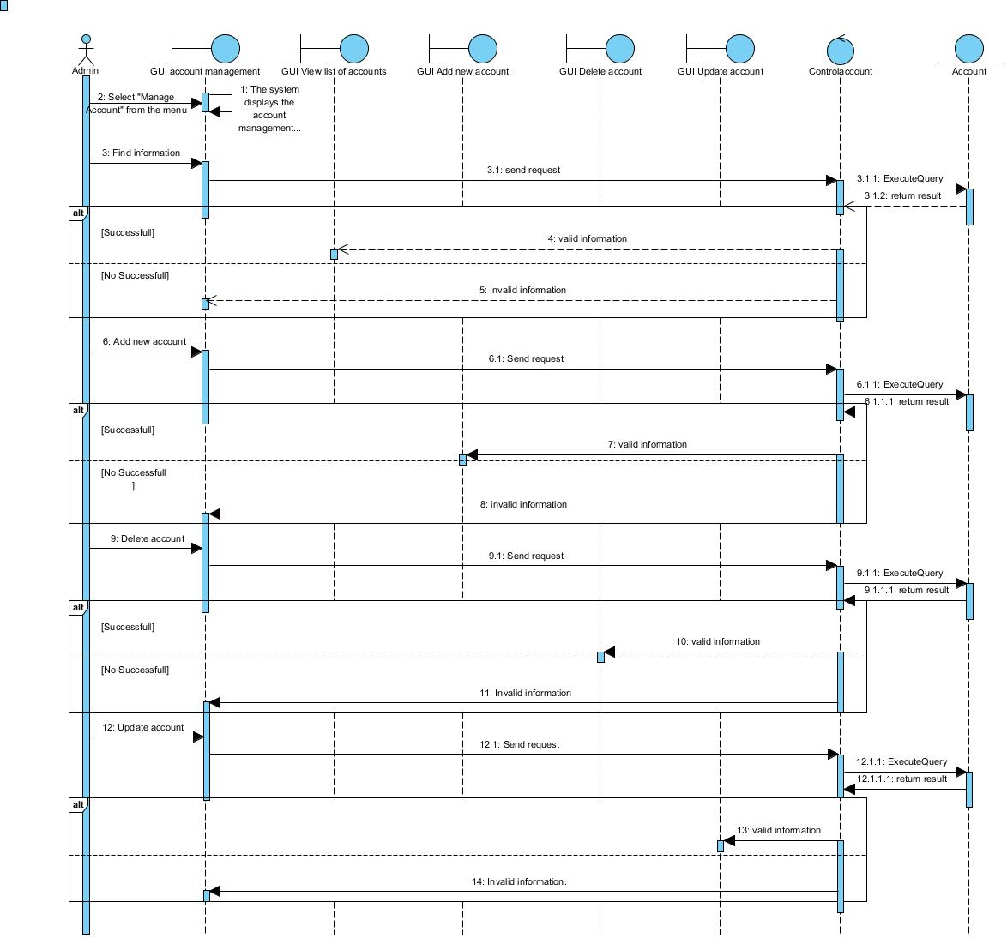

## Activity Diagrams

### Scan QR code

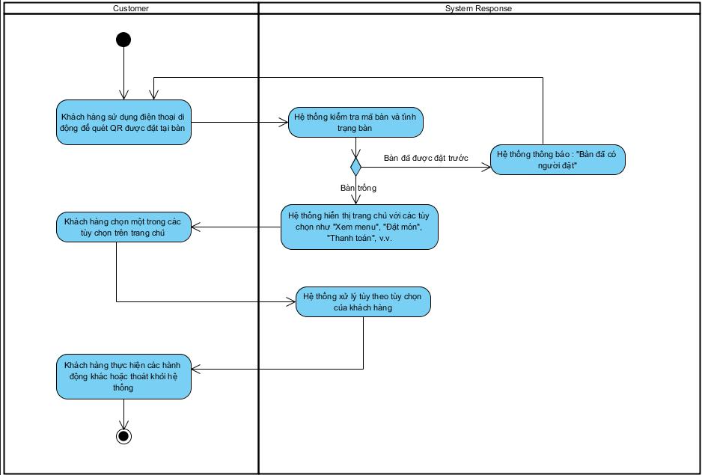

### View menu

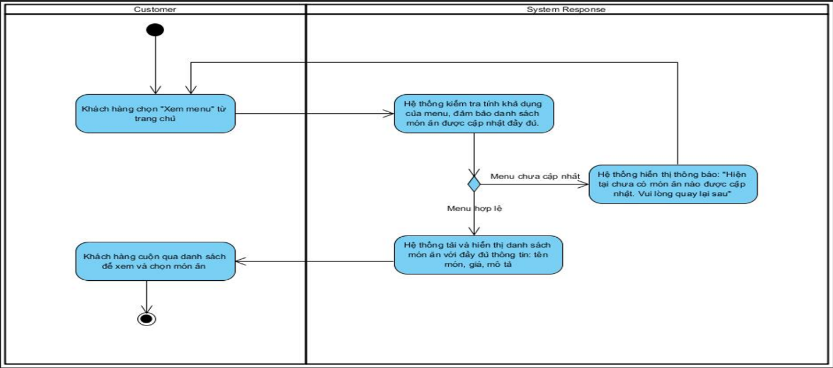

### Order

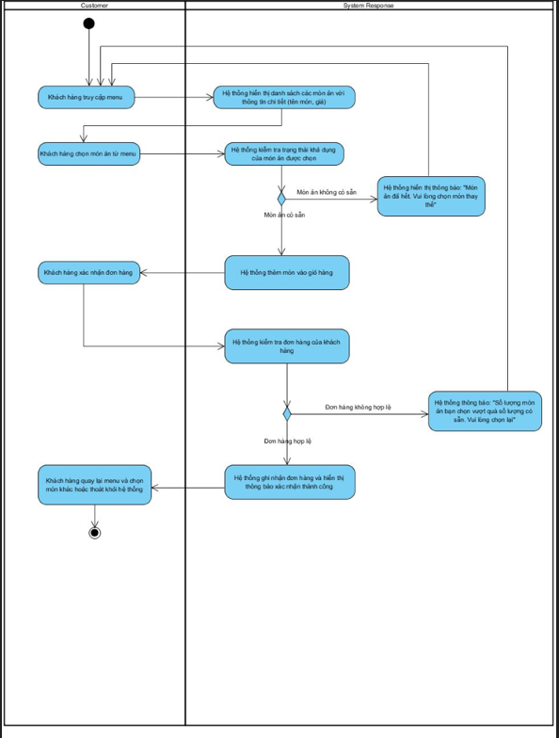

### View order status

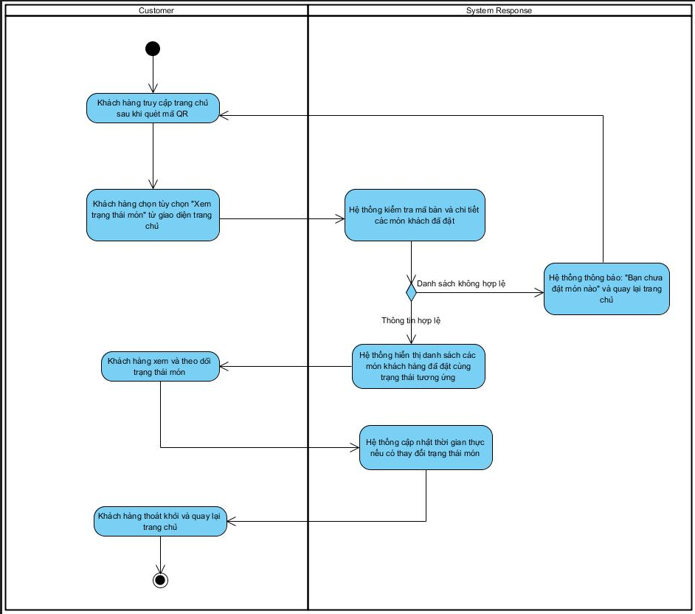

### Cancel the dish

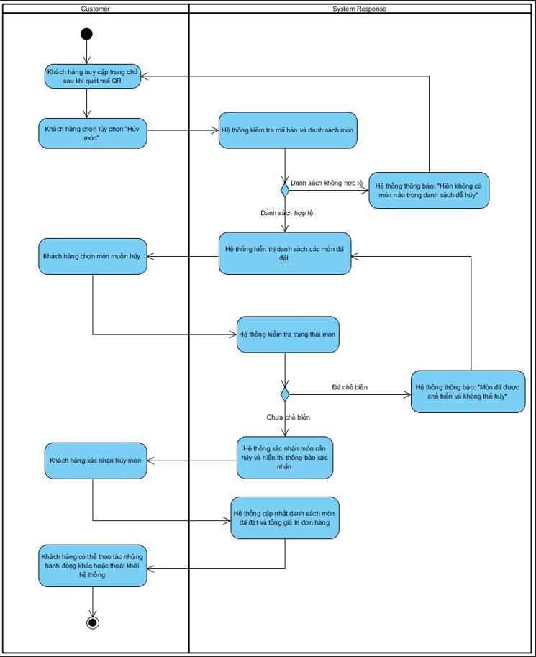

### Payment

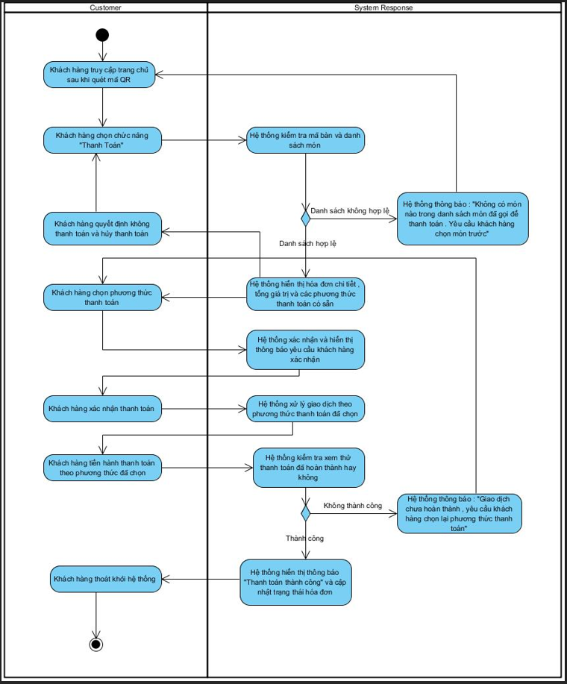

### Book

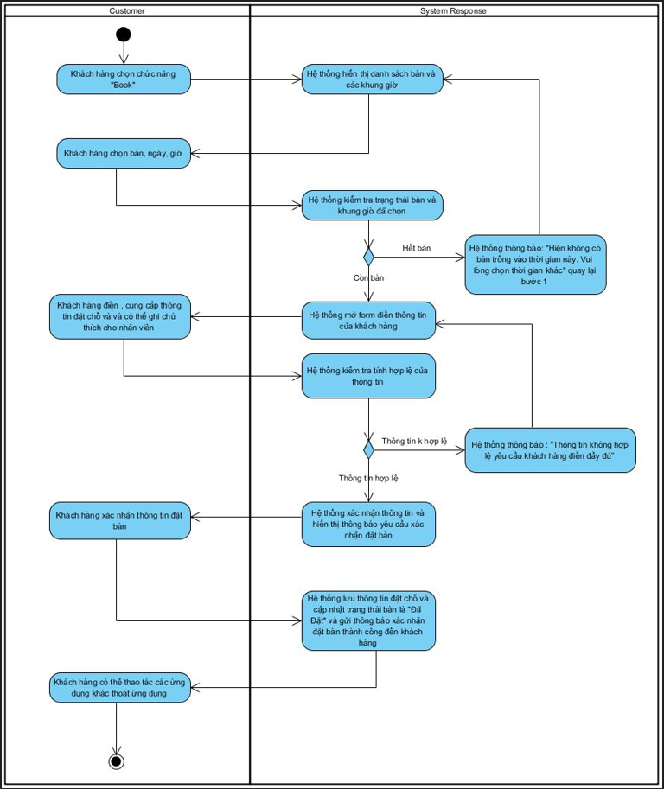

### Login (Waiter)

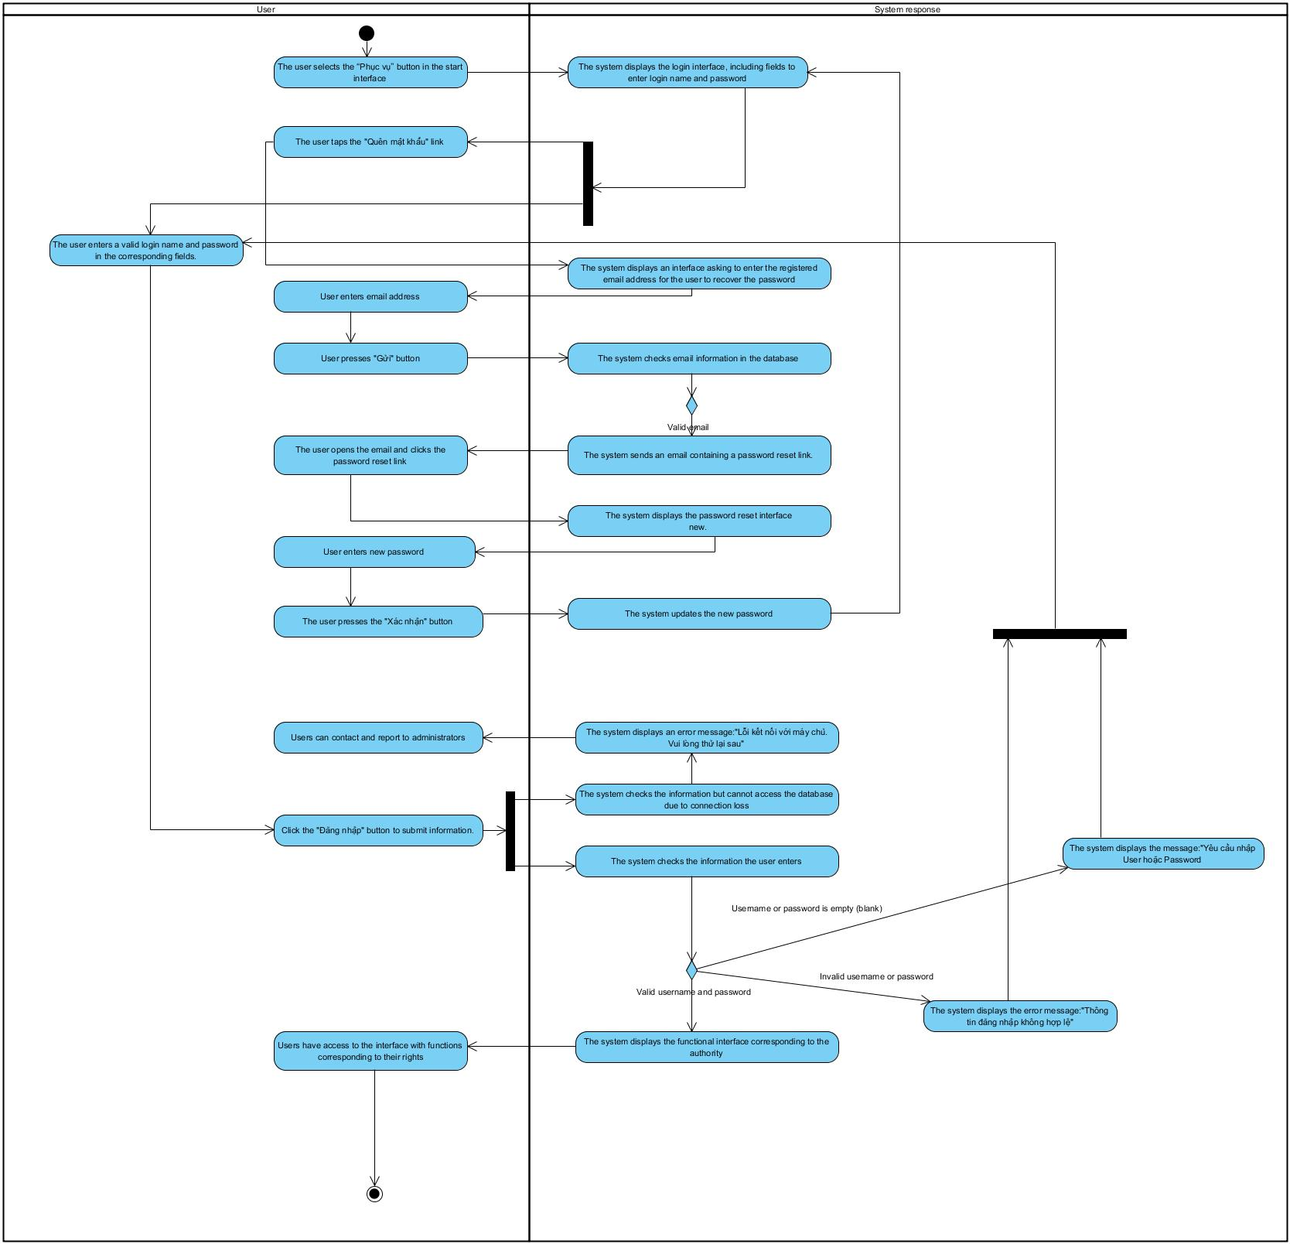

### Receive service notifications

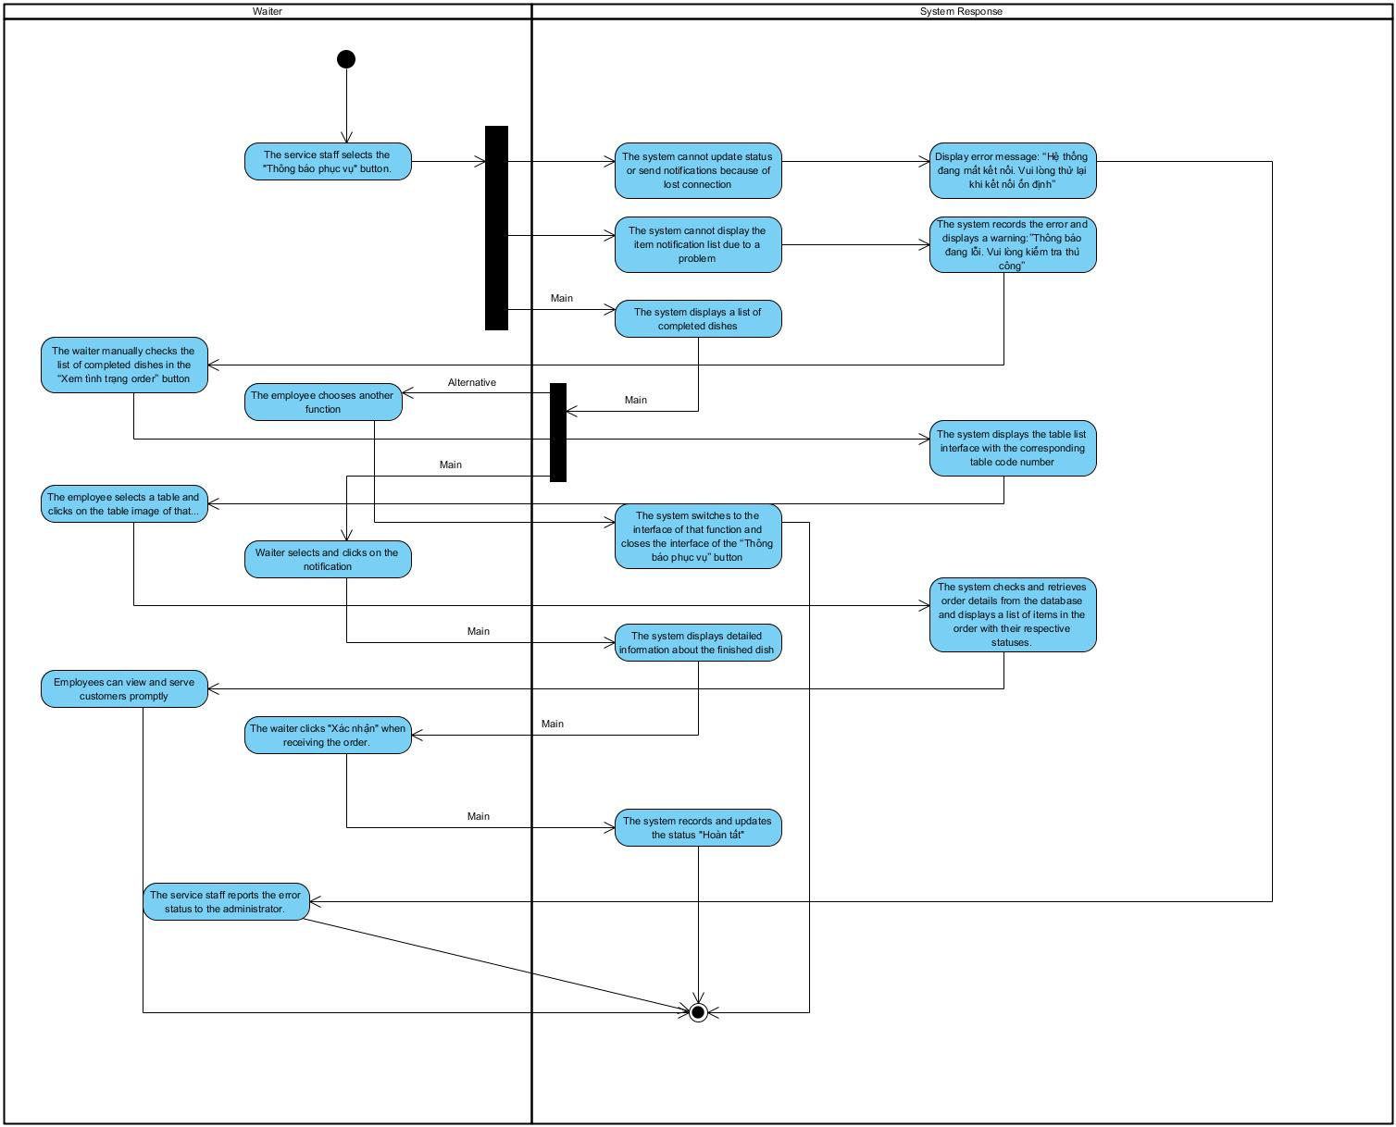

### View order status

### Login (Barista)

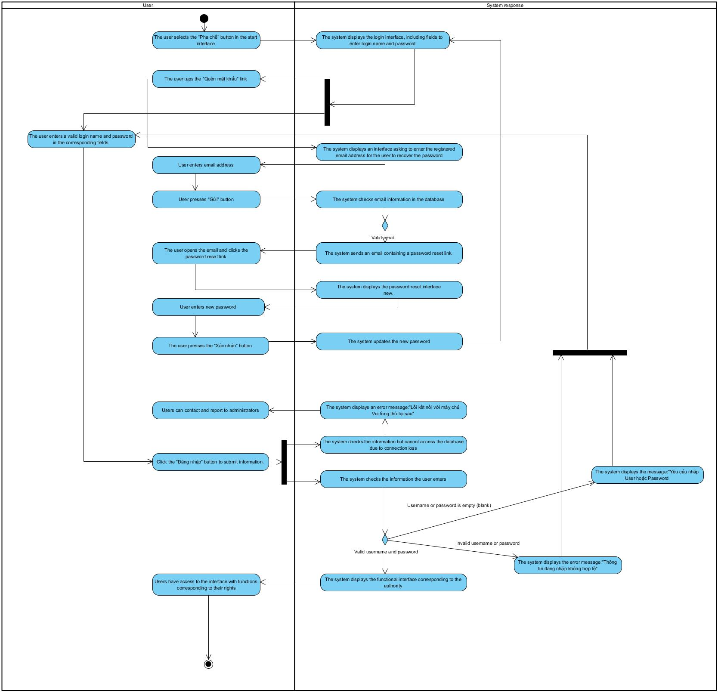

### See list of dishes ordered by customers (Barista)

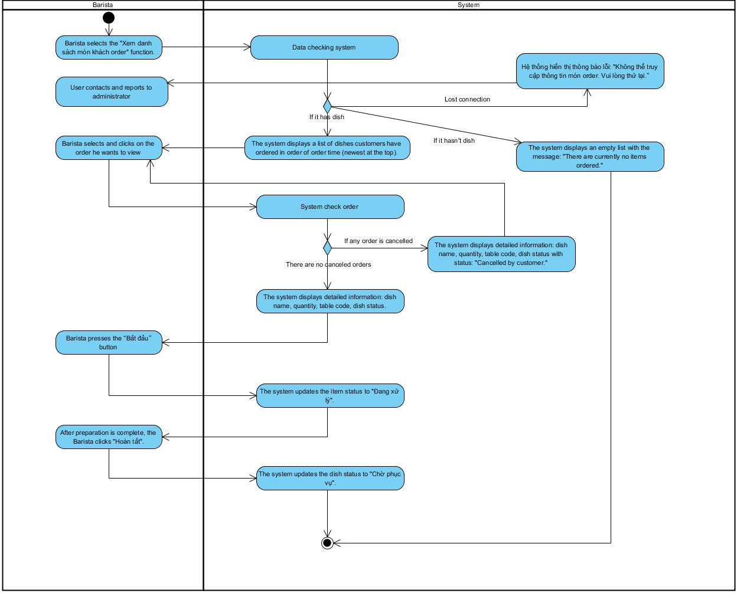

### Notice of out of stock

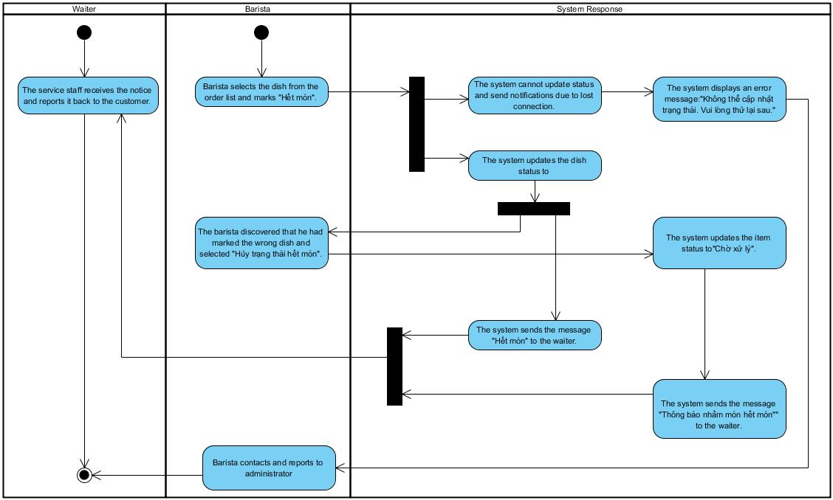

### Notify that the dish is done

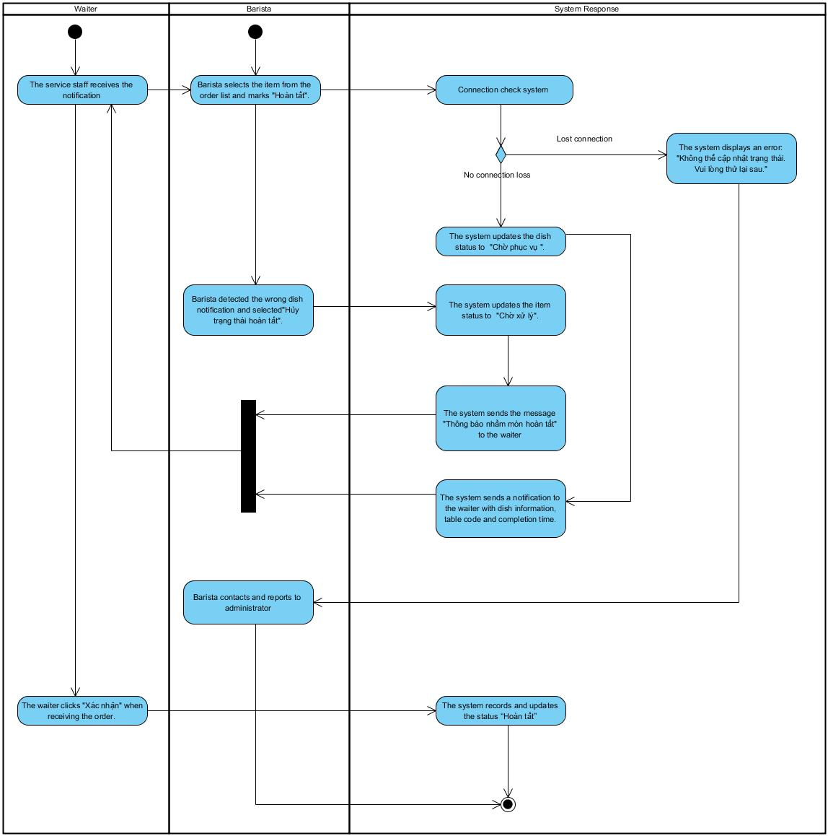

### Login (Cashier)

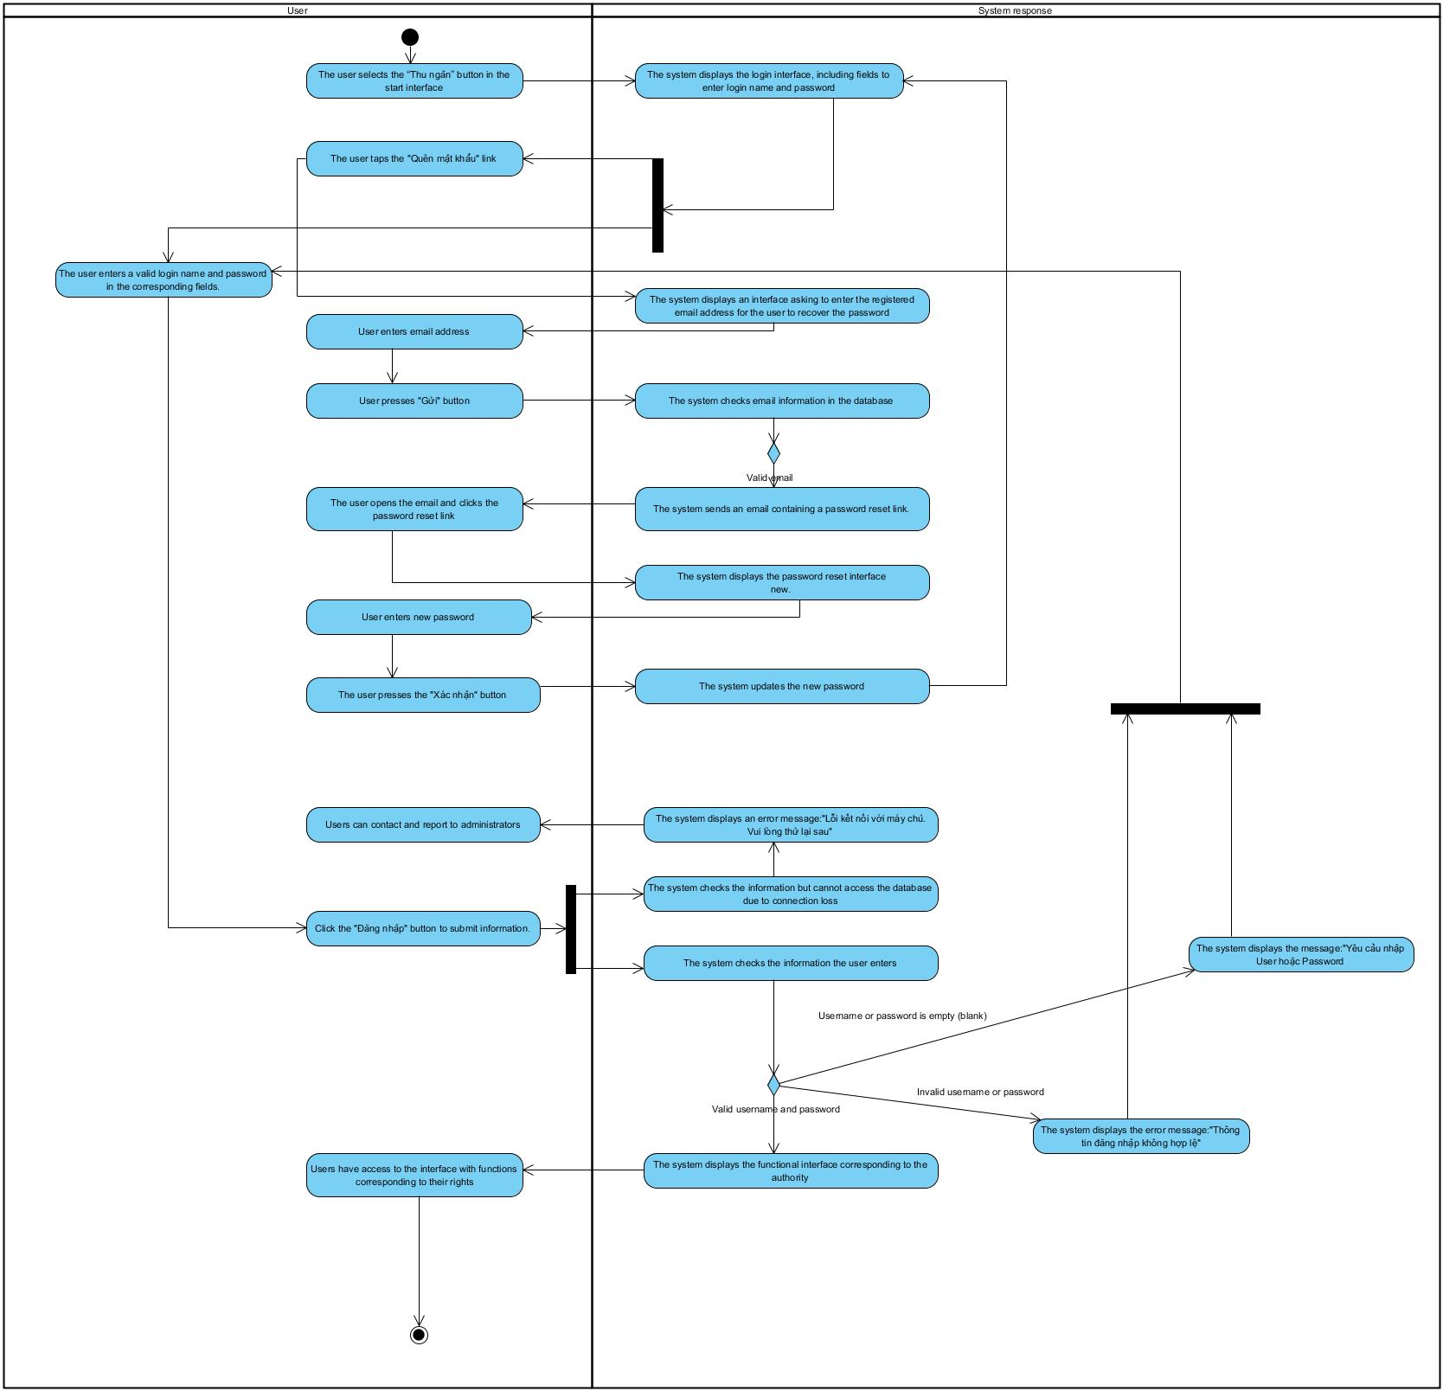

### See list of dishes ordered by customers (Cashier)

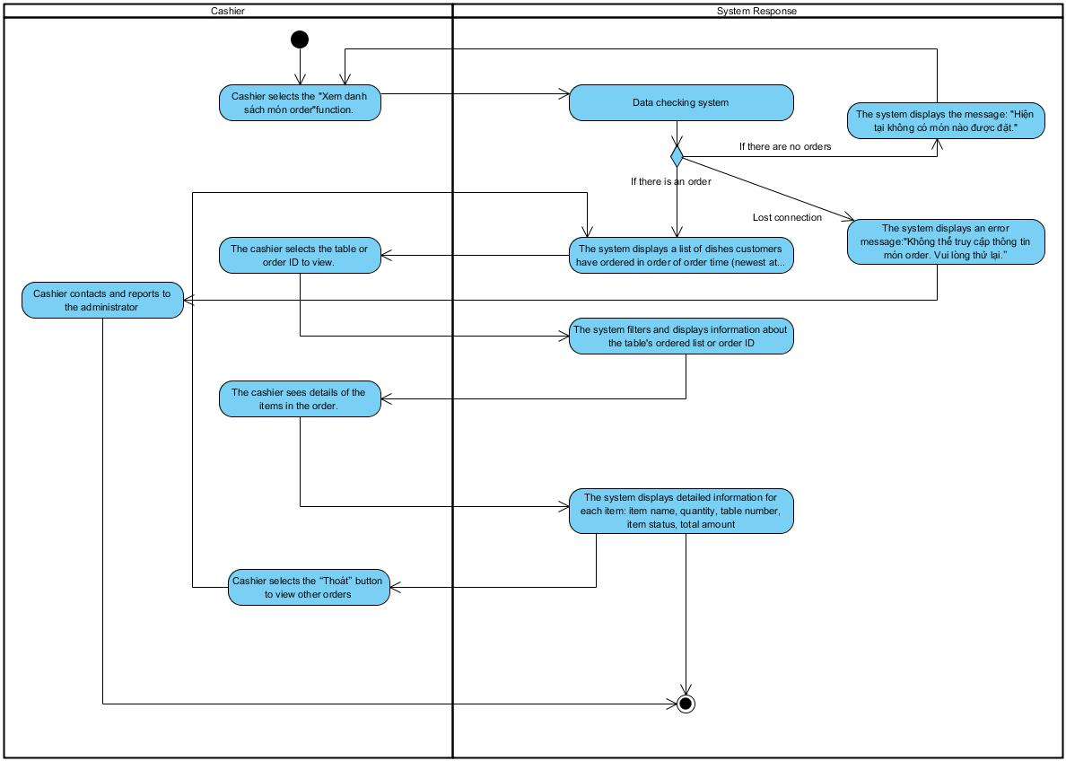

### Issue invoices

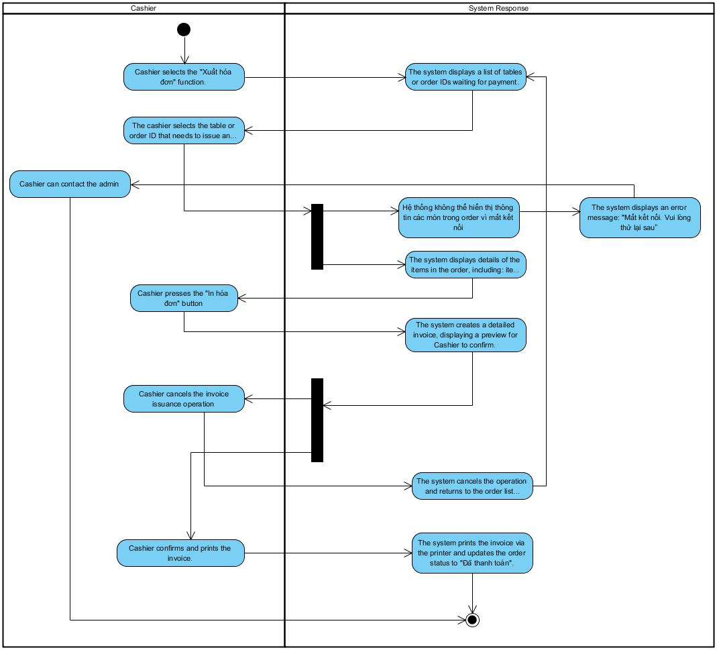

### Payment (Cashier)

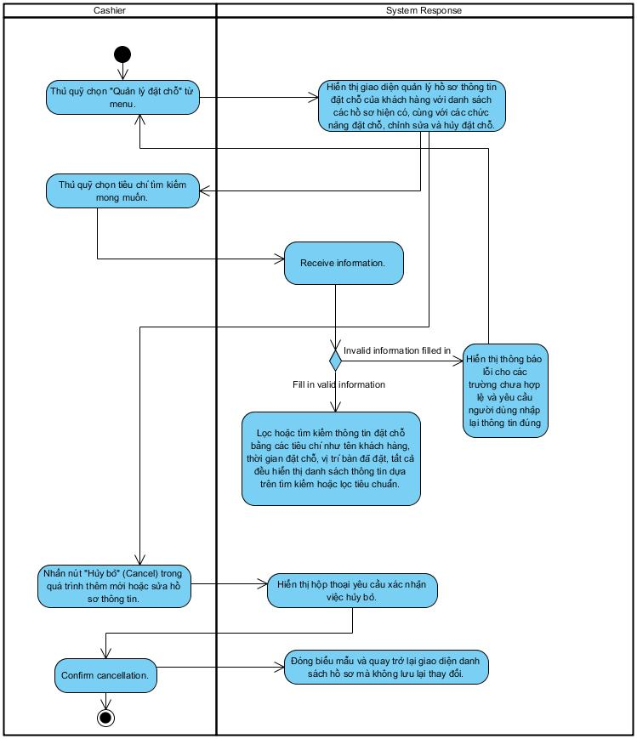

### Summary of revenue

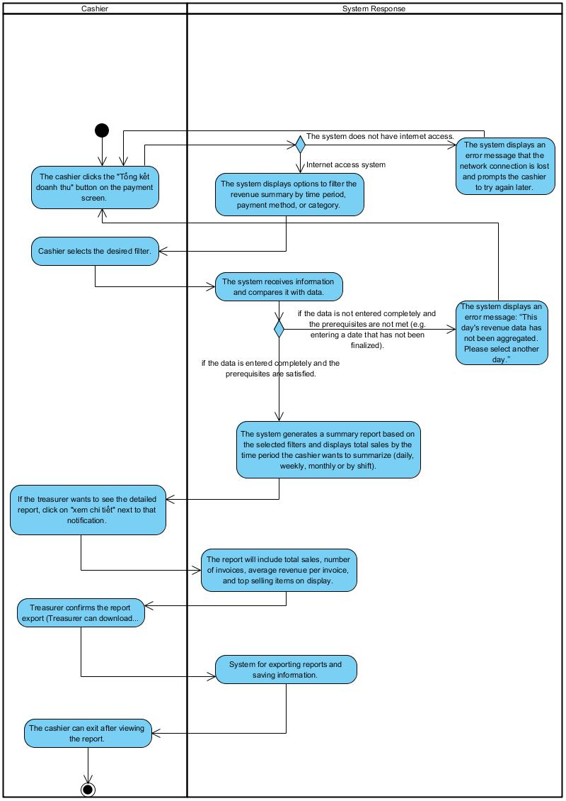

### Manage customer bookings

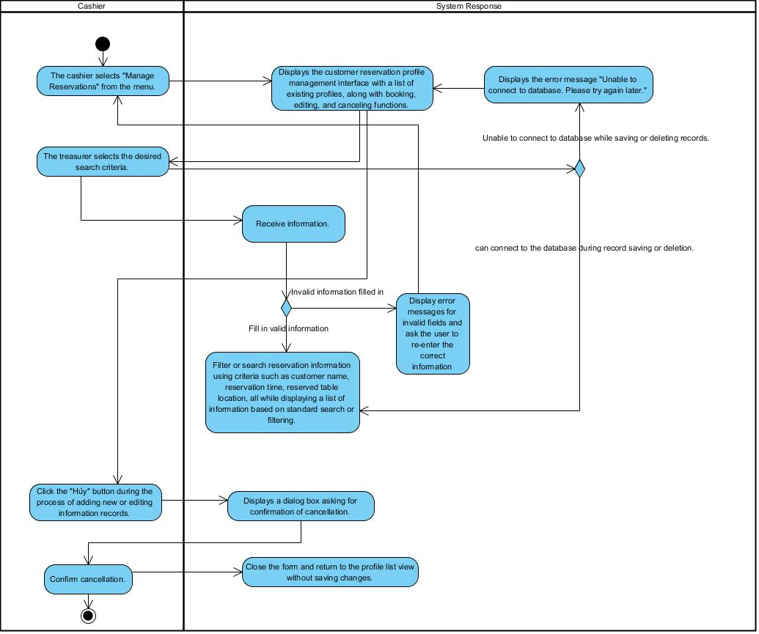

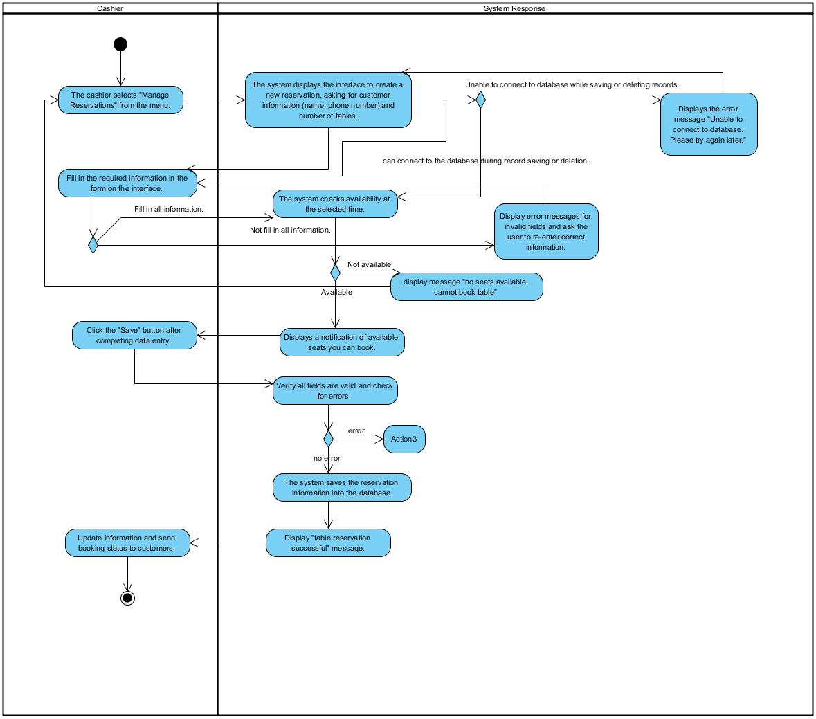

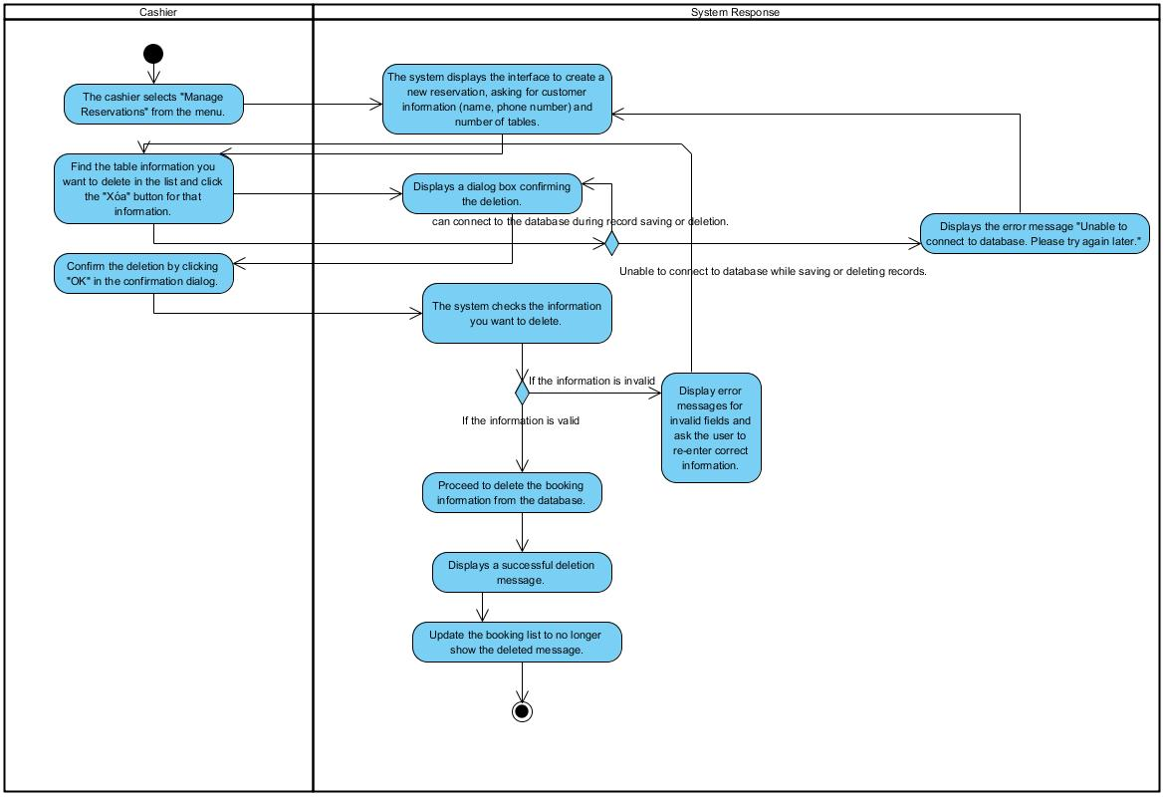

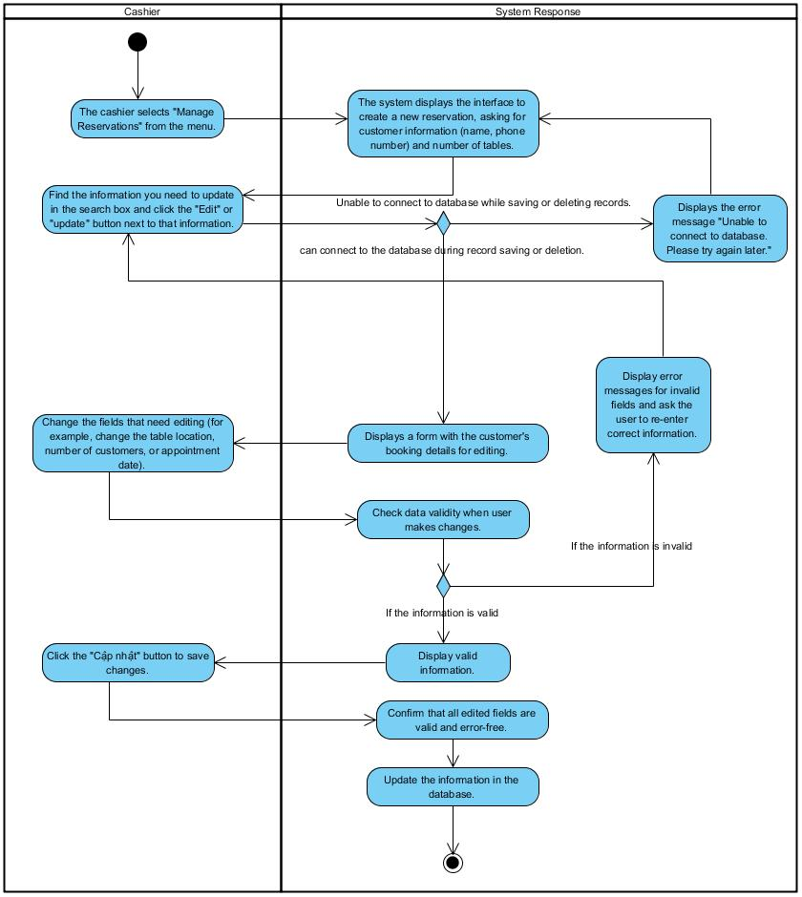

### Login (Admin)

### Manage desk plans

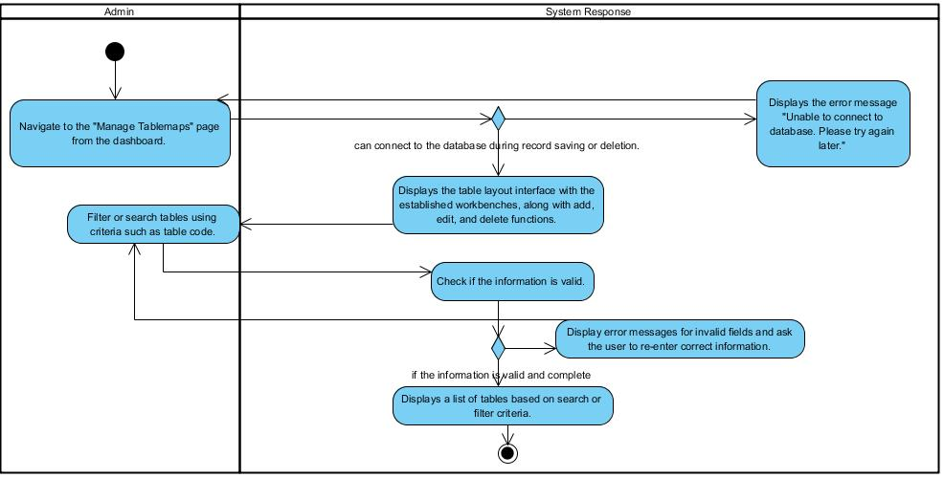

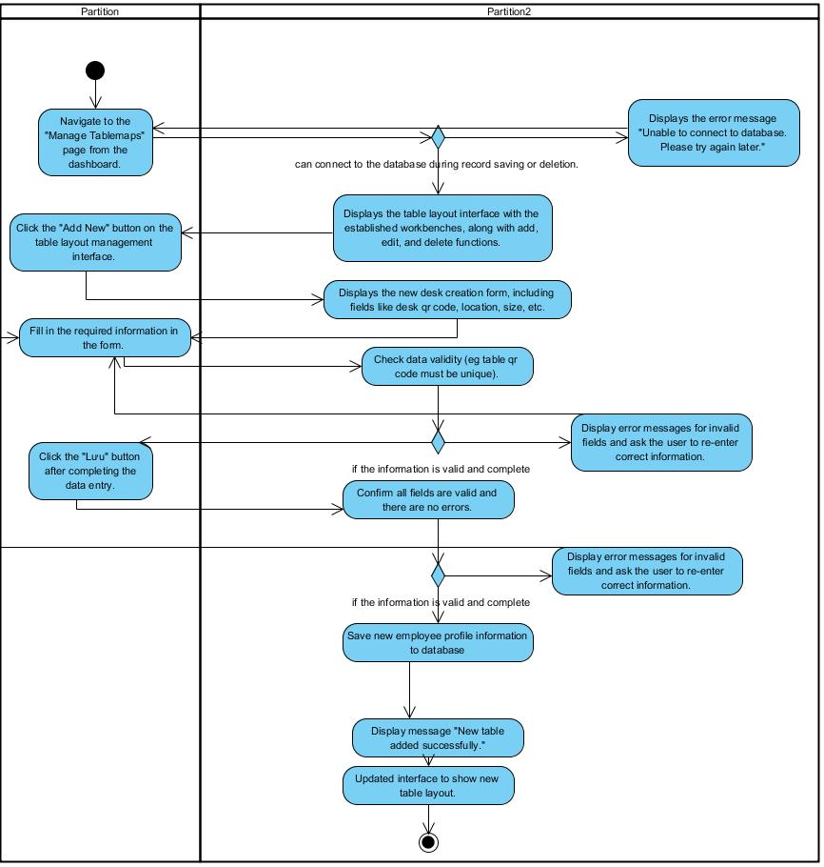

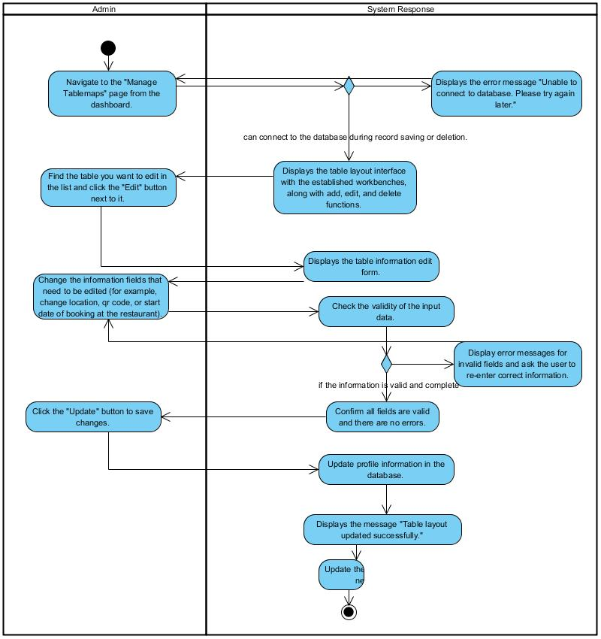

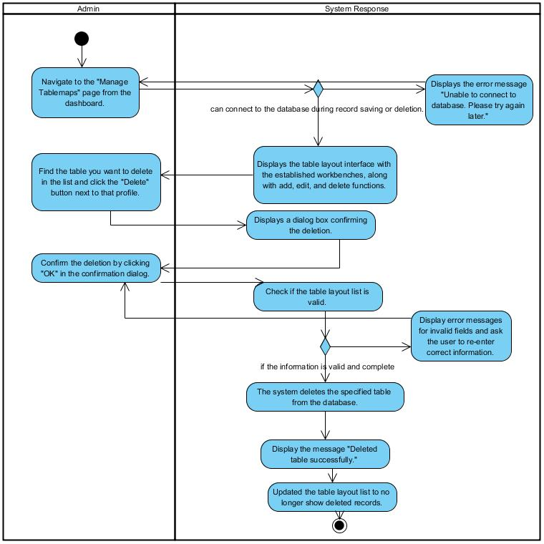

### Menu management

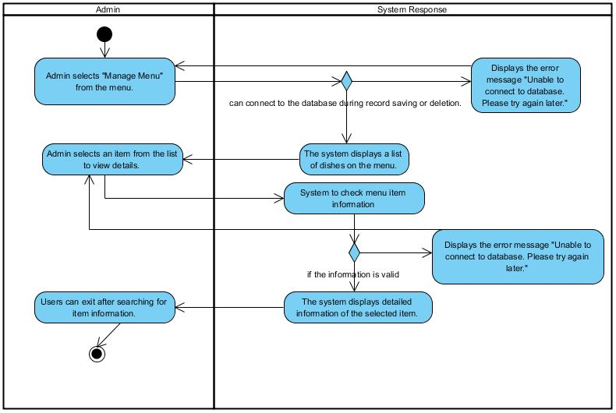

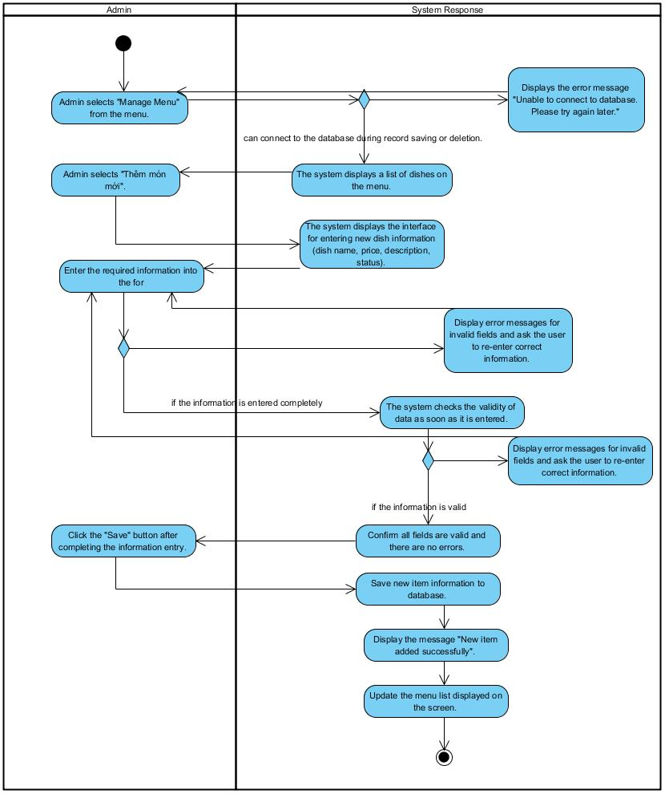

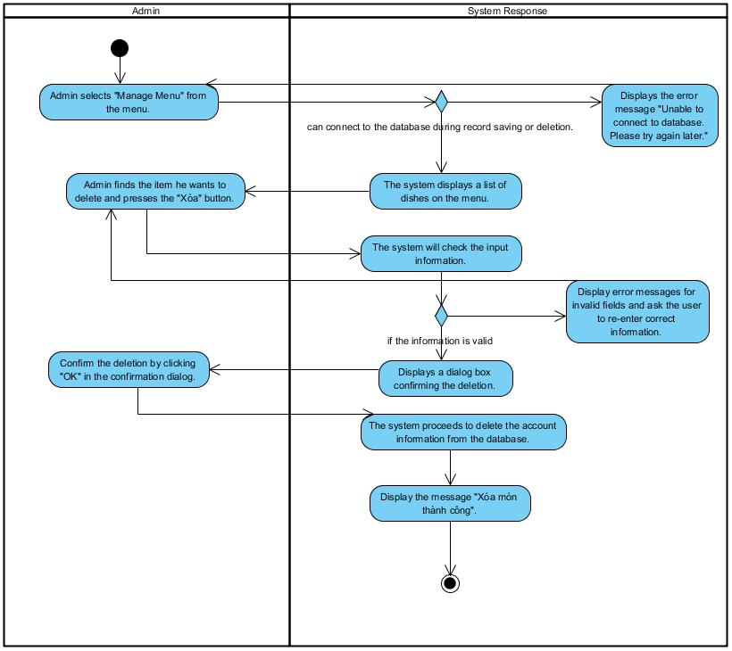

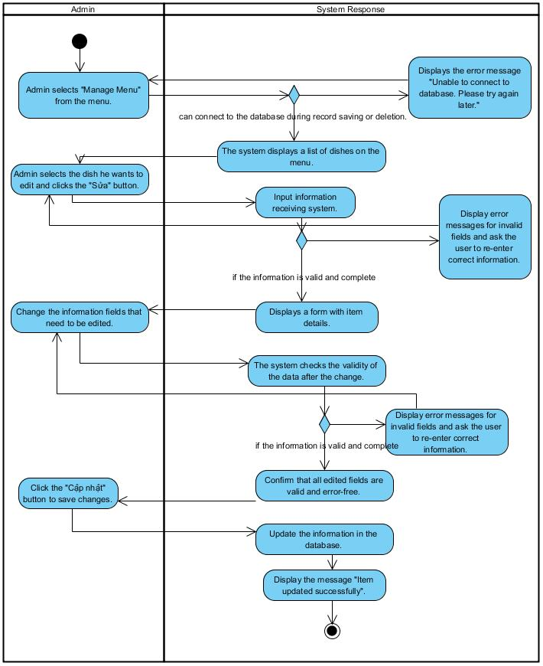

### Update price

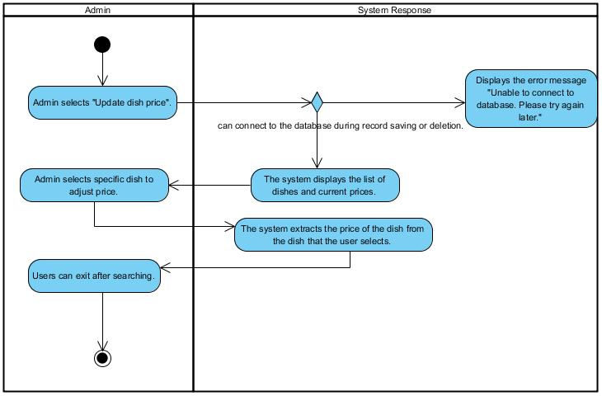

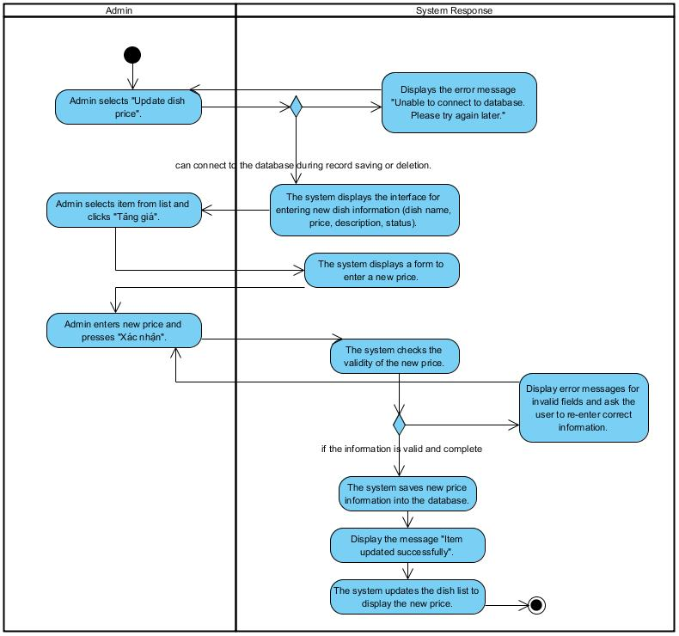

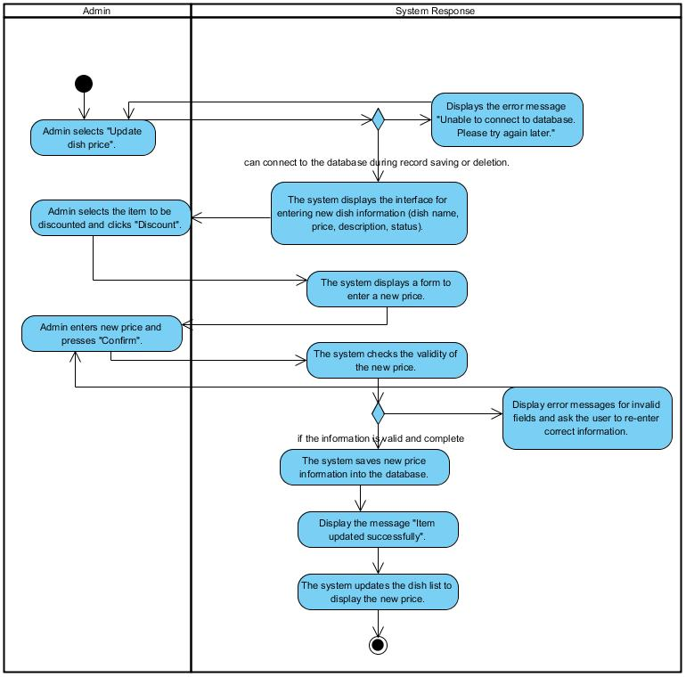

### Manage QR codes of each tables

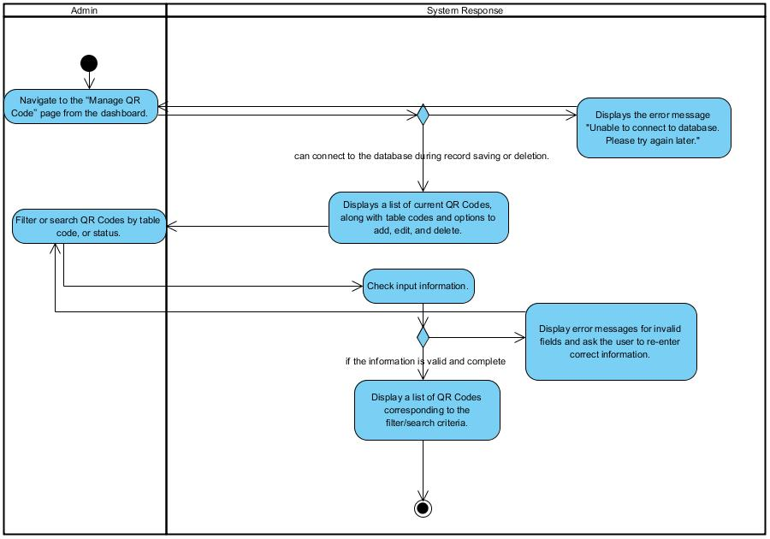

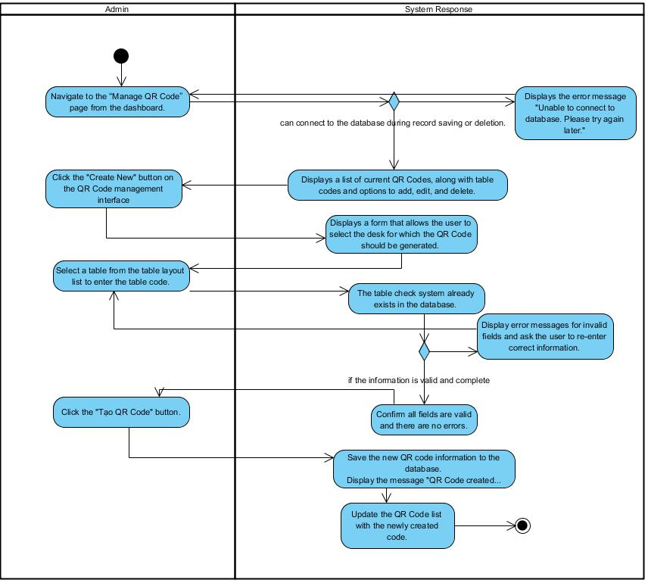

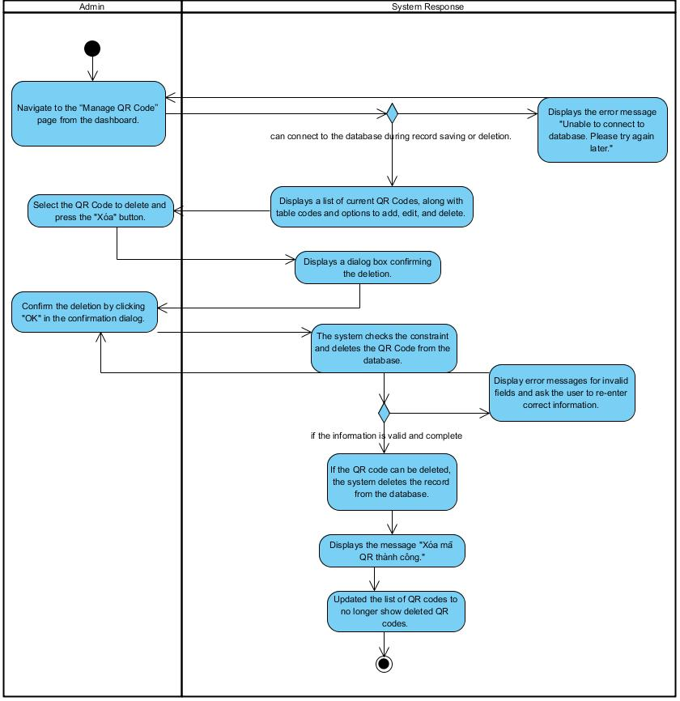

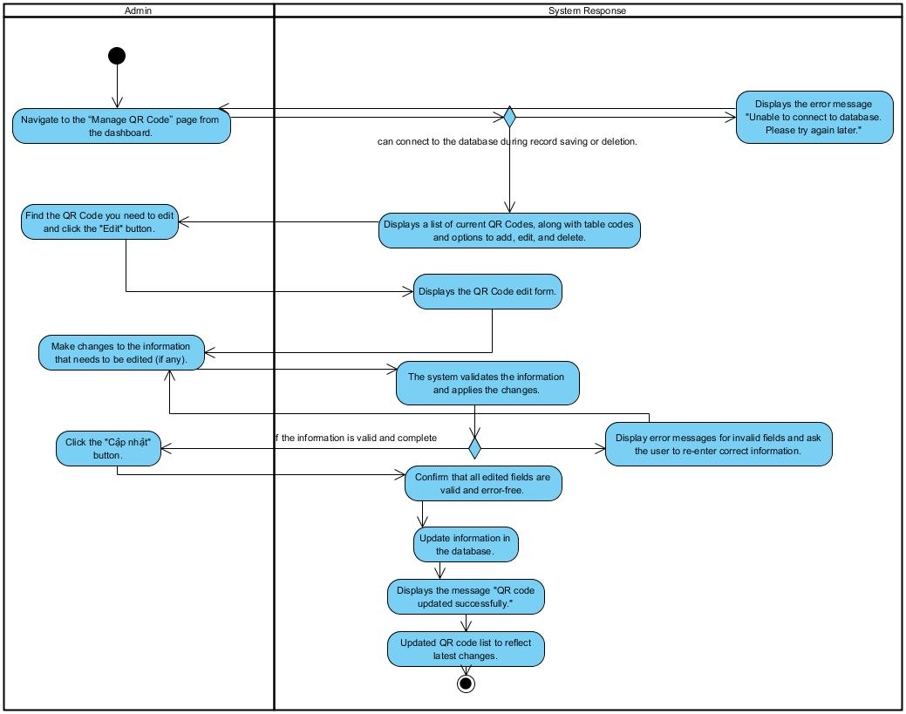

### Revenue management

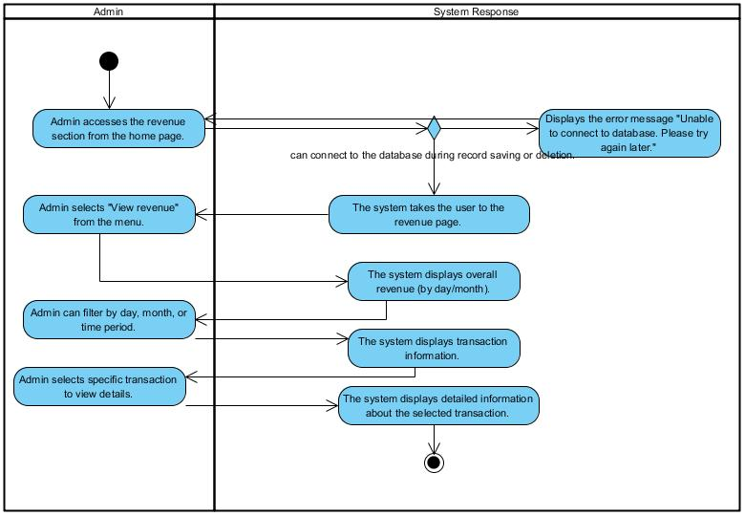

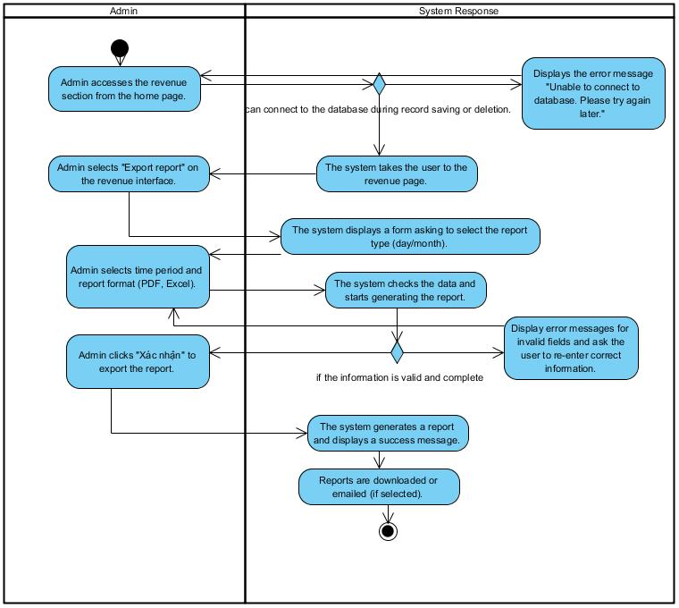

### Account management

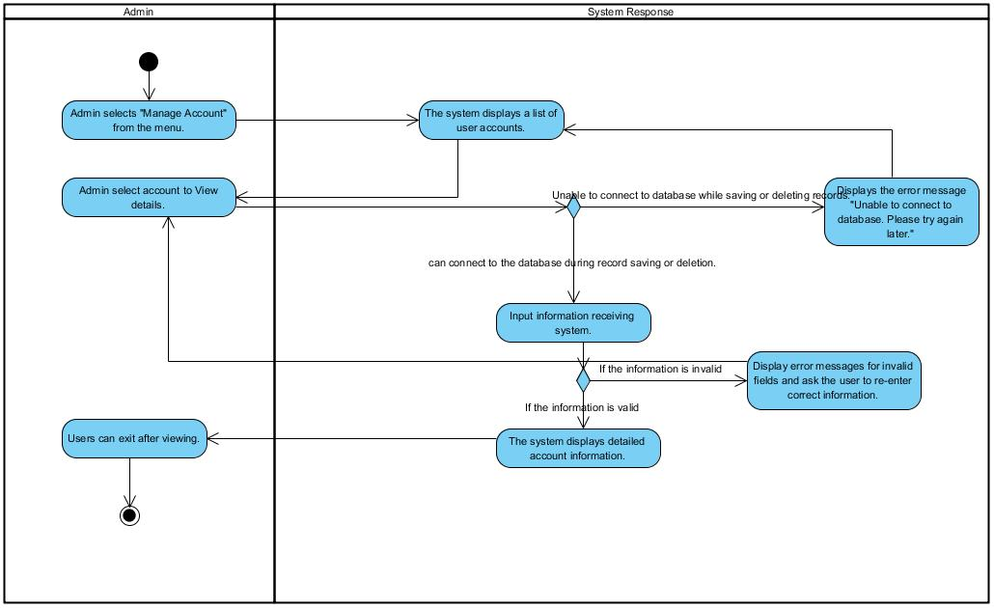

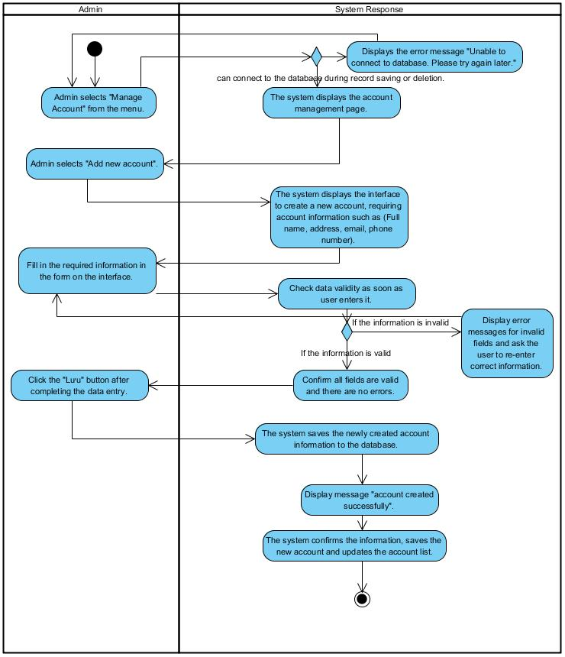

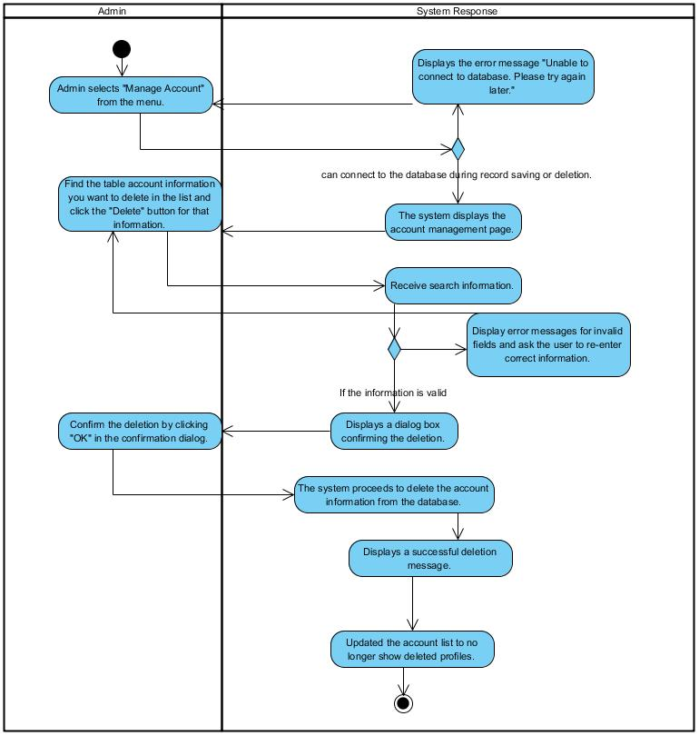

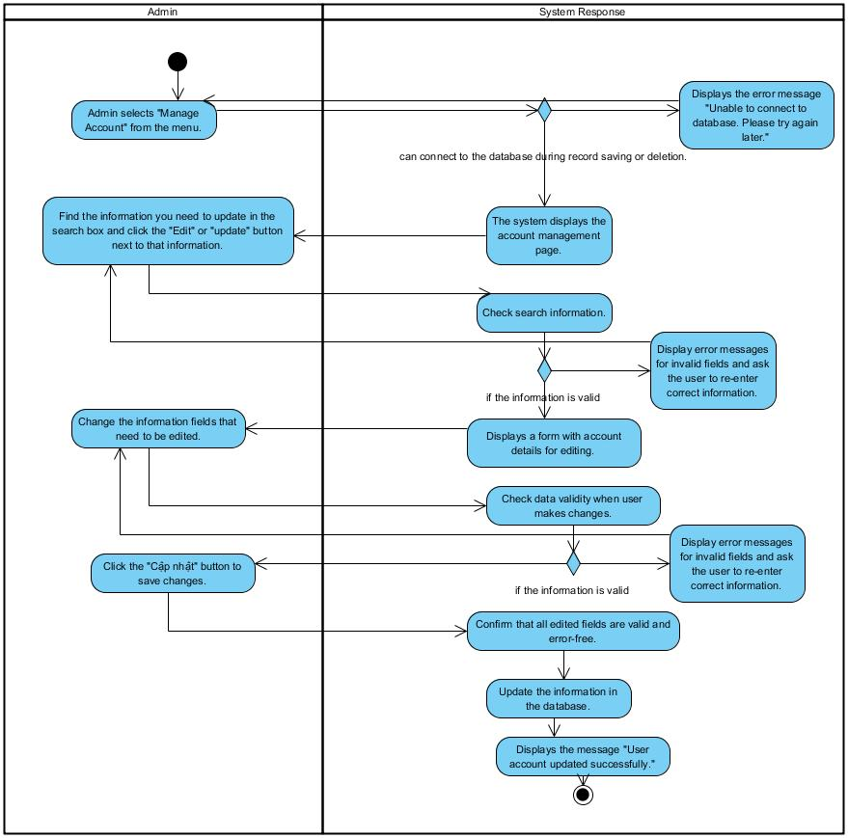

## Class Diagram

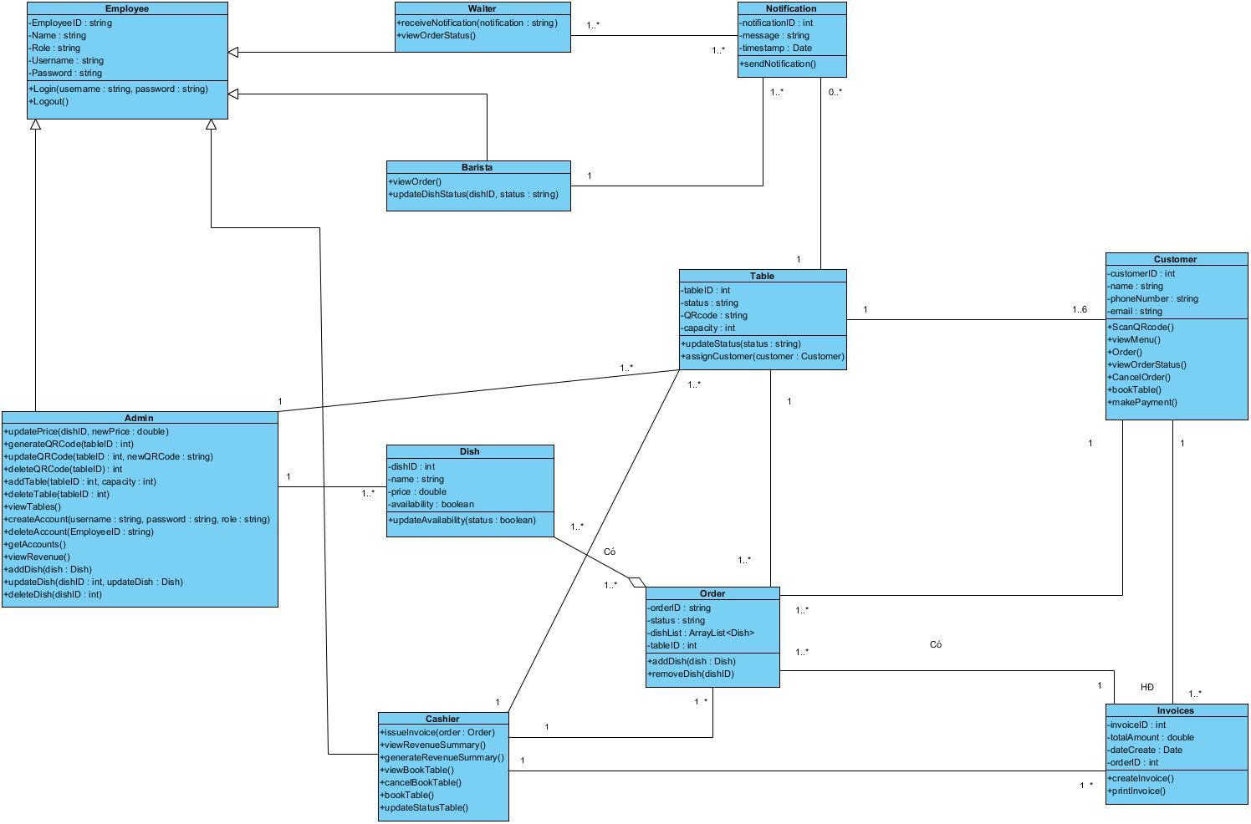

## Allocation Diagram

# Appendix A: Glossary

|  |  |
| --- | --- |
| BC | Business Constraint |
| TC | Technical Constraint |
| FR | Functional Requirement |
| QA | Quality Attribute |
| UC | Use case |
| BR | Business rule |